Create a Wild Flower Mini Meadow.
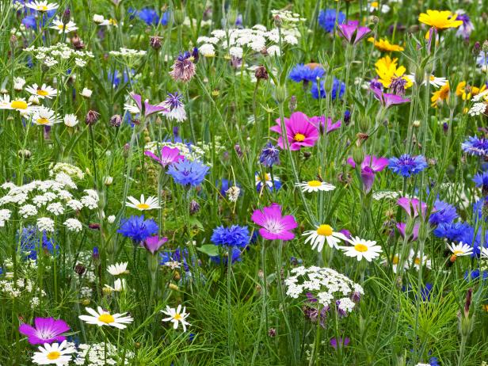

Sow wildflowers:
First, choose wild flower mix.
Next, prepare area: remove existing grass, weeds etc.
After that, remove the top 5cms soil and any stones, rake the area to create fine level seedbed.
Then, scatter the seed (mix with sand).
Now, lightly rake the seed into the soil.
Finally, water gently for a few weeks

