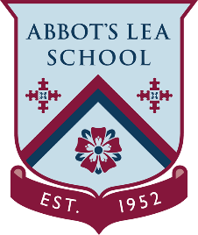
YouTube and other helpful links
Inspiring Future Engineers - The James Dyson Foundation
INSPIRING FUTURE ENGINEERS
The James Dyson Foundation, Dyson’s charitable arm, introduces young people to the exciting world of engineering, encouraging them to think differently, make mistakes and realize their engineering potential.
YouTube Channel:
The James Dyson Foundation aims to ignite young people's interest in engineering. Through free resources and workshops students are encouraged to think differently, experiment and invent. Use our video library to learn more about what it means to be a design engineer. Get an insight into design at Dyson, learn about Dyson machines and how they work. Develop your engineering skills and learn to design, build and test your own inventions.
https://www.youtube.com/user/JamesDysonFoundation
Challenge Cards:
https://www.youtube.com/playlist?list=PLpBQHVUlKs3qD7-u1bm164Qs3WJ0ZVU6X
Website:
https://www.jamesdysonfoundation.com/
Resources: Shaping Tomorrow’s Engineers
Design engineering is an exciting and rewarding career. Our free resources help students use their hands and their heads to solve real-world problems. Just like Dyson engineers.
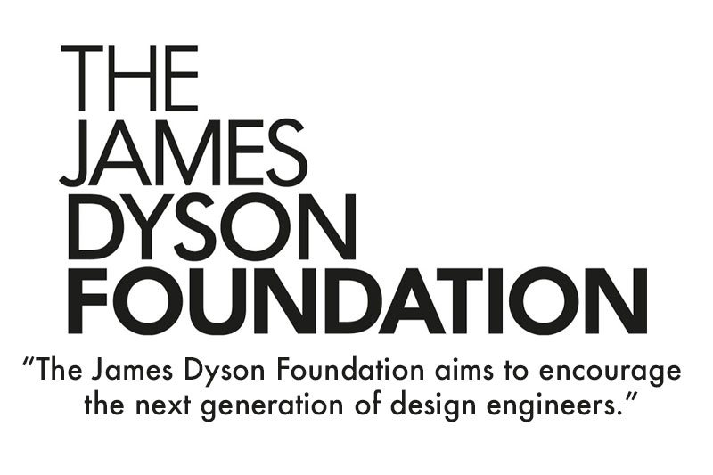
https://www.jamesdysonfoundation.com/resources.html

