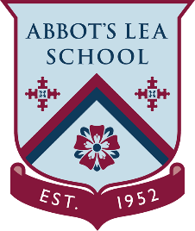
YouTube and other helpful links
Mental Floss
Mental Floss: A Destination For Curious People
“Since its founding in a Duke University dorm room in 2001, Mental Floss has reached more than 1 billion readers with smart, quirky content presented in a witty, upbeat voice. Our New York City-based team of editors and writers—as well as our worldwide network of contributors—answers life’s big questions, uncovers fascinating facts, and finds stories so interesting that our readers absolutely must share them.
When you read Mental Floss, you will discover amazing things like: why Paraguay loves Rutherford B. Hayes; hilarious Victorian slang you can incorporate into current conversations; the 100 best movies to stream right now; why both ravens and crows form—and hold—grudges; and how a famous board game was used to bust soldiers out of POW camps in World War II.
The bottom line? Whether we are covering history, science, pop culture, language, music, true crime, or entertainment, we help our audience feel smarter.”
YouTube Channel:
Mental Floss is where curious people come for trivia-tastic information. New episodes every Wednesday at 3pm.
The List Show airs on the first and third Wednesday of each month.
Mental Floss produces lists of fun facts, debunks common misconceptions, and tells untold stories from history, science, culture and more.
https://www.youtube.com/user/MentalFlossVideo
Website:
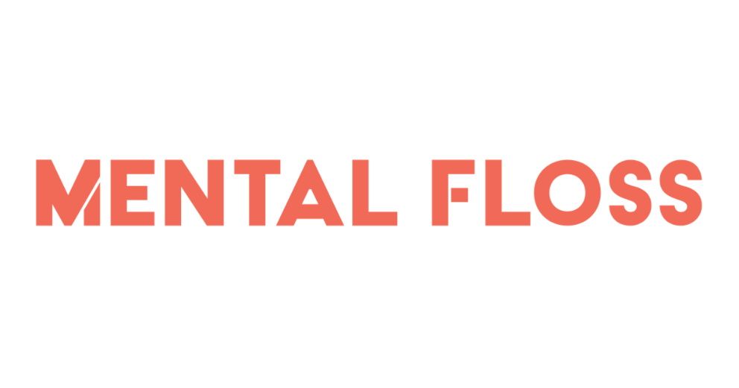
https://www.mentalfloss.com/uk

