Purple Mash
Below are instructions on how to access this week’s Science activities on Purple Mash.
Log in to Purple Mash.
Go to the search bar and type Planets.
Below is what you should see on your screen.
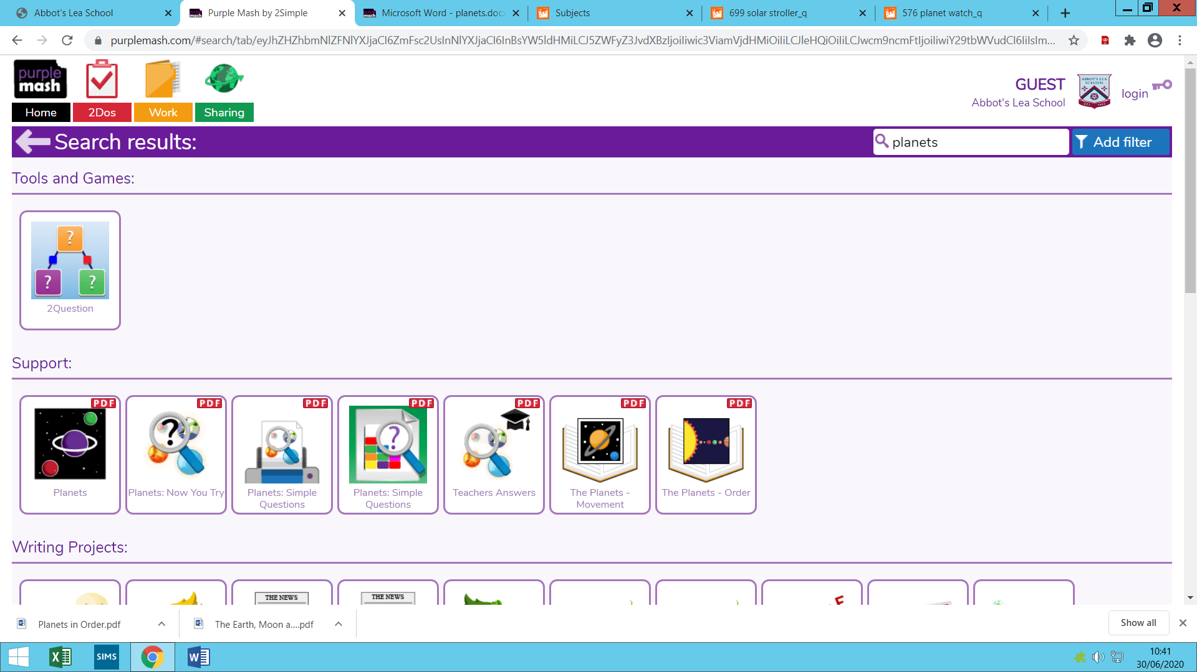

You should try to complete the activity that is circled. This is a writing activity with resources to help you along the way.

There are many activities in this section so feel free to try them! Just make sure you save your work for your teacher to mark!

