Name…..................................................... Date......................................................
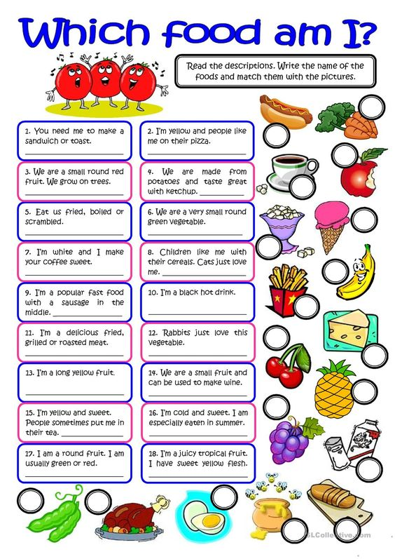
Write the question number in the circle next to the food item described.

