Fun Planter Flower Garden for Kids
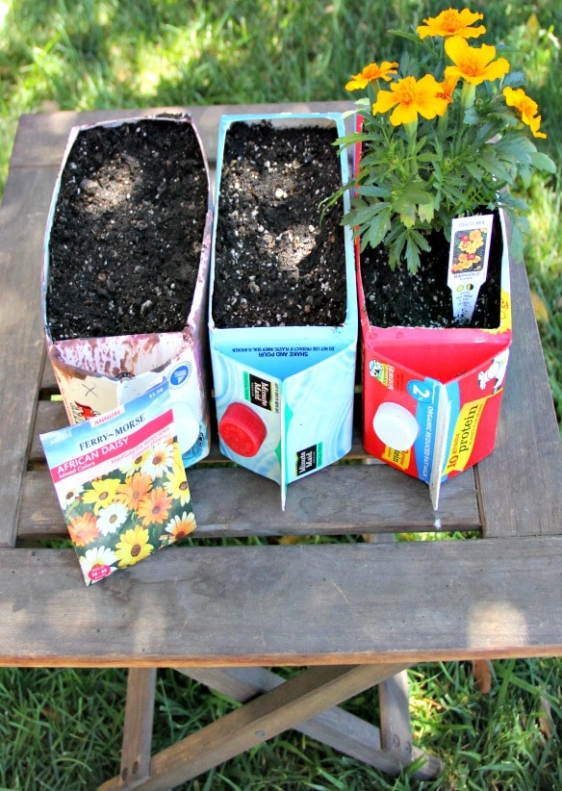
.
You will need:
Juice or milk carton (half litre) with cap
Scissors (children with guidance)
Potting soil
Flower seeds or flowers from nursery
Soap and water

- Wash out carton with soap and water.
- Let the kids shake carton really well!
- Pour out rinse with clean water.
- To cut opening, take carton turn on side so cap is facing sideways.
- Begin to cut carton – poke a small hole in one corner, put scissors in the hole and begin to cut along the edge of the carton.
- Age and stage appropriate or parent cut carton child helps to hold carton.
- Fill carton with potting soil, patting smoothing along the way.

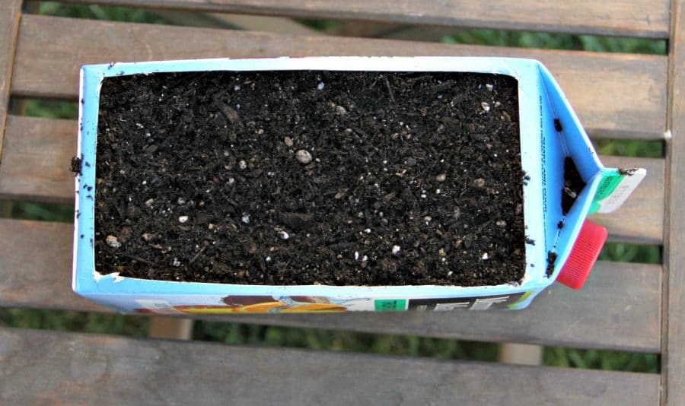

- Once full add a little water, then add flower seeds – kids poke holes with their finger and put in the seeds.
- Another option, plant some already grown flowers/plants. You could choose to make one flower carton with African Daisy seeds and one with Geranium flowers.
- Keep on the window sill for a few days
then put in outside in the sunshine.

