How to Make Pinecone Bird Feeders

Start with a fun little nature walk, hunt for pinecones and have fun watching the birds!

What you will need:
. Large open pinecones (or shop on Amazon)
. Soy butter or sunflower seed butter
. Twine
. Birdseed
INSTRUCTIONS

- First cut out piece of twine 10 inches long tie on top of your pinecone to make a loop.
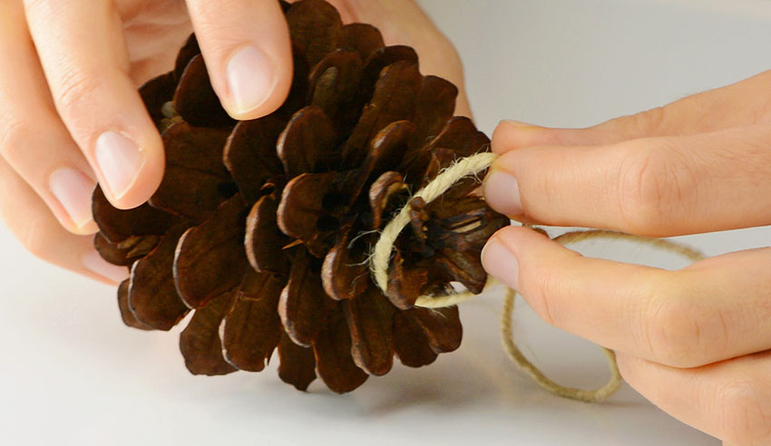

- Then place a scoop of soy butter on a plate.
- Finally spread the soy butter on the pine cone, little bit on each pine scale.

