MONSTER FOOTPRINT HOP

You will need:
. construction paper in various colours
. masking tape
. pencil
. scissors

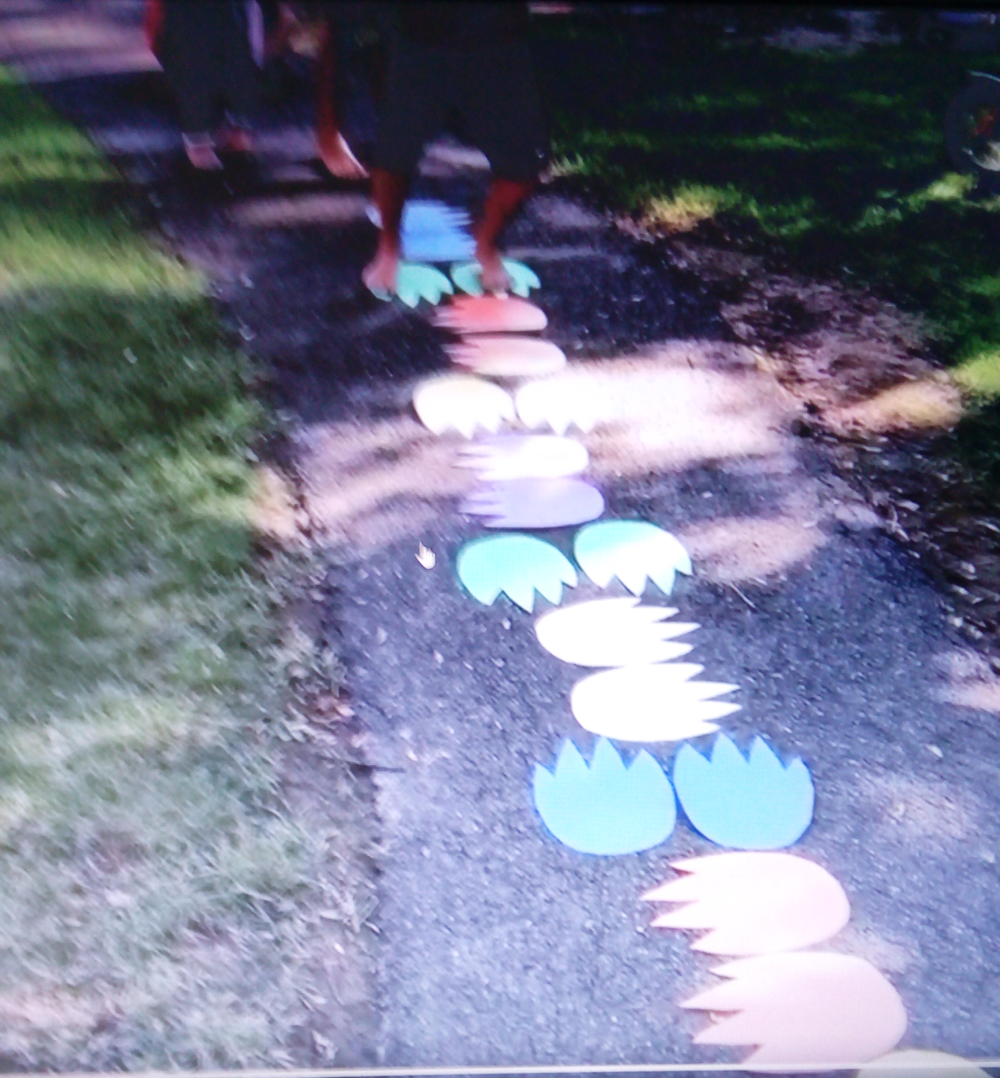
WHAT TO DO:
Start by collecting various colours of construction paper. Even numbers of each colours so you have 2 footprint sets.

Then, trace/sketch outline of a monster print (basically a large oval on the bottom and then 4 pointed claws) on one of the sheets.

Cut out the monster print.

Hold this print over about 6 sheets of construction paper and cut more matching print outs. Repeat until all the prints are cut out.

Take a small piece of masking tape and apply it to the bottom of each footprint.

Place each print on the ground with a match print.

Be sure to turn sets of prints in different directions to make the course more challenging.

