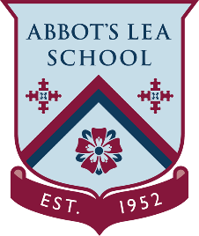
YouTube and other helpful links
Apprenticeships

What is an apprenticeship?
It is a real job, with hands-on experience, a salary and the chance to train while you work. You are treated just like all the other employees, with a contract of employment and holiday leave.
If you are 16 or over, you can become an apprentice as long as you spend at least 50% of your working hours in England - for the duration of the apprenticeship and you are not in full-time education.
When you are an apprentice:
- You get paid and train at the same time, with at least 20% of your time spent in off the job training, often at a college, university or with a training provider.
- You train to be fully competent in your chosen occupation.
- You are on a career path - with lots of future potential for you.
Your apprenticeship can take between one and six years to complete, depending on which apprenticeship you choose, what level it is at, and your previous experience.
Completing your apprenticeship means you have earned and learned. Given your training is funded by contributions from the government and your employer, and you receive a regular salary, apprenticeships are a great option for getting on the job ladder or supercharging your career.
Find an apprenticeship:
https://www.apprenticeships.gov.uk/apprentice/find-an-apprenticeship
https://www.ucas.com/apprenticeships-in-england
Useful links:
https://www.apprenticeships.gov.uk/apprentice/application
https://www.apprenticeships.gov.uk/apprentice/interview
https://www.youtube.com/user/ApprenticeshipsNAS

