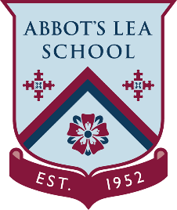
YouTube and other helpful links
BBC YouTube Channels
BBC:
“The BBC is the world’s leading public service broadcaster. We are impartial and independent, and every day we create distinctive, world-class programmes and content which inform, educate and entertain millions of people in the UK and around the world.”
https://www.youtube.com/user/BBC
BBC Teach:
“BBC Teach offers free classroom resources to schools throughout the UK. Find thousands of free curriculum-linked class clips on BBC Teach to help you deliver lessons - all arranged by subject and age group.”
https://www.youtube.com/channel/UC4KN50fal7f45fx2DqG7ttg/featured
BBC Documentary:
“Welcome to the Official BBC Documentary Channel, offering audiences epic documentaries that deliver a thought provoking and captivating viewing experience inside key moments from history and the lives of fascinating people.”
https://www.youtube.com/channel/UCZEPItn2Nb62Zso5eohHAAA
BBC Food:
“Welcome to the BBC Good Food channel. This is the best place to find mouth-watering recipes you will love as well as handy hints & tips on how to improve your culinary skills. Whether you are a novice in the kitchen or fancy yourself as a master chef, we have got the content for you.”
https://www.youtube.com/user/BBCFood
BBC Music:
“BBC Music brings you the biggest artists in the world from the biggest events. There are tracks from the legendary festivals like Glastonbury and Reading and Leeds, sessions from emerging artists with BBC Music Introducing, performances from the iconic Later… with Jools Holland series, unique performances from Radio 2, exciting artist on The One Show as well as moments from all of the other music content from across the BBC.”
https://www.youtube.com/user/bbcintroducing

