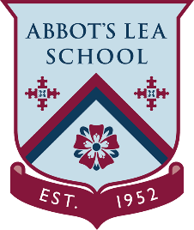
YouTube and other helpful links
DC Comics - YouTube Channel

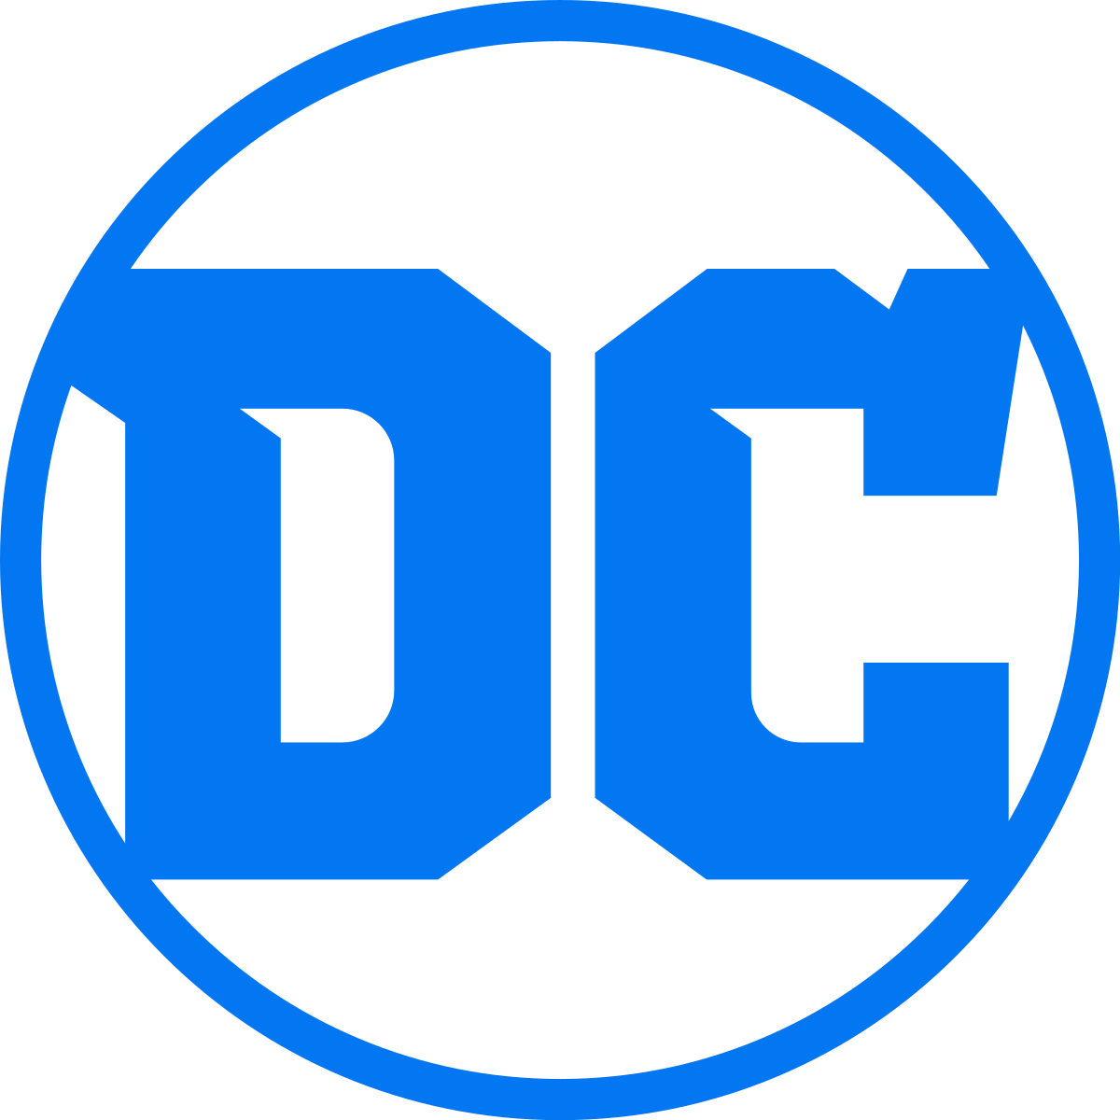
DC Comics
Founded in 1934 as National Allied Publications, DC Comics is the largest and most diverse English language publisher of comic books in the world. It features Comics, News, Videos, Games, Television and more about the world’s greatest Super Heroes for all the DC fans around the world.
DC - YouTube Channel:
“Welcome to the Official YouTube channel for DC Entertainment, home to DC Comics (Superman, Batman, Green Lantern, Wonder Woman, The Flash and more), Vertigo Comics (Sandman, Fables, American Vampire and more) and MAD.”
https://www.youtube.com/dcentertainment
DC Fans - YouTube Channel:
“Welcome to the DC Fans Channel - the official YouTube Channel devoted to YOU - the DC Fan. We are showcasing our favourite videos made by fans, for fans, of the vast DC Universe.
We love what you have been doing, and we want your voice to be heard.”
https://www.youtube.com/c/dcfanschannel
DC Kids - YouTube Channel:
“Welcome to the Official YouTube channel for DC Kids! Enjoy great entertainment from your favourite shows like Batman Unlimited, DC Super Friends, Teen Titans Go! and more!”
https://www.youtube.com/channel/UCyu8StPfZWapR6rfW_JgqcA

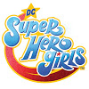
DC Super Hero Girls - YouTube Channel:
“Welcome to the official DC Super Hero Girls YouTube Channel!
DC Super Hero Girls are more than crime-fighting besties, they are a diverse group of dedicated super-teens! Working together, they fight the battles of Metropolis and the battles of growing, up all at the same time. Always discovering new ways to control their powers and abilities, these awesome girls are quickly learning (sometimes the hard way) how to deal with the super challenges of being a teenage Super Hero.”
https://www.youtube.com/c/DCSuperHeroGirls

