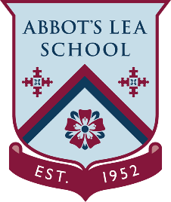
YouTube and other helpful links
Art and Crafts

Art and Crafts workshops and techniques.
Creativebug:
The Creativebug channel, brings you inspiration and know-how to realize your creative potential. Experience the pride and satisfaction of making something by hand, through hundreds of videos featuring top designers and artists.
https://www.youtube.com/user/cbugstudio
Crafts Council:
The Crafts Council is responsible for advancing craft in The U.K.
https://www.youtube.com/channel/UCYYL-qgMdl3adnB_BkoNi9g
https://www.craftscouncil.org.uk/
Watercolour Painting:
Stuck at home? Use that time to take care of yourself by distressing through the art of watercolour painting!
https://www.youtube.com/channel/UCEYTvzdLrD1bx1NTOO4nwpA
Art is Fun!:
Do you want to learn how to draw or paint? Are you looking for painting tips and drawing techniques that will help you along your artistic journey? Or perhaps you'd like to deepen your understanding of and appreciation for art? This website has something for everyone - from the complete beginner to the avid art enthusiast. Basically, this is a website for the creative spirit!
https://www.art-is-fun.com/

