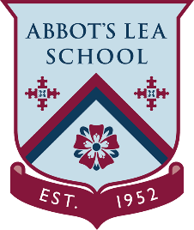
YouTube and other helpful links
Harry Potter at Home
Harry Potter: A History of Magic
“The British Library’s Harry Potter: A History of Magic exhibition is online for you to visit anytime. The perfect mix of fun, fascinating and educational that will keep you and your family spellbound.
The Harry Potter: A History of Magic exhibition unveils rare books, manuscripts and magical objects from the British Library’s collection, capturing the traditions of folklore and magic which are at the heart of the Harry Potter stories. Here’s our little reminder that you can explore the exhibition again, or marvel at the magic for the very first time from your own home, through Google Arts & Culture.
This online curation, which includes highlights from the British Library’s exhibition, is not only ideal escapism for curious adults but perfect for parents looking for engaging activities for their children. They’ll love the interactive experience of searching the Ripley Scroll, an ancient manuscript that sets out the ingredients for the elixir of life. Get those imaginations flowing by flicking through ancient spell books, as well as insiders’ insights into the exhibition in videos featuring Julian Harrison, its lead curator.
Jim Kay’s beautiful artwork (including a study of dragon eggs!) will no doubt inspire many a budding young artist, as well as reading the words of the illustrator himself from a rare interview. For the animal-loving there are plenty of magical creatures to fervently study, and for some story-writing inspiration, read early notes and sketches by J.K. Rowling as she created the wizarding world we all know and love.
There’s even a ‘how to study like a wizard’ section, where you can discover the history behind the classes at Hogwarts. Grab your quills and delve into eight online exhibits – Potions, Charms, Herbology, Alchemy, Astronomy, Divination, Defence against the Dark Arts and Care of Magical Creatures. Which subject will you excel in? Beautifully curated for an online experience, each exhibit is visually dynamic – zooming into manuscripts, artwork and sketches – as well as fascinating and easily accessible.”
Explore the British Library’s Harry Potter:
https://artsandculture.google.com/project/harry-potter-a-history-of-magic
Wizarding World - YouTube Channel:
https://www.youtube.com/channel/UChPRO1CB_Hvd0TvKRU62iSQ

