ICT Functional Skills
Task 10: Plan a 3 week family cruise to the Caribbean

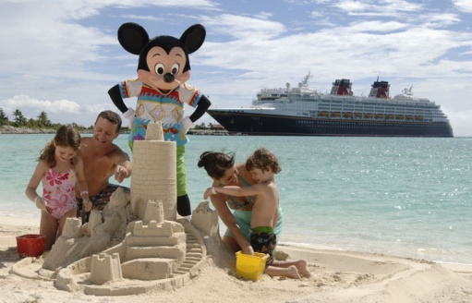
You have been asked to plan a 1 week family cruise to the Caribbean in August 2012 for Mr and Mrs Singh and their 3 children: Maya (4), Sumat (7) and Bulwinder (12)

The cruise ship must have on board facilities and activities suitable for all the family. The itinerary must be suitable for young children. Mr and Mrs Singh have up to £12000 to spend on the cruise.

1.Using Google search for Disney Caribbean Cruises.
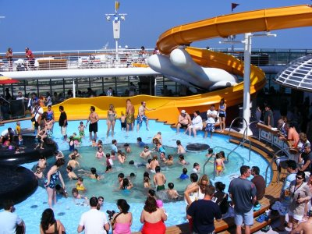

2. List the total cost of the cruise, dates, itinerary and facilities on board the ship.

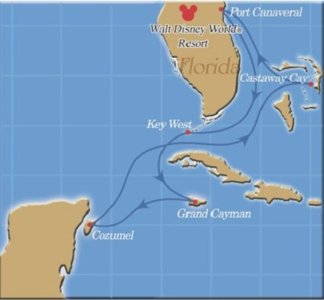
3. Include images of the facilities on board the ship, pictures of places you will stop over and a map showing the route of the cruise.

4. Once you have found all the required information, show that you know how to alter the appearance of the document by using a range of tools such as Word Art, Page Borders and Picture Styles.

5. Save Document as T13 Cruise Ship and email it to me.

