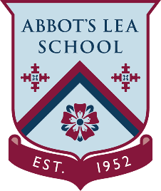
YouTube and other helpful links
Staying Active

NHS – Fitness Studio:
Take your pick from 24 instructor-led videos across our aerobics exercise, strength and resistance, and Pilates and yoga categories. These workouts have been created by fitness experts, and range from 10 to 45 minutes.
https://www.nhs.uk/conditions/nhs-fitness-studio/

NHS – ‘One You’, Home Workout Videos:
To stay fit and healthy, you are recommended to get at least 150 minutes of moderate physical activity a week, or around 20 to 30 minutes a day. Plus, you should aim to do strengthening and balance exercises at least 2 days a week. This home workouts are an easy way to help you reach your exercise goals, so give them a go!
https://www.nhs.uk/oneyou/for-your-body/move-more/home-workout-videos/
Sport in Herts – Workout from Home:
In light of the current COVID-19 pandemic and everyone being asked to stay at home, we have put together a suite of tools, resources and more importantly, activities, to help keep everyone moving.
https://sportinherts.org.uk/workoutfromhome/

