Now here’s a chance for you all to show your true colours and do something to promote your favourite football team. For this task you will need to produce a poster to advertise your chosen team’s next fixture. You must include
- Your teams name and badge

- The other teams name and badge

- The date of the fixture.
- The price of the tickets.
- An image of the ground where the fixture is to be played.
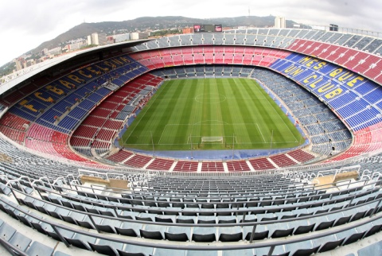

- Pictures of current players or managers from both teams.

- The score and date of the last fixture played by these teams.

