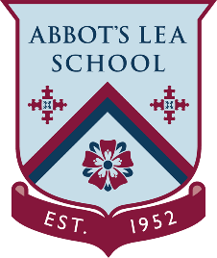
YouTube and other helpful links
National Careers Service
YouTube Channel:
Welcome to the National Careers Service YouTube channel where we follow stories that show how the right advice can help with your employment goals. Whether you need to create a CV, find a course, or explore your options, our advisers are here to help.
https://www.youtube.com/user/RightDirectionForYou
#HereForYou:
The #HereForYou series of short videos helps to arm you with the right information and preparation techniques to help you advance in your career, or find a job. You can contact us 7 days a week up until 22:00 on 0800 100 900.
Website:
“We provide information, advice and guidance to help you make decisions on learning, training and work.
Use our career tools to help you with your choices on careers, training and work. Whatever your situation, there's something to help.”
https://nationalcareers.service.gov.uk/

