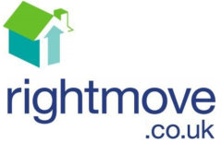
Task 7: House price investigation

Use www.rightmove.co.uk to investigate the lowest and highest price for a 3 bedroom house in the following areas. Use the drop down menu for each location so it looks like this.

Specific location | Highest price | Lowest price
Lymington | £ | £
Totton | £ | £
Southampton | £ | £
Marchwood | £ | £
Hythe | £ | £
Romsey | £ | £
Lyndhurst | £ | £
Brockenhurst | £ | £
Fawley | £ | £
Winchester | £ | £
Portsmouth | £ | £
Basingstoke | £ | £
Fareham | £ | £

