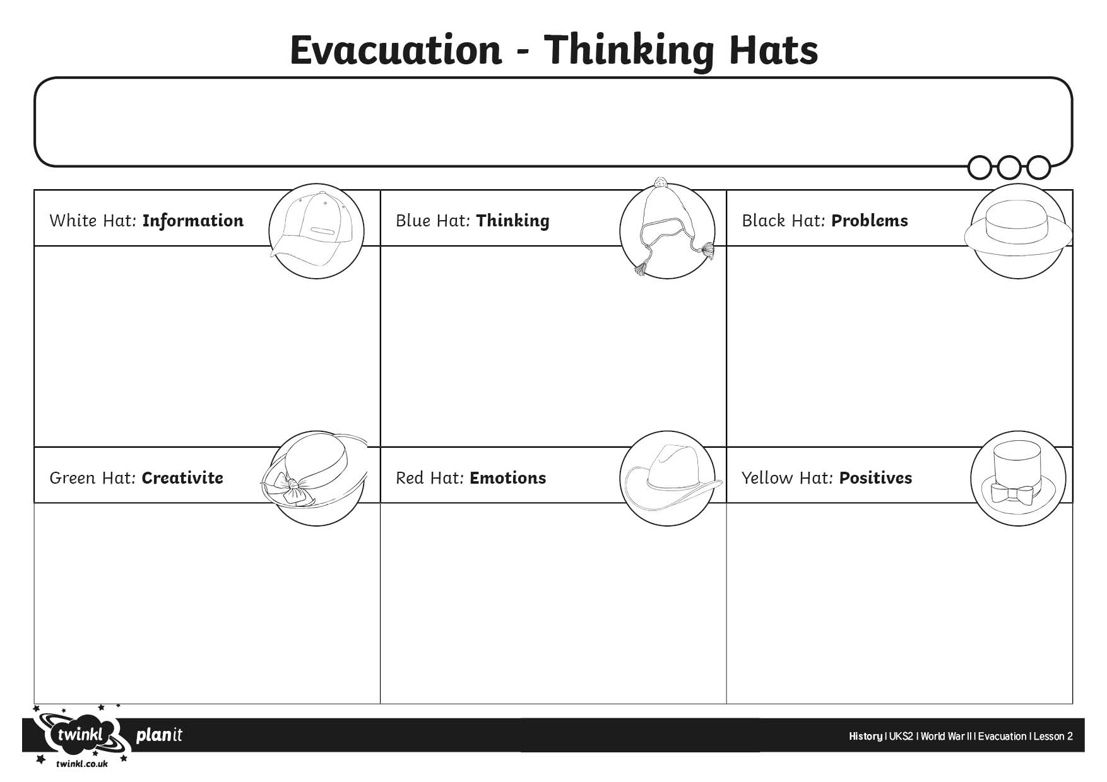
I can use different thinking skills to help me organise information about being evacuated.

