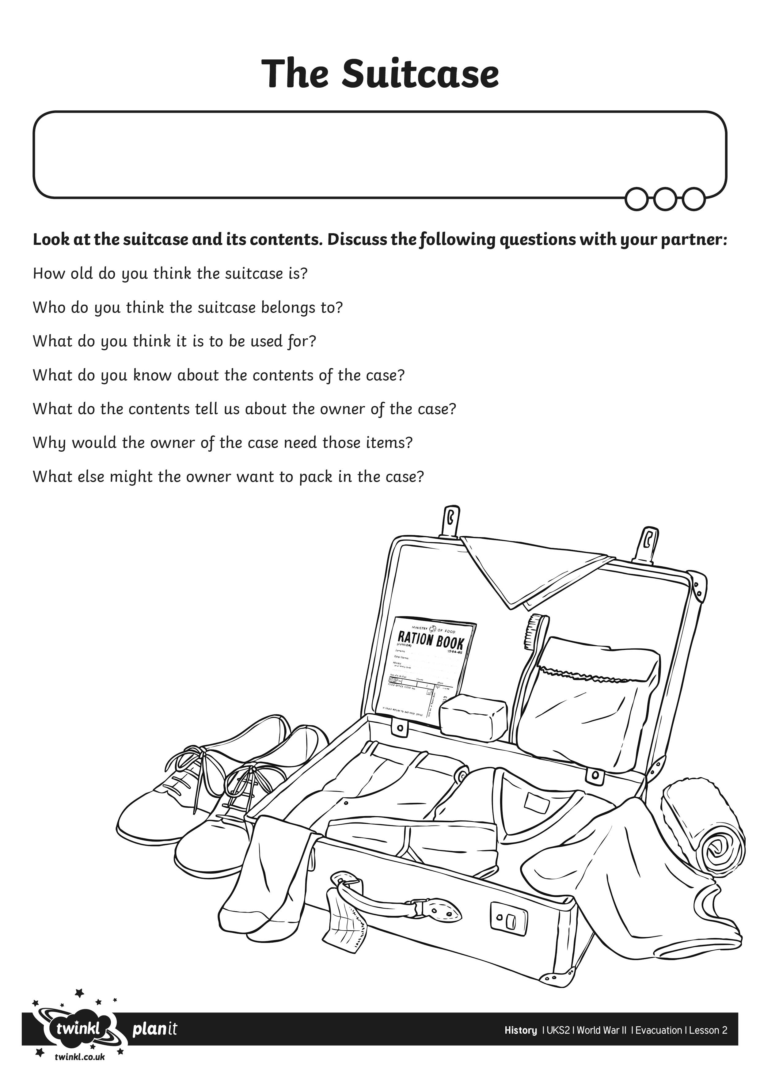
I can describe what evacuees needed to take with them on their journey.

