Customer services

NAME:

In your own words tell me what Customer Service is

____________________________________________________________________________________________________________________________________________________________________________________________________________________________________

Explain what non-verbal customer service is and give 2 examples

____________________________________________________________________________________________________________________________________________________________________________________________________________________________________

What ways do we interact with customers without using our voice?

____________________________________________________________________________________________________________________________________________________________________________________________________________________________________
_______________________________________________________________________________________________________________

What are the benefits of good customer service?

Scenario 1 | What should you do to prevent miscommunication and poor customer service, for this scenario?
A client at a hairdressing salon requests a particular hairstyle. She imagines just a trim and a touch up of her usual colour. The resulting hairstyle was not what the client desired. She received a different colour and felt her hair had been cut too short.  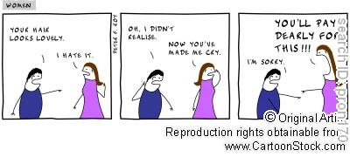 | What should have been said or done before the hair cut?  What should be said or done after the haircut?

