KS4 Skills Builder booklet

Miss Woolerton and Mrs Mmurdo

Archbishop Holgate’s School

KS4 Skills Builder booklet

Literacy Skills Builder

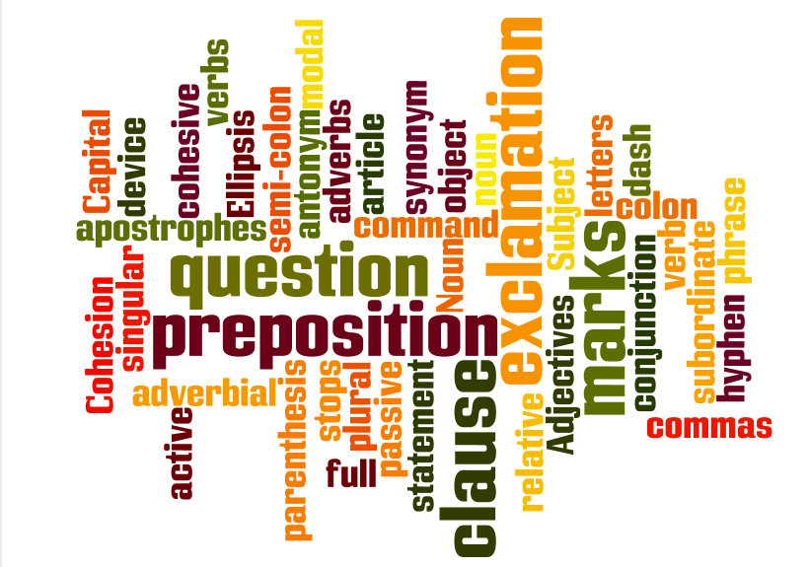

Name:

Year:

English Teacher:

Week 1: Determiner articles

Autumn term 1and 2

What is a determiner article and when do I use one?

Rules:

**Determiners** : many of the most frequent English words – the, a, my, this, some. They are used with nouns and they limit (ie determine) the reference of the noun in some way.

You wilsually find the determiner at the beginning of a noun phrase *eg* ***the*** *big dog*.

**ALL ARTICLES are also determiners**.

There are three articles — *a, an, the*. *The* is called the **definite article** because it usually goes in front of a specific or previously mentioned noun; *a* and *an* are called **indefinite** articles because they are used to refer to something in a less specific manner.

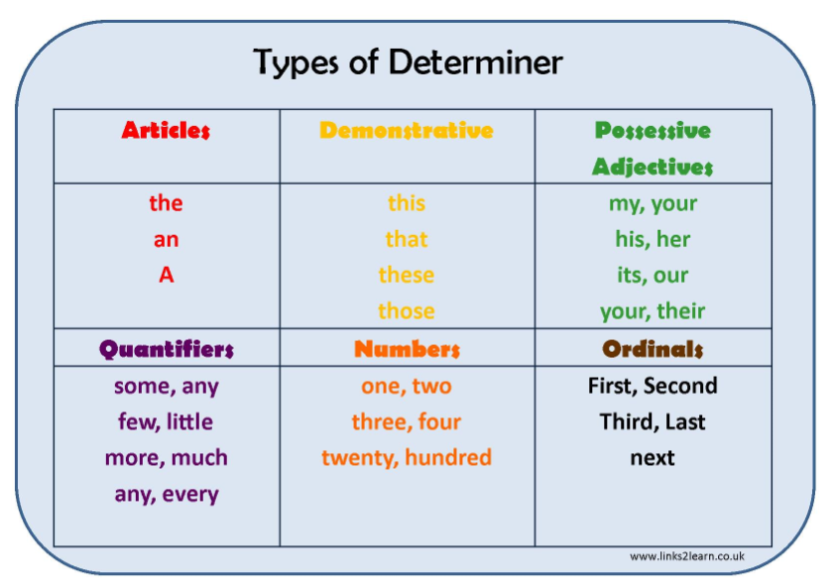

Task 1

Read each of the following noun phrases. If they are not correct, write them again. Make sure that the noun agrees with the determiner:

1. a green bag ___________________________________

2. some big table ___________________________________

3. a beautiful pictures ___________________________________

4. ten long dress ___________________________________

5. the new black trousers ___________________________________

6. an uncooked egg ___________________________________

7. a annoying person ___________________________________

8. some nice people ___________________________________

9. some fresh sandwich ___________________________________

10. a good programmes ___________________________________

11. an interesting journeys ___________________________________

12. a few young mans ___________________________________

13. lot of big problems ___________________________________

14. the left-hand side ___________________________________

15. a old suitcases ___________________________________

**Merit Challenge!**

Find an example of a determiner article in your reading book and write it down here:

Look through your exercise book. Have you used any determiners? Highlight an example and get your partner to check it.

Review learning

Record the rules for using determiner articles in the box below. You can bullet point them. No cheating!



Progress timeline

How confident are you with determiners?

Week 2: Demonstratives

What is a demonstrative and when do I use one?

Rules:

The demonstratives ***this, that, these, those*** *,*show *where* an object or person is in relation to the speaker.

*This* (singular)and *these* (plural) refer to an object or person near the speaker. *That* (singular) and *those* (plural) refer to an object or person further away. It can be a ***physical*** closeness or distance as in:

* Who owns ***that*** house? (distant)
* Is***this***John's house? (near)

Or it can be a ***psychological*** distance as in:

* ***That***'s nothing to do with me.. (distant)
* ***This***is a nice surprise*!* (near)

**2. Position**

* Before the noun.
* Before the word *'one'.*
* Before an adjective + noun.
* Alone when the noun is 'understood'.

Task 1

Highlight the demonstrative in the following sentences. Next to it, write down whether it is singular or plural.

* This tastes good.
* Have you seen this?
* These are bad times.
* Do you like these?
* That is beautiful.
* Look at that!
* Those were the days!
* Can you see those?
* This is heavier than that.
* These are bigger than those.

**Circle the demonstrative adjectives in each sentence.**

( 1 ) That bus ride is too bumpy for me to do my homework on.

( 2 ) Is my term paper somewhere in that stack of papers?

( 3 ) I think those kids are watching us.

( 4 ) I think that battery is dead.

( 5 ) We need to wash all of those dishes before we watch any television.

( 6 ) What do you see in those clouds?

( 7 ) Any of those computers should be good enough for what you need.

( 8 ) We ate dinner at this restaurant last year.

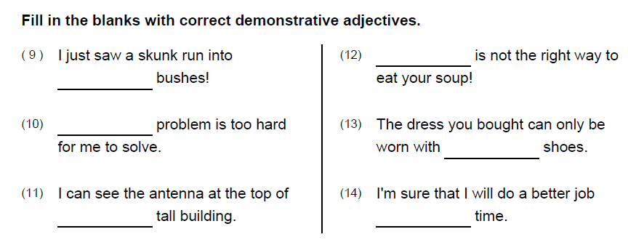

**Merit Challenge!**

Find three examples of demonstratives in your reading book or your exercise book. Why have they been used? Are there any times when you have forgotten to use a demonstrative in your exercise book?

Review learning

Record the rules for using demonstratives in the box below. No cheating!



Progress timeline

How confident are you with demonstratives?

Week 3: Possessives

What types of possessive words are there and when do I use them?

Rules:

Possessive pronouns

We use possessive pronouns to refer to a specific person/people or thing/things (the "antecedent") belonging to a person/people (and sometimes belonging to an animal/animals or thing/things).

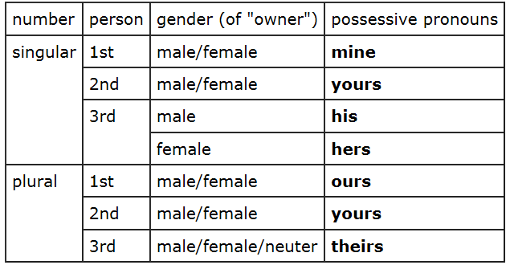

We use possessive adjectives to show who owns or "possesses" something. The possessive adjectives are:

* my, your, his, her, its, our, their, whose

|  |  |  |  |  |
| --- | --- | --- | --- | --- |
| number | person | gender | possessive adjective | example sentence |
| singular | 1st | male/female | my | This is **my** book. |
| 2nd | male/female | your | I like **your** hair. |
| 3rd | male | his | **His** name is "John". |
| female | her | **Her** name is "Mary". |
| neuter | its | The dog is licking **its** paw. |
| plural | 1st | male/female | our | We have sold **our** house. |
| 2nd | male/female | your | **Your** children are lovely. |
| 3rd | male/female/neuter | their | The students thanked **their** teacher. |
|  |  |  |  |  |
| singular/plural | 1st/2nd/3rd | male/female (not neuter) | whose | **Whose** phone did you use? |

Task 1

Replace the personal pronouns with possessive adjectives

* + Where are (you) ______ friends now?
  + Here is a postcard from (I) ______ friend Dees.
  + She lives in England now with (she) ______ family.
  + (He) ______ wife works in Tilburg.
  + (He) ______ company builds websites.
  + Joanie is (John and Nancy) ______ daughter.
  + Our names are Kathy and Robin. This is (Kathy and Robin) ______ mother.
  + Jeremy and Valerie are (Tim and Carey) ______ parents.
  + Tony is (Mary) ______ grandson.
  + My name is Annie. This is (Annie) ______ father.
  + (Alex) ______ name is Alex.
  + Peggy and Martin are (Kelly) ______ children.
  + Your name is Greg. They are (Grey) ______ parents.

Task 2

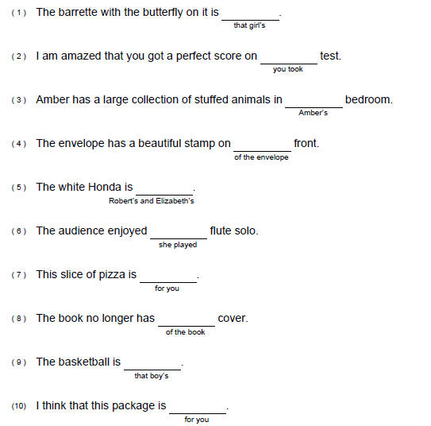

Write the possessive pronoun that should be used in each sentence.

****Merit Challenge!

In your book, find 3 examples of possessive pronouns and adjectives and highlight them. Now look for a possessive in your reading book. What rules does it follo

Review learning

Record the rules for using possessives in the box below. No cheating!



Progress timeline

How confident are you with possessives?

Week 4- Quantifier

What is a quantifier and when should I use one?

Rules:

We use quantifiers when we want to give someone information about the number of something: how much or how many.

Sometimes we use a **quantifier** in the place of a **determiner**:

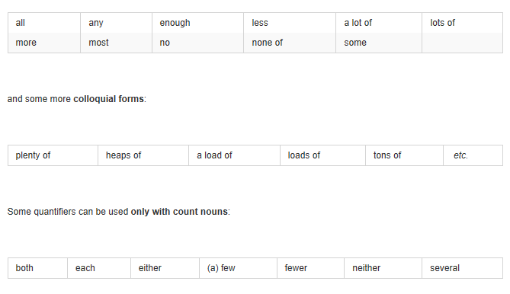Most children start school at the age of five.  
We ate some bread and butter.  
We saw lots of birds.

Task 1

Write the correct quantifier on the line.

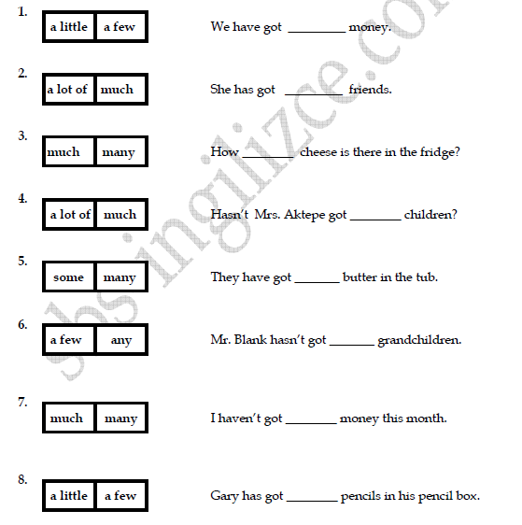



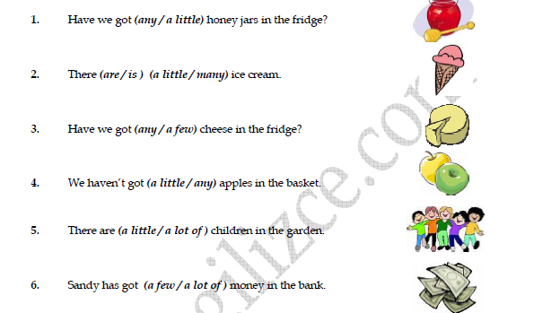

Merit challenge

Find an example of a quantifier in your reading book and write it down here:

Look through your exercise book. Have you used any quantifiers? Highlight an example and get your partner to check it.

Review learning

Record the rules for using quantifiers in the box below. No cheating!



Progress timeline

How confident are you with quantifiers?

Week 5- Modifiers

What are modifiers and when do I use them?

Rules:

A modifier is a word, phrase, or clause which functions as an adjective or an adverb to describe a word or make its meaning more specific.

**Modifiers As Adjectives**  
  
When a modifier is an [adjective](http://www.grammar-monster.com/glossary/adjectives.htm), it modifies a [noun](http://www.grammar-monster.com/glossary/nouns.htm) or a [pronoun](http://www.grammar-monster.com/glossary/pronouns_definition.htm). (In these examples, the modifiers are shaded, and the words being modified are bold).

* Lee caught a small **mackerel**.

(Here, the adjective *small* modifies the noun *mackerel*.)

* Lee caught a small **mackerel**.

(Don't forget that [articles](http://www.grammar-monster.com/glossary/articles.htm) (i.e., *the*, *an*, and *a*) are adjectives too. Here, *a* modifies the noun *mackerel* as does *small*.)

* Lee caught another **one**.

(Here, the adjective *another* modifies the pronoun *one*.)

**Modifiers As Adverbs**  
  
When a modifier is an [adverb](http://www.grammar-monster.com/glossary/adverbs.htm), it modifies a [verb](http://www.grammar-monster.com/glossary/verbs.htm), an adjective, or another adverb. For example:

* Lee accidentally **caught** a small whelk.

(Here, the adverb *accidentally* modifies the verb *caught*.)

* Lee caught an incredibly **small** mackerel.

(Here, the adverb *incredibly* modifies the adjective *small*.)

* Lee supposedly **accidentally** caught a small whelk.

(Here, the adverb *supposedly* modifies the adverb *accidentally*.)

A misplaced [modifier](http://www.grammar-monster.com/glossary/modifiers_modify.htm) makes the meaning of a sentence ambiguous or wrong.

## Examples of Misplaced Modifiers

Here are some examples of misplaced modifiers (shaded):

* Andrew told us after the holiday that he intends to stop drinking.

(In this example, it is not clear whether Andrew made this statement after the holiday or whether he intends to stop drinking after the holiday.)

* Running quickly improves your health.

(In this example, it is not clear if *running* modifies *running* or *improves*.)

Task 1

Revise the following sentences to correct misplaced or dangling modifiers.

1. The tall boy led the parade with red hair.

2. My brother just listens to one radio station.

3. After dancing solo on stage, the audience applauded Anna's performance.

4. While taking a nap, the volcano erupted.

5. The new student will take the corner seat wearing the muscle shirt.

6. Hoping the weather would improve, the corn was planted during the heat wave.

7. Unfortunately, I can only take three students to the concert.

8. Totally destroyed by the tornado, he had to rebuild his barn.

9. While standing in line, the thunder could be heard.

10. Kathy donated a television to the Youth Center that she no longer used.



Merit challenge

1. Find an example of where a modifier has been used in your reading book. Write it here:
2. Find an example of where a misplaced modifier has been used in your exercise book. Write it here:

Look through your exercise book. Have you used any modifiers? Highlight an example and get your partner to check it.

Review learning

Record the rules for using a modifier in the box below. No cheating!



Progress timeline

How confident are you with modifiers?

Spring term 1and 2

Week 1 –Homonym

**What is a homonym and when would I use one?**

[Homonyms](http://www.yourdictionary.com/homonym) are words that sound the same, and are sometimes spelled the same, but have different meanings. For example:

* Aunt - Ant
* Ate - Eight
* Berry - Bury
* Be - Bee
* Beat - Beet
* Brake - Break
* Buy - By - Bye
* Close - Clothes

Task 1

**Select the correct homonym and write it on the line**

Once upon a time __________ (their/there) was a beautiful princess. She lived with her Uncle and __________ (Auntie/Ante). She spent ___________ (ours/hours) every day brushing her long _________ (fair/fare), curly ________ (hair/hare). Her favourite moment was when she let it flop down lightly on her ________ (bear/bare) neck.

Most days the princess liked ______ (to/too) go for long walks in the near by ________ (wood/would).

One day she was walking, and the sky was a wonderful ________ (blue/blew) colour. She stopped to admire the pretty view. The _______ (sun/son) was positively gleaming like a jewel. She didn’t notice the approach of a hunched figure with a cloak, carrying a basket of ___________ (flours/flowers). The figure stopped about __________ (ate/eight) feet from the princess and watched her carefully.

She turned around, and couldn’t believe the _____________ (sight/site) before her.

“What do you want with me?” she asked worriedly.

The figure merely ________(made/maid) a grumbling sound in _________ (they’re/their) throat.

The princess didn’t want to get ________ (to/too) ___________ (clothes/close) because she had often been warned by her Uncle that she shouldn’t talk to any ________ (mail/male) on her own.

Being uncommonly ___________ (board/bored), the Princess decided to risk her life in discovering the identity of her strange companion.

She whipped the cloak __________ (of/off) with a flourish and gasped.

Standing before her was a massive __________ (mail/male) ___________ (bare/bear).

The princess screamed all the way home.

Merit challenge

1. Find an example of a homonym in your reading book. Write it here:

Look through your exercise book. Have you used any homonyms, correctly or incorrectly? Highlight an example and get your partner to check it.

Review learning

Record the rules for using a homonym in the box below.



Progress timeline

How confident are you with homonyms?

Week 2- homophones

What is a homophone and how is it different to a homonym?

Rules:

**Homophones** are a type of homonym that also *sound* alike and have different meanings, but have different spellings. A **homophone** is a word that is pronounced the same as another word but differs in meaning. The words may be spelled the same, such as rose (flower) and rose (past tense of "rise"), or differently, such as carat, caret, and carrot, or to, two and too.

Homophones: two, to and too.

Task 1 adjectives

1. There were __________ trains standing in the station.

Top of Form

Bottom of Form

2. I usually go ________ the swimming pool on Saturdays.

Top of Form

Bottom of Form

3. The question was _______________ hard for me.

Top of Form

Bottom of Form

4. My best subject is Geography but I'm quite good at English ___________.

Top of Form

Bottom of Form

5. Maisie tries ________ train my dog at least four times a week.

Top of Form

Bottom of Form

6. The music was far ___________ loud for Joe's parents.

Top of Form

Bottom of Form

7. “Today you will need _______ use your calculators” said the teacher.

Top of Form

Bottom of Form

8. Jack's ambition is ____________ become an actor.

Top of Form

Bottom of Form

9. _______________ heads are better than one!

Top of Form

Bottom of Form

10. "I'd like a cookie please," said Emma. "Me _______ !" shouted Mick.

Top of Form

Bottom of Form

11. I wouldn't bother ____________ much about what to wear at the party.Top of Form

There, their and they’re.

Bottom of Form

1. The teacher told them to leave …….. books on the desk.

2. Billy is always ……. on time.

3. ………. are over 900 students at our school.

4. Ask them if ……….. coming tomorrow.

5. Dad was pleased they had done well in ………. exams.

6. We’ll go to McDonalds if ………. is time.

7. ………. baking a cake for their Grandma.

8. Can you give me ……… telephone number?

9. My parents won’t be coming as ………… both working on Saturday.

Merit challenge

1. Find an example of a homophone in your reading book. Write it here:
2. Find an example of a homophone in your exercise book. Write it here:

Look through your exercise book. Have you used any homophones? Highlight an example and get your partner to check it.

Review learning

Record the rules for using a homophone in the box below.



Progress timeline

How confident are you with homophones?

Week 3- fronting

What is fronting in grammar?

The most common word order in a sentence is to have a subject, followed by a verb plus an object. For example:

I bought a new camera

Sometimes, particularly in speaking, when we want to focus on something important, we bring it to the front of the clause. This is called ‘fronting’:

***I bought a new camera. And a very expensive camera it was.* (Most common word order: It was a very expensive camera.)**

|  |  |
| --- | --- |
| ***Carefully****, he removed the lid.*  (fronted so as to focus on *carefully*) | *He removed the lid* ***carefully****.*  (most common word order) |
| ***All of a sudden****, it started to snow.*  (fronted so as to focus on *all of a sudden*) | *It started to snow* ***all of a sudden****.*  (most common word order) |

**Fronting is common with:**Adverbials (place and movement)  
On the table stood a vase of flowers  
(A vase of flowers stood on the table)  
  
There is / there are  
Next to the window was a bookcase  
(There was a bookcase next to the window)  
  
Participles  
Gone were the designer sunglasses  
(The designer sunglasses were gone)

Task 1

Re-write the following sentences to make them more emphatic by fronting or using inversion. For example, number 1 could be: ‘Into the sky burst the rocket’.

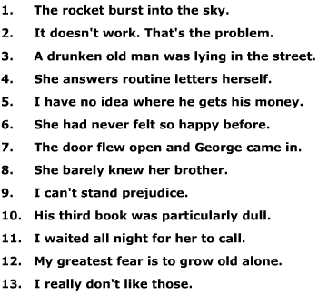

Merit challenge

1. Find an example of fronting in your reading book. Write it here:

Review learning

Record the rules for fronting in the box below.



Progress timeline

How confident are you with fronting?

Week 4 and 5-preposition phrase

What is a preposition phrase and when would I use it?

***A preposition is a word that joins a noun to the rest of a sentence.***

***It explains where the noun is.***

*The bag was* ***on*** *the table.*

*The girl walked* ***under*** *the scaffolding.*

*It sat* ***among*** *the bushes.*

*The sentences would not work without the prepositions.*

Common prepositions

*about beneath into throughout*

*above beside near to*

*across between of toward*

*against by on under*

*among except onto up*

*at for out upon*

*behind from over with*

*below in through without*

Prepositional phrases that begin sentences are usually followed by commas. However, short prepositional phrases need not be.

*Original sentence:*

*A fat yellow cat lay sleeping on the narrow sill.*

*How would it read if it started with the preposition?*

*On the narrow sill, a fat yellow cat lay sleeping.*

Task 1

Spot and underline the prepositions

* The cat sat under the bush as it was raining.
* The girl walked slowly across the playground.
* Helen put the book on the table.
* The postman posted the letter through the letterbox.
* James was hiding behind the sofa.

Add a prepositional phrase to the end of these sentences to show where the events happened.

a) The boy climbed ***over the fence***

b) The man was standing

c) The girl jumped

d) The dog ran

Add a prepositional phrase that tells us when each of these events happened.

1. Sally went for a run ***before she went to work***
2. James knocked on his friend’s door
3. It began to rain
4. We went to the cinema

Merit challenge

1. Find an example of a prepositional phrase in your reading book. Write it here:

Look through your exercise book. Have you used any prepositions or prepositional phrases? Highlight an example and get your partner to check it.

Review learning

Record the rules for prepositional phrases here.



Progress timeline

How confident are you with prepositional phrases?

Week 1-Past tense

Summer term 1and 2

What is the past tense, and when would I write in past tense?

The simple past tense:

We use this tense to talk about events or situations that are finished. Normally we use a time reference.

We also use the **Past Simple** tense in English to talk about long-lasting events or situations in the past;

"When I **was** a child, I **lived** in the countryside."

**WAS, WERE, THERE WAS, THERE WERE, WENT**

*“Last weekend, I* ***went*** *to the Leisure Centre for a swim very early in the morning.* ***There were*** *six people in the swimming pool, so it* ***was*** *not too bad. And they* ***were*** *all guys!* ***There was*** *nobody in the ladies’ dressing room! After swimming, I* ***went*** *for breakfast with my friends. It* ***was*** *cold outside but we* ***were*** *indoors, so it* ***was*** *all right.”*

**Irregular past tense verbs**

There are some verbs that don’t follow a regular pattern; you simply have to learn these.

Task 1

Complete each sentence with the past tense of the irregular verb in brackets.

**1.** Ethan **[ slept** late that morning. (sleep)

**2.** Ria **[ got** her new book yesterday. (get)

3. Harry [ kept me waiting for an hour. (keep)

4. Mary [ thought about her topic for the report before the class last week. (think)

5. My cat just [ sat there while the mouse escaped. (sit)

6. I had [ paid too much for the CD at the mall. (pay)

7. Akira [ won the art prize last year. (win)

8. Jessica [ brought success to our track team last season. (bring)

9. I [ caught this cold last week. (catch)

10. Mary had [ begun the homework before I arrived. (begin)

11. The horse never [ lost a race until yesterday. (lose)

12. Duwana had [ sung in the choir before. (sing)

13. We had [ left before the buses arrived. (leave)

14. Mr. Hasan [ taught that class last year. (teach)

15. My front tire had [ sprung a leak. (spring)

16. Cal [ felt bad about the test. (feel)

17. Susan’s dog [ sought a sunny nook in which to sleep. (seek)

18. They have always [ got *or* gotten new books for their birthdays. (get)

19. The cat [ crept up on me before he pounced playfully. (creep)

20. They [ said they thought the snow was too good to be true. (say)

21. My little brother had [ drunk all the orange juice. (drink)

22. The door bell [ rang sharply against the quiet. (ring)

23. Sheila [ swam across the lake last year. (swim)

24. Shawn had [ bought one last week. (buy)

25. I [ laid the book down somewhere and lost it completely. (lay)

26. Yesterday Tama [ began her science project. (begin)

27. Two of the art students have [ made the set for this play. (make)

28. He had [ lent his jacket to another member of the team. (lend)

29. Wendy had down before the music began. (sit)

**Fill in the spaces with the correct form of the verb in any aspect of the past tense.**

Eric and Ilsa are brother and sister. They (grow) _______ (1) up together in the city that used to be known as West Berlin, in the former West Germany. Eric (move) _______ _______ (2) to the United States decades ago, before the eastern and

western parts of both Berlin and Germany were reunited in 1990.

Ilsa and her family (visit) ___________ (3) Eric and his family last year. llsa's

Family (fly) ____________ (4) from Berlin to Detroit for the visit. Although the children (never, meet) _______ _______ _______ (5) before, except through e-mail, the families (have) __________ (6) a great time together.

Every day for a week, the adults and the children (play)_______ _______(7), talking, and eating together. One day, they (cook) _______ (8) some German recipes that (be) _______ ________(9) in the family for generations. For years, Ilsa (save)

_______ _______ _______ (10) them and treasuring them in a box their mother (give)

_______ _______(11) her just before she (die)_______ (12). One of their mother's favorites (be) _______ ________(13) a dessert called Apple Kuchen.

One night after everyone else (already, go) _______ _______ ________(14) to bed, Eric and Ilsa (quietly, sit) _______ _______ ________(15) and talking.

"What have you (miss) ____________ (16) most about Berlin?" Ilsa wanted to know.

Eric (pause) __________ (17), then answered, "Mostly, I miss living in a city with such wonderful landmarks. The kids and I (look) _______ _______ _______(18) at some books about Berlin and Germany for a while before you and your family (arrive) __________(19). We (discuss) _______ _______ (20) the Brandenburg Gate when

Franz interrupted to ask why its image (use) _______ _______ _______ (21) as a design on some of the coins back when Germany had converted its money to euros."

"What (do) _______ (22) you tell him?" Ilsa asked.

"I (say) _________ (23) that I (not, be)_______ _______(24) sure," answered Eric, “but that I (think) _______(25) it was because the gate (become) _______ _______(26) a symbol for Germany, like the Statue of Liberty had emerged as a symbol for the United States."

Merit challenge

1. Find an example of a past tense verb in your reading book. Write it here:

Look through your exercise book. Have you used any past tense verbs? Highlight an example and get your partner to check it.

Review learning

Record the rules for using the past tense in the box below.



Progress timeline

How confident are you with the past tense?

Week 2-present tense

What is the present tense and when would I use it in my writing?

Rules:

The present tenses in English are used:

* to talk about the **present**
* to talk about the **future**
* to talk about the **past** when we are telling a story in **spoken** English or when we are summarising a book, film, play etc.

There are **four** present tense forms in English:

| **Present simple:** | **I work** |
| --- | --- |
| Present continuous: | I am working |
| Present perfect: | I have worked |
| Present perfect continuous: | I have been working |

Task 1

This student was asked to write about her morning using the present tense. Which verbs seem out of place?

At 7.30 exactly, I leap out of bed and stagger over to my alarm clock. It’s the loudest alarm clock in the world. I walked downstairs and am greeted by my mum. She is always there fussing over me in the morning. She said I am going to be late, that I can’t get up on time, and that she doesn’t know what to do with me. I have the same thing for breakfast every day. I ate a banana with toast, and washed it down with tea. My brother eventually makes an appearance. He’s incredibly lazy, and was really grumpy in the morning. After a few minutes of listening to him moan I’m ready to leave the house. I slammed the door shut with relief.



Task 2

Book blurbs are written in the present tense. This one has been switched to the past. Can you switch it back? The verbs in green are the ones you need to change or modify.

* On a wild and stormy night Molly **ran** away from her grandparents’ house. Her dad **[ ] sent** her to live there until he Sorts Things Out at home. In the howling darkness, Molly **saw** a desperate figure running for his life from a terrifying midnight hunt. He **had** come to help her. But why? And who **was** he?

Merit challenge

1. Find an example of a present tense verb in your reading book. Write it here:

Look through your exercise book. Have you used any present tense verbs? Highlight an example and get your partner to check it.

Review learning

Record the rules for using the present tense in the box below.



Progress timeline

How confident are you with the present tense?



Week 3-future tense

What is the future tense and when would I use it?

Rules:

Now, future tense is where the author writes about the future.

The author will probably write about the future in terms of ideas, plans, and probability of outcomes.

I will / he will / she will

I intend to / he intends to / she intends to.

"Nothing *will work* unless you do."  
(Maya Angelou)

"I*'ll be* back."  
(Arnold Schwarzenegger, *The Terminator*)

Task 1

|  |
| --- |
| Fill in the spaces with the correct form of the verb |

**Example:** Governor Taylor (sign) is going to sign the new law.

**Example:** Stan (share) is going to share a room with Tim next year.

**1)** Mrs. Garrison (teach) _______ ________ ______ ________ the class next year.

**2)** The soldiers (march) _______ ________ _______ _______ for three hours.

**3)** The sorority sisters (paint) _______ ________ ______ ________ the house blue on Saturday.

**4)** Mom and I (rake) _______ ________ _______ _______ the yard tomorrow.

**5)** I (ski) _______ ________ _______ _______ in Colorado this winter.

**6)** Eduardo (marry) _______ ________ _______ ________ Carmen in June.

**7)** The baseball team (travel) _______ ________ _______ ________ to Florida for the playoffs.

**Example:** The grass (grow) will be growing faster in the summertime.

**Example:** At noon, the children (eat) are going to be eating lunch.

**Example:** Martha (plant) will be planting flowers while Katie is planting vegetables.

**Example:** Robert (receive) is going to be receiving the package when it arrives.

**1)** The class (listen) _______ _____ ________ closely during the review for the test.

**2)** Matthew (shave) _____ _______ _____ _____ ________ while Valerie is dressing.

**3)** I (cut) _______ _____ ________ these boards while you study the building plans.

**4)** If we lift weights, our muscles (get) _____ _______ _____ _____ ________ stronger.

**5)** The mayor (greet) _____ _______ _____ _____ ________Senator Arnold when the senator exits his plane.

**6)** When our company arrives, we (serve) _______ _____ ________ a delicious meal.

**7)** The sergeant (train) _______ _____ ________ the new recruits for the next month.

**8)** The children (laugh) _______ _____ _________ while the clown is riding his tricycle.

**9)** Before rehearsals begin, the director (cast) _____ _______ _____ _____ ________ actors for parts in the play.

**10)** If you don’t watch them, the puppies (wander) _______ _____ ________ into the street.

Merit challenge

1. Find an example of a future tense verb in your reading book. Write it here:

Look through your exercise book. Have you used any future tense verbs? Highlight an example and get your partner to check it.

Review learning

Record the rules for using the future tense in the box below.



Progress timeline

How confident are you with the future tense?

Week 4-pariticple

What is a participle and how/when do I use them in English?

**Participles** are added to verbs in the present or past tenses. In the present participle, parts of the verb *to be* is used with the infinitive verb;

-ing is added to the infinitive. In the past participle, parts of the verb to have is used with the infinitive verb; -ed is added to the infinitive.

A participle is a word formed from a [verb](http://www.grammar-monster.com/lessons/verbs.htm) which can be used as an [adjective](http://www.grammar-monster.com/lessons/adjectives.htm).  
  
The two types of participles are the [present participle](http://www.grammar-monster.com/glossary/present_participle.htm) (ending *ing*) and the [past participle](http://www.grammar-monster.com/glossary/past_participles.htm) (usually ending *-ed*, *-d*, *-t*, *-en*, or *-n*).  
  
Here are some participles being used as adjectives:

|  |  |  |
| --- | --- | --- |
| **The Verb** | **The Past Participle** | **The Present Participle** |
| To rise | the risen sun | the rising sun |
| To boil | the boiled water | the boiling water |
| To break | the broken news | the breaking news |
| To cook | the cooked ham | the cooking ham |

## Participle Phrases

It is really common to see participles in [participle phrases](http://www.grammar-monster.com/glossary/participle_phrases.htm). A participle phrase also acts like an adjective. In the examples below, the participle phrases are shaded and the participles are in bold:

* The man **carrying** the bricks is my father.

(The participle phrase *carrying the bricks* describes the *the man*.)

* She showed us a plate of scones **crammed** with cream.

(The participle phrase *crammed with cream* describes the *scones*.)

* **Whistling** the same tune as always, Ted touched the front of his cap with his forefinger as she dismounted.

(The participle phrase *Whistling the same tune as always* describes *Ted*.)

* **Stunned** by the blow, Mike quickly gathered his senses and searched frantically for the pepper spray.

(The participle phrase *Stunned by the blow* describes *Mike*.)

Task 1

Rewrite the sentences replacing the italic part with a present participle.

1. *She was talking to her friend* and forgot everything around her.  
   → 
2. *Since we watch the news every day* we know what's going on in the world.  
   → 
3. *They are vegetarians* and don't eat meat.  
   → 
4. *The dog wagged its tail* and bit the postman.  
   → 
5. *While she was tidying up her room* she found some old photos.  
   → 
6. *He was a good boy* and helped his mother in the kitchen.  
   → 
7. *As they didn't have enough money* they spent their holidays at home last year.  
   → 
8. The man was sitting in the cafe. *He was reading a paper.*?  
   → 
9. *Since I didn't feel well* I didn't go to the cinema.  
   → 
10. *She walked home* and met an old friend.  
    → 

The verbs in italics are sometimes followed by a participle. Complete the sentences using the Present Participle.

1. I *smelled* something (burn) in the house.
2. She did not *see* the car (come) closer.
3. Do you *notice* Tom (talk) to Amelie?
4. We *heard* the boys (knock) at the door.
5. We *listened* to the mother (sing) her child to sleep.
6. She could *feel* herself (blush) .
7. I *found* my two cats (sit) on the table.
8. She jealously *watched* her boyfriend (flirt) with another girl

Merit challenge

1. Find an example of a participle in your reading book. Write it here:

Look through your exercise book. Have you used any participles? Highlight an example and get your partner to check it.

Review learning

Record the rules for using participles in the box below.



Progress timeline

How confident are you with the past and present participles?

Week 5-perfect

What is the perfect in English?

Rules:

The perfect tenses are built from the verb ‘to have’.

Think of the tenses like a timeline (Let’s conjugate the verb ‘to ask’)

X_________________________X________________________X

PAST PRESENT FUTURE

(had, ed) **(have, ed) (will have, ed)**

We use the Present Perfect to say that an action happened at an unspecified time before now. The exact time is not important. You CANNOT use the Present Perfect with specific time expressions such as: yesterday, one year ago, last week, when I was a child, when I lived in Japan, at that moment, that day, one day, etc. We CAN use the Present Perfect with unspecific expressions such as: ever, never, once, many times, several times, before, so far, already, yet, etc.

Examples:

* I **have seen** that movie twenty times.
* I think I **have met** him once before.
* There **have been** many earthquakes in California.
* People **have traveled** to the Moon.
* People **have not traveled** to Mars.
* **Have** you **read** the book yet?
* Nobody **has** ever **climbed** that mountain.

Task 1

Using the words in parentheses, complete the text below with the appropriate tenses

1. It is already 9:30 PM and I (wait) here for over an hour. If John does not get here in the next five minutes, I am going to leave.   
  
2. I was really angry at John yesterday. By the time he finally arrived, I (wait) for over an hour. I almost left without him.   
  
3. Did you hear that Ben was fired last month? He (work) for that import company for more than ten years and he (work) in almost every department. Nobody knew the company like he did.   
  
4. I (see) many pictures of the pyramids before I went to Egypt. Pictures of the monuments are very misleading. The pyramids are actually quite small.   
  
5. Sarah (climb) the Matterhorn, (sail) around the world, and (go) on safari in Kenya. She is such an adventurous person.   
  
6. Sarah (climb) the Matterhorn, (sail) around the world and (go) on safari in Kenya by the time she turned twenty-five. She (experience) more by that age than most people do in their entire lives.   
  
7. When Melanie came into the office yesterday, her eyes were red and watery. I think she (cry) 

Merit challenge

1. Find an example of an example of the perfect in your reading book. Write it here:

Look through your exercise book. Have you used any perfect tense forms? Highlight an example and get your partner to check it.

Review learning

Record the rules for using the perfect in the box below.



Progress timeline

How confident are you with the perfect tense?

Week 6-register

What do we mean by ‘register’ in English? When is it important to consider register?

Rules:

Register often refers to the degree of formality of language, but in a more general sense it means the language used by a group of people who share similar work or interests, such as doctors or lawyers. *Register* is the term used to indicate degrees of formality in language. Register can be arranged into a spectrum from formal to informal.

The way we speak changes depending on a great many things.

You wouldn’t talk to your parents the same way you would talk to your siblings. You wouldn’t speak to your head teacher the same way as you would talk to your mates. You change the way you speak, often without knowing it, but now it’s time to study that phenomenon…

Example   
For formal and informal register; 'Would you mind passing the salt?' is appropriate for a formal situation with strangers, whereas 'Pass me the salt' would be used for a situation where friends are talking, or possibly when being rude.

* **Standard English – informal, neutral, formal and very formal. Standard English (SE) is the term used for vocab and grammar constructions considered to be ‘correct’ English, there is still a spectrum within this register.**
* **Colloquialism – a loose term meaning ‘language as it is spoken’. This could be applied to some kinds of slang or to the most informal language accepted as SE.**
* **Non-Standard (regional) dialect – words considered not to be ‘good’ or ‘correct’ SE. These words are usually region specific but do vary between person to person (Idiolects).**
* **Slang – a broad term for different use of language not considered to be ‘proper’ SE but may be fairly widespread.**
* **Vulgarism – language which falls short of taboo and not usually used in ‘polite’ society.**
* **Taboo Language – words that are generally considered to be deeply offensive and unacceptable – swearing! There is also an undefined spectrum within this register.**

Task 1

Pair each of the following sentences with their intended audience.

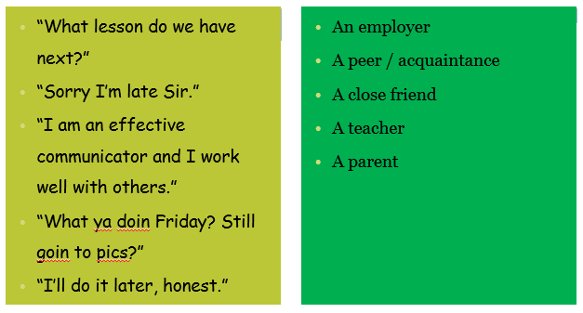

Task 2

**Read the different situations below and choose which of the three options would be most suited, circle your choice and write a sentence saying why underneath.**

**i) You are in court as a witness in a case. One of the barristers is asking you to point out a woman in the courtroom. What is the most appropriate answer?**

a) “It was her. I saw her do it, honest.”

b) “I'm certain it was her.”

c) “I'm certain it was the lady over there.”

**ii) You are at an interview for a job you really want. You are asked why you want the job. What is the most appropriate answer?**

a) “Don't know.”

b) “I'd love to work for you. I think it would be enjoyable and rewarding.”

c) “I reckon it'll be ok. If I go for it, I'd be good at the job.”

**iii) You are on a building site and a bricklayer shouts over to you to pass him a trowel. What is the most appropriate answer?**

a) “Here you go, mate.”

b) “Take this, my friend.”

c) “Is this the one you require?”

**iv) In class, a teacher asks you a question, but you don't know the answer.**

a) “I don't know.”

b) “How am I supposed to know?”

c) “I'm not sure. Could you explain, please?”

Merit challenge

1. Find an example of an example of where the writer has used an informal register in your reading book. Write it here:

Look through your exercise book. Have you used any formal register? Highlight an example and get your partner to check it.

Review learning

Record the rules for using the appropriate register in the box below.



Progress timeline

How confident are you with register?

[](http://www.google.co.uk/url?sa=i&source=images&cd=&cad=rja&uact=8&docid=C0WVovxD1zS0kM&tbnid=-U8Sm3QGlk8InM:&ved=0CAgQjRw&url=http://www.reddit.com/r/nrl/comments/25rj43/round_10_eels_vs_dragons_discussion_thread/&ei=ume6U7jbGYqi0QXC64CoBA&psig=AFQjCNECizppXSzcTAcCmRvGyGBjxd4-dQ&ust=1404811578550626)**Bright Sparks Extension tasks**

What is an auxiliary verb and when would I use one?

**Helping verbs** or **auxiliary verbs** such as *will, shall, may, might, can, could, must, ought to, should, would, used to, need* are used in conjunction with **main verbs** to express shades of time and mood. The combination of helping verbs with main verbs creates what are called **verb phrases** or **verb strings**. In the following sentence, "will have been" are helping or auxiliary verbs and "studying" is the main verb; the whole verb string is underlined:

* As of next August, I will have been studying chemistry for ten years.

|  |  |  |
| --- | --- | --- |
| Be | Do | Have |
| am is are was were being been | does do did | has have had having |

**Modal Auxiliary Verbs** – *can, could, do, may, might, ought, used to.*

**Examples: *Can*** *I take your dog, Toto, for a walk to the park?*

*Susana* ***could*** *sing as well as dance.*

***Do*** *you know the Eight Parts of Speech, my dear?*

***May*** *I have the pleasure of dancing with you?*

*I* ***might*** *go to the party with Hannah.*

*Michael* ***ought*** *to look for another job in the hospital.*

*I* ***used to*** *design pencil sharpeners before I became famous*

Task 1

Underline the complete verb in each sentence. Circle the helping verb (auxiliary verb).

1. Jason will play video games tomorrow.

2. The surgeon has operated many times before.

3. My little sister is singing like a rock star.

4. Scott can kick better than anyone on the team.

5. The beautiful sailboat was built in 1985.

6. Sarah is walking her puppy in the park.

7. Jake and his dad are using the computer.

8. Mom will bake special cookies for the party.

9. Tim had given his mother some flowers.

10. The very small girl can ski all by herself.

**Identifying the Complete Verb**. Underline the main verb and the auxiliary

verb(s) in the following sentences. Do not include any modifiers.

1. When are you going on your canoe trip?

2. Mr. Costello is constantly giving us directions.

3. Jim should have pitched his tent sooner.

4. Joe could have been badly injured.

5. The new paints are constantly being improved.

6. We will be electing class officers tomorrow.

7. The snowfall had not quite ended at six this morning.

8. I shall certainly miss you next week.

9. Mrs. Barnes has always given generously to charity.

10. The price of most food is rising again.

11. How many books have you read this year?

12. I have already seen that TV program.

13. The old man does not walk to town any more.

14. Nancy and Mark have been given major parts in the school play.

15. Your good deed will never be forgotten.

16. Ms. Smith has definitely agreed to our suggestions.

17. The new club officers will have been chosen by tomorrow evening.

18. You could have gone to the party without me.

19. Mr. Davis has never neglected his work before.

20. Our team could have played in the state tournament.

Finite and non-finite verbs

What is a finite verb and when would I use one?

Rules:

**A Finite** verb is one that can be used with a subject to make a tense.

*I* ***walked*** *to school yesterday. We* ***watched*** *the cricket match together.*

The finite forms of the verb are those which signal contrasts of number, tense, person and mood.

Show a contrast in **tense:**

She **works** in London. She **worked** in London.

Show a contrast in number and person:

He **works.** They **work**. I **am.** You **are.**

Allow the expression of facts, possibilities wishes, and other contrasts of **mood**:

He asked that the car **be** moved. It **was** moved.

A **finite verb** is a word like **break, work, broke, sing, write** etc. Finite verbs change their form according to the number and person of the subject. For instance, when the subject is a singular noun, the *finite verb break* changes its form into *breaks*. Finite verbs are also governed by the tenses. For instance, when the sentence is in the simple past tense, *the finite verb break changes its form into broke.* Similarly, *work changes into worked and sing changes into sang in the past tense.*

Non-finite verbs do not change their form according to the number and person of the subject. Examples are **gerunds, participles and infinitives.**

I like reading.  
He likes reading

Here the verb **like** is finite because it changes its form according to the number and person of the subject. The gerund **reading** is non-finite because it does not change its form according to the number and person of the subject.

There are three non-finite forms of the verb:

The **-ing** participle: I’m **going**. They’re **going**. He was **going**. **Going** home, I/ we/they felt concerned.

The **-ed** participle:

I’ve **asked**. He was **asked**. They were **asked**. **Asked** to come home early, I/you/we arrived at 3.

The base from used as an **infinitive**: They might **see**. I’ll **see.** He wants to **see**.

Task 1

**Add a finite verb to the subordinate clause in each sentence:**

When the bus _____________, the children all rushed off.

The horses were grazing happily until the motorbike ______________ past their field.

When Thomas __________________ the news, he did not believe it.

**Find out the finite and non-finite verbs in the sentences given below:**

1.    He gave me a chair to sit.  
2.    It was a sight to see.  
3.    I want to buy some clothes.  
4.    Barking dogs seldom bite.  
5.    He is about to leave.  
6.    It is time to start.  
7.    He was wearing a torn shirt.  
8.    He had his shoes polished.  
9.    They got the roof repaired.  
10.  Finding the door open I went inside.