Purple Mash
Below are instructions on how to access this week’s Science activities on Purple Mash.
Log in to Purple Mash.
Go to the search bar and type environment.
Below is what you should see on your screen.
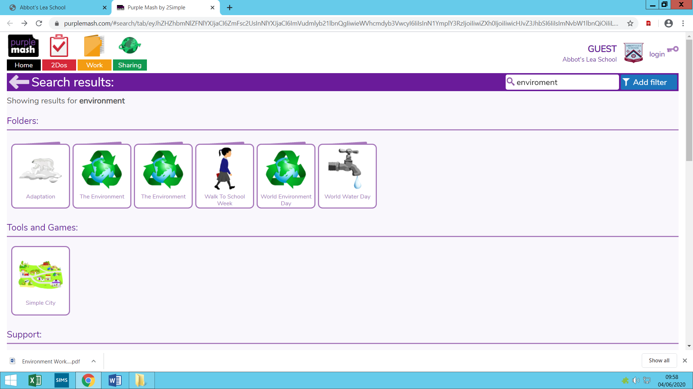

You should try to complete the activities that are circled. The activities in this section are mixed ability and can all be completed online.
They all focus on recycling and human impact on the environment.

Go to the search bar and type light quiz.
Below is what you should see on your screen.
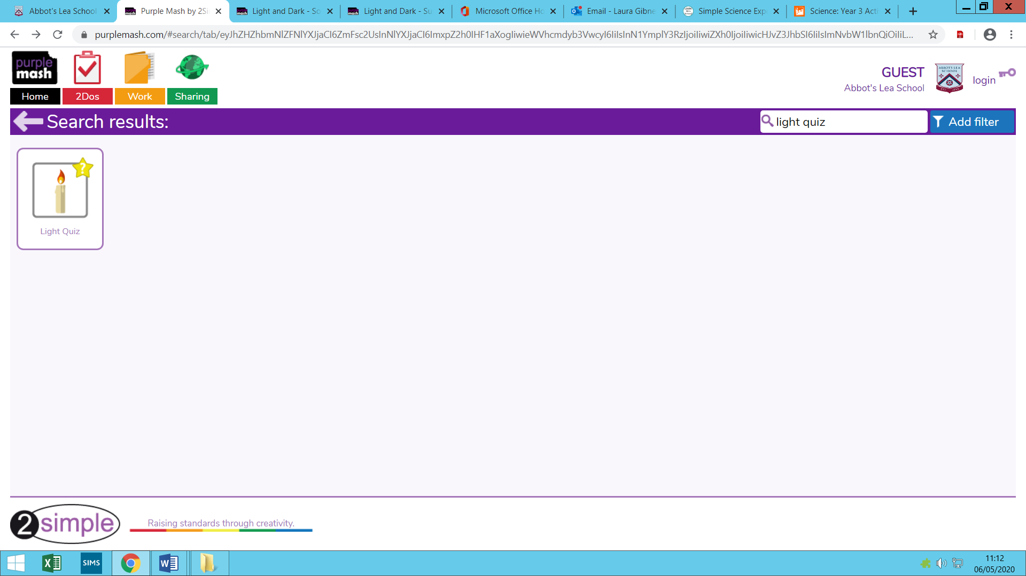

Complete any of the above activities to help support your understanding of light.

