Recognise Stress
Developing Own Interpersonal Skills
NAME:
DATE:
WORKPLACE:

Can you identify when you are stressed?

How do you notice?

What symptoms do you have when you are stressed?
Headache Restlessness / Poor Irritability
fidgeting concentration

Bellyache Lack of Poor planning & Depressed
motivation task execution
Indigestion Increased Difficulty making Impatient
aggression decisions
Lack of appetite/ Avoiding contact Confusion and Frightened
Over eating with others disorientation
Nausea Loss of sense Negative Worried /
of humour thoughts panic attacks

List ways you experience stress physically, emotionally and behaviourally.
Physically | Emotionally | Behaviourally

What do you do to manage stress? (think back to your Little Miss Sunshine session)

Identify stress in others. Can you circle the examples of stressed people?

1 2

3 4
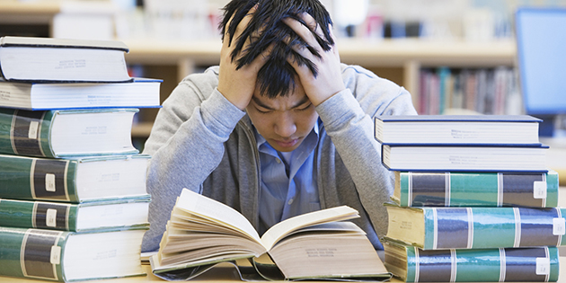

5 6

Correct answers:

2

3

5

