With children off school and gaming online, parents face shock bills

With everyone in lockdown, children can rack up huge costs for unsuspecting parents with the explosion of in-game purchases.
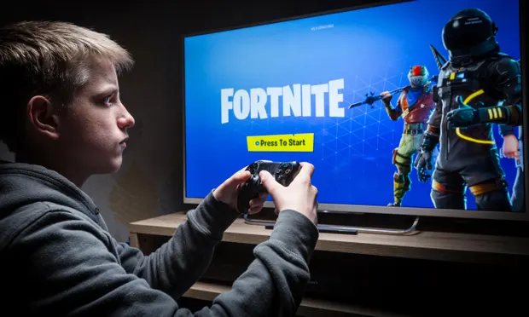

Worrying times ... half of parents of 12 to 15-year olds are concerned about their children playing online games like Fortnite. Photograph: True Images/Alamy.
Arguments between parents and children about screen time and online gaming are set to escalate with UK schools closed for the foreseeable future.
Concern was already growing among parents and children’s charities about the increasing monetisation of popular computer, console and video games. Almost half of parents of children aged 12 to 15 who play online games, such as Fortnite, Fifa and Minecraft, are worried about the pressure on children to make in-game purchases (up from four in 10 parents a year ago). This is according to Ofcom’s adults’ media use and attitudes report last month.
There has been an explosion of in-game purchasing over the past few years. The online gaming market, which is worth around £6bn in the UK, centres on games that players download, meaning the software can be updated at any time – and new content added during gameplay – at extra cost (known as “micro-transactions”). The games and apps are linked to the customer’s (parent’s) bank account. Even supposedly “free” apps and downloaded games have incentives for players to make in-game purchases.

Reading Questions.
- Look at text A. What is meant by the quotation, “Screen time and online gaming are set to escalate”

- Children are spending less time online.
- Children need to spend less time playing games and study more.
- Children are going to spend more time gaming.

- Look at text A. Identify the statistic that has been used to describe the amount of parents that are concerned about gaming.
__________________________________________________________

- The purpose of the text is to inform readers of the dangers of in-game purchases. Identify one quotation that supports this idea.
____________________________________________________________________________________________________________________

- Look at text A. According the article, how much is the gaming market work in the UK?
__________________________________________________________

- Look at text A. The quotation, “foreseeable future,” is an example of what language technique?
Stretch and Challenge: Identify details from the article to use in your own writing.
- Emotive Language
- Alliteration
- Direct Address
- Hyperbole

