Name ____________________________________ Date __________________
My Trip in a Time Machine
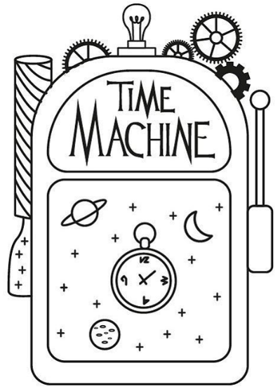
____________________________________________________________________________________________
____________________________________________________________________________________________
____________________________________________________________________________________________
____________________________________________________________________________________________
____________________________________________________________________________________________
____________________________________________________________________________________________
____________________________________________________________________________________________
____________________________________________________________________________________________
____________________________________________________________________________________________
____________________________________________________________________________________________
____________________________________________________________________________________________
____________________________________________________________________________________________
____________________________________________________________________________________________
____________________________________________________________________________________________
____________________________________________________________________________________________
____________________________________________________________________________________________
____________________________________________________________________________________________
____________________________________________________________________________________________
____________________________________________________________________________________________
____________________________________________________________________________________________
____________________________________________________________________________________________
____________________________________________________________________________________________
____________________________________________________________________________________________
Imagine that you have discovered a time machine that you can take forwards or backwards in time. Write a story about the trip you make in the time machine. Would you like to go back to the past or see into the future? What happens to you there? Would you like to stay there?

