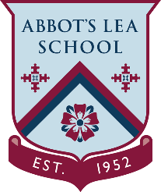
Body Language
Developing own interpersonal skills

NAME:
DATE:
WORKPLACE:

What does your body language say about you as a person?

I want you to write a paragraph and tell me what your body language say about you on a day to day bases.

Take A Body Language Quiz To Assess Your Own Body Language Skills. Click the link below!
https://www.scienceofpeople.com/quiz/

Body Language
Below are some nonverbal communicators, below them I would like you to tell me what they mean to you.
1. Smile

2. Rolling eyes

3. Shrug

4. Stretch

5. Frown

6. Hand held up with palm facing you

7. Wave 8. Look another person straight in the eyes

9. Touch another person

10. Stand close to another person

11. Avoid eye contact

12. Wink

13. Sit with arms crossed

14. Shake hands

15. Yawn

16. Drumming fingers on the desk

17. Placing hand over mouth

18. Tapping foot or swinging crossed leg

19. Nod head up and down

20. Shake head side to side

