Transition Toolkit

Helpful information for transition to College and life after Abbot’s Lea school.

Introduction

We have written this booklet to try and provide useful information and contacts for parents and students of Abbot’s Lea school when preparing for transition into KS5, Supported internship, college or employment. Once a young person reaches the end of year 11 they have the choice to remain at Abbot’s lea school and progress into Key stage five or they can progress onto another college or learning provider. We hope this booklet helps you make an informed decision and provides information on those options.

This booklet also contains some useful numbers and websites to aid student’s independence, provide support for parents and students, and suggest groups who could aid social interactions for both.

Whilst this booklet contains some useful information, if you would like to discuss any issues further, or ask for a more personalised response to a query, please do not hesitate to contact us.

Many Thanks

Mr Mason
Key Stage five leader

For Careers, Supported Internship and college information please contact our Job Coach;
nathan.fernyhough@abbotsleaschool.co.uk

For Transition into Key Stage 5 and Key stage five curriculum offer please contact Key Stage five Leader;
ryan.mason@abbotsleaschool.co.uk

For information about your child’s EHCP contact Jo Scarrott;
joanna.scarrott@abbotsleaschool.co.uk

All can also be contacted by main reception at Abbot’s Lea school on; 0151 4281161
Key Stage Five

Key stage five is for students in year’s 11 through to 14. It is the final destination within Abbot’s Lea school and students can choose to stay for the full three year programme or may leave to progress to another learning provider after any of the academic years.
Our Supported Internship programme is a 1 year programme that sit’s within key stage five and students can choose to access this programme in year’s 12, 13, or 14.
Students in Key Stage 5 continue to gain academic qualifications but there is also an increased focus on the continued development of life, personal and social skills in readiness for leaving school.
Qualifications available are;
· Functional skills Maths, English and ICT Entry level—Level 2.
· Asdan Employability EL3—L1
· Open awards independent travel training
There are also a range of additional qualifications and sector based qualifications available within Key Stage five including; first aid, food hygiene.
Work experience is also available through the Job Coach team.
Trips to the Gym and other community settings are timetabled in weekly during our community days and students will also visit a variety of post 16 educational settings to inform them on the variety of options available to them when they leave Abbot’s Lea school.

Key stage 5—Supported Internship programme
Supported internships are a structured study programme based primarily at an employer. They enable young people aged 16-24 with an Education, Health and Care plan to achieve sustainable paid employment by equipping them with the skills they need for work, through learning in the workplace.
Wherever possible, they support the young person to move into paid employment at the end of the programme. Alongside their time at the employer, young people complete a personalised study programme which includes the chance to study for relevant qualifications and training that will help them gain employment.
Supported internships are usually 4 days with the employer and one day as a study day, although there is flexibility with days to meet the needs of the young person.
The young person is still a member of the Abbot’s lea family and a classroom place is saved for the student should they need to return to withdraw from the programme at any point. The student is also supported by the careers coach and a team of Job coaches who are based within the employer but employed by Abbot’s lea school and known to our students.
The type of placements vary from gardening, ICT and hospitality. We aim to meet the career aspirations of our young people but placements may vary year to year.
Some of our graduate Interns are now in employment and say that the Internship programme is the best decision they ever made.
Previous and current Internship employers include;
· Amey Plc · Regenda housing
· Aloft hotels · Cadent Gas
· National Trust · Imagine Independence

Important Council Websites

Liverpool Local Offer

Information, advice and guidance for anyone aged 0-25 years old with Special Educational Needs or Disability can be found on the Liverpool’s Local Offer webpage.

This can be accessed via the below link
http://fsd.liverpool.gov.uk/kb5/liverpool/fsd/localoffer.page?familychannel=10

Or go to

Liverpool.gov.uk/local offer and click on the link “View Liverpool’s local offer website”

Both will take you to the following page:

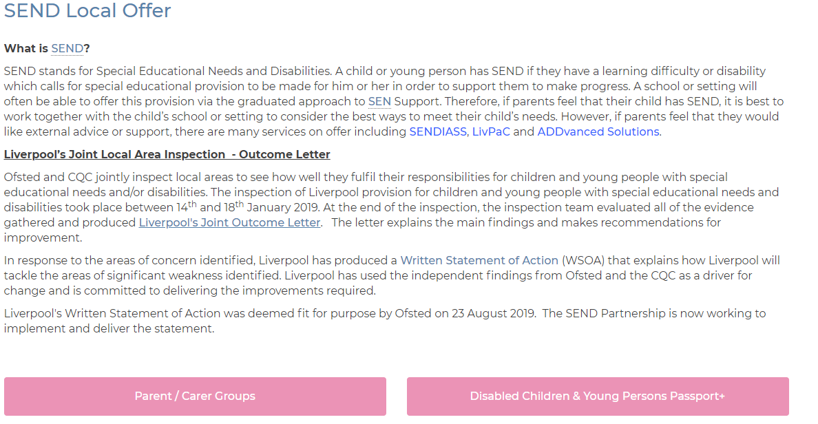

This page offers information on support from the council and other groups for SEN and Disability on:
- Early Years
- Activities, advice, support groups,
- Social care,
- Early Years Consortia
- Educational Health Care Plans,
- Post 16,
- Specialist services,
- Personalisation and personal budgets,
- Health,
- Schools,
- Transport

Liverpool Early Help Directory

This provides support and guidance on a variety of issues including financial support and benefits, childcare, adult services amongst others. This page also provides a link to the ‘Liverpool Local Offer’ for SEND and Disability discussed above.

http://fsd.liverpool.gov.uk/kb5/liverpool/fsd/home.page

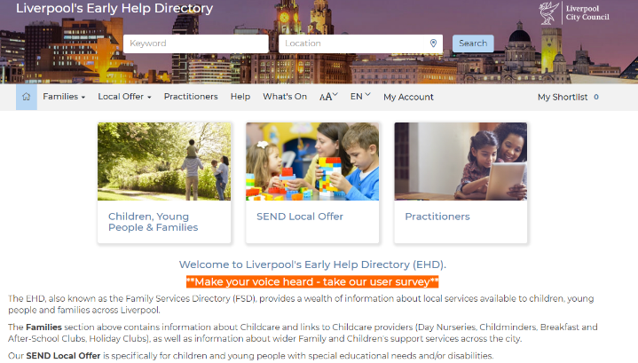

Financial Support

There are several forms of financial support that students and parents can receive.

Support can be given with accessing financial help by contacting our Safeguarding Officer Lisa Sharpe: lisa.sharpe@abbotsleaschool.co.uk

Personal Independence Payments

If you’re aged 16 to 64 you could get between £23.20 and £148.85 by claiming Personal Independence Payment (PIP).

The amount you get depends on how your condition affects you.
An assessment is carried out by a health professional to work out the level of help you can get.

Your rate will be regularly reviewed to make sure you’re getting the right support.
Your carer could get Carer’s Allowance if you have substantial caring needs.

Go to https://www.gov.uk/pip to download a form and read the advice on how to make a claim for a Personal Independence Payment.

Carer’s Allowance

A Carer could get £69.70 a week if they care for someone at least 35 hours a week and they get certain benefits.

They don’t have to be related to, or live with, the person they care for. https://www.gov.uk/carers-allowance

Travel Pass

Students can apply for a Disabled Persons travel Pass through Mersey Travel.
The form can be found here:

https://www.merseytravel.gov.uk/tickets/concessions/pages/disabled.aspx

Once completed it can returned by a PO Box or taken to 6 named bus stations on the form in the Merseyside area.

Direct Payments

Direct payments are a resource given to parent(s), carer(s) or young people by the authority to enable them to buy in support. These payments do not affect benefits and are paid into a bank account regularly or as a one off payment.

To get access to Direct Payments, the Disabled Children’s Service team need to carry out an assessment. This assessment is done by a qualified social worker and is called a ‘Single Assessment’.

The social worker will assess if the young person is eligible to access direct payments and if the parent or carer (or young person if over 16 years old) is willing and able to administer direct payments with support. The Single Assessment is presented to a panel of managers in the service to decide if direct payments are the most appropriate option and how funds should be allocated.

If agreed, an agreement will be drawn up and advice given to the parent or carer setting out the responsibilities and obligations of both them and the local authority. The parent or carer will be supported when employing personal assistants, using agencies or any other services to meet the assessed need.

To request an assessment from the Disabled Children’s Team, a parent, carer or agency should contact Careline on 0151 233 3700.

Young people’s services

The Disabled Children’s Service

The Disabled Children’s Team is a specialist social work team responsible for the assessment of disabled children and young people up the age of 18 and the provision of information and the packages of support to meet their assessed need. The team works in partnership with Education, Health, other Social Work teams and Short Break providers to ensure good outcomes for children and young people are delivered.

Access to specialist support is identified through an assessment by a qualified social worker called a Single Assessment. When completing the Single Assessment the social worker will communicate with the child or young person to gain their views using their preferred method of communication. The social worker will also talk to parent(s), carer(s) and any relevant agencies which can assist with the assessment. Other professionals may also assist to complete the assessment.

What does a Single Assessment cover?
When completing the Single Assessment the social worker will look at a number of issues that may be affecting the child (or children) and family. The worker will find about the strengths and difficulties in the family by asking questions about:

- The nature of the child’s disability and how it impacts on both their life and their family or carer.
- The child’s needs including- their health, behavior, education, social and emotional wellbeing as well as their social and family relationships.
- The family’s situation – the number of children within the household and if there is more than one disabled child within the household, if the parent(s) or carer(s) have a disability or health needs.
- If the parent(s) or carer(s) are employed, have money issues, housing, relationships within the family and those who support the family.
- The care of the child - including how well parent(s) or carer(s) are offering basic care, keeping the child safe, helping them learn, offering guidance and a stable home.
- The child’s wishes and feelings.
- Depending on the age of the child, any needs to prepare for adulthood or the transition to Adult Services

Services can be provided for children and young people with complex needs, such as:
- Social work support, advice and guidance
- Social work assessment and planning to address particular need arising from the child or young person’s disability
- Advice and guidance on services available in the community to meet the needs of the child concerned, their parents and carers
- Family Support
- Support within the home or community
- Overnight care provision with family carers, residential units or at home
- Parental Short break services
- Domiciliary Care in the home
- Access to direct payments
- Safeguarding Services
- Looked after Children Services

To be eligible for an assessment by the Disabled Children’s Team the child must:
- be under 18 years old
- be a resident in Liverpool
- have a permanent and substantial impairment, resulting in a functional disability, which affects their daily living including a severe learning need

How to make a referral?
To request an assessment from the Disabled Children’s Team, a parent, carer or agency should contact Careline on 0151 233 3700.

How to contact us?
The Disabled Children’s Team can be contacted on 07876844310 during week day working hours (Monday- Thursday 9- 4.45, Friday 9- 4.15pm

YPAS

YPAS or The Young Person’s Advisory Service deliver mental health services for children, young people and families. Affiliated to CAMHS they offer Counselling and Psychotherapy services, and Support services to the community.

YPAS offer advice and support, specialist and targeted open access youth provision, issue based activities, advocacy support, IAG (Information, advice and guidance) and informal psycho-social / education programmes.

  - LGBTQ support
  - Talent match programme ( NEET)
  - Systemic family practice
  - Parental support
  - Anger awareness
  - Self-injury
  - Domestic abuse
  - Youth justice
  - Youth groups
  - Youth health

YPAS is based in 3 hubs in the city;
The main base (city Centre) is;

36 Bolton Street
Liverpool
L3 5LX
T: 0151 707 1025

W: https://ypas.org.uk/
E: support@ypas.org.uk
http://www.ypas.org.uk

Child Adolescent Mental Health Service (CAMHS)

CAMHS are specialists in children and young people’s mental health wellbeing. They deliver accessible support to children, young people and their families, whilst working with professionals to reduce the range of mental health issues through prevention, intervention, training and participation.

The Liverpool CAMHS offer promotes the mental health and emotional wellbeing of all children, young people and their families/carers.

CAMHS aim to respond to the mental health and emotional wellbeing needs of children, young people and their families/carers. They look to enable families and professionals to develop their capacity to manage the impact of distress, whilst working alongside children and young people to improve access to services that provide vital support to build resilience, as well as offering help and intervention, allowing children and young people to thrive.

Who to contact
Contact: Child Adolescent Mental Health Service
Telephone: 0151 293 3662
Website http://liverpoolfyi.com/

Where to go
Name Single Point of Access
Address Mulberry House
Alder Hey Children's Hospital
L12 2AP

Other details a referral is required

Referral and availability notes
Referrals can be made via the Single Point of Access number by General Practitioners (GP) or other professional within the statutory and community sector.

For example, any health professional, teachers, school mentors, connexions, social workers, youth and community workers, providing the young person or family has consented to the referral.

Transition Team

This department deal with students 17 and upwards preparing them for the transition to adult services and life outside of school.

Liverpool City Council Adult Services are currently working with Children's Services, Education, Health, Schools and Colleges to develop a revised pathway to adulthood for young people who are in transition.

They are seeking to deliver, with partnership agencies, a co-ordinated multi agency support service for young people to achieve good life outcomes.

The transition team have a duty to carry out a transition assessment for a young person and / or their carer, in order to help them plan if they are likely to have support needs once they turn 18.
Any young person (or their carer) who is aware that they are likely to have needs when they become 18 must inform the Transition team. They will offer an assessment of needs. This is called a "Supported Self-Assessment" under the Care Act 2014. Requests for an assessment, if they do not have a children's Social Worker, are made to Careline on 0151 233 3800.

If the person is already known to Children's Services, their Social Worker will make a referral.

If you are a carer for a young person who is likely to have support needs when they have turned 18, please contact Careline on 0151 233 3800 to find out what support you can be offered.

The Team include;
Team Leaders: Rebecca Ellard & Lindsay Feeney
Social Workers: Sue Menzies, Melanie McCarfrae, Janet Woodruff, Kayleigh Cook, John Shipman, Laura Alvis, Rachhel Plant-Carlyon & Sarah Ward
Social Care Assessors: Alan Dodd, Kate Maher, Mark Murphy, Jim North & Carol Hosdon

All can be contacted via Careline on 0151 233 3800

Clubs/ Youth groups/ Activities groups

Using the Liverpool Local Offer webpage click on the link for ‘Activities, Advice and Support.”

This gives a comprehensive list of support groups and activity group for young people and adults with SEND in Merseyside.

Fusion (up to 19)

Fusion aims to direct disabled children and young people into mainstream play and leisure provision within their community. Fusion works with families to explore the possibilities locally to help children and young people make connections that could lead to friendships. Fusion also gives information on different types of childcare and how to access Tax Credits to help you pay for it.

Telephone Fusion on 0151 233 3621 or
E-mail fusion.project@liverpool.gov.uk

Autism Initiatives

They provide a variety of support to people with ASC and their families. This can include social support in the community and at home, and social enterprise through businesses set up to provide employment in a safe environment for Autistic employees.

http://www.autisminitiatives.org
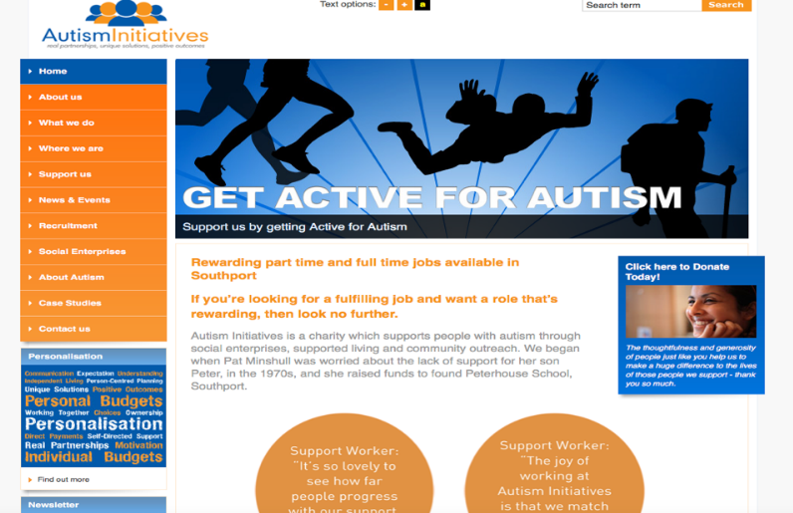

Colleges and Further Education Providers

Greenbank College
Greenbank Lane,
Liverpool,
Merseyside
L17 1AG
England ·
Tel: 0151 733 7255

Contact: Elizabeth Brocklehurst/Mary Weir/Alison Stoddart
Elizabeth.Brocklehurst@greenbank.org.uk
http://www.greenbankcollege.org.uk

City of Liverpool College
Based on 5 Campuses. These are:
- The Learning Exchange, L1
- The Arts Centre, Myrtle Street
- Duke Street Campus
- Clarence Street Campus
- Vauxhall Road Campus

Contact: Gill McDonough/Maria Rimmer
Gill.McDonough@liv-coll.ac.uk
College information: +44 (0)151 252 3000.
http://www.liv-coll.ac.uk

Riverside College
Riverside College,
Kingsway,
Widnes,
WA8 7QQ
0151 257 2800

http://www.riversidecollege.ac.uk

Hugh Baird College
Hugh Baird College
Balliol Road
Bootle
Liverpool
L20 7EW
Telephone: 0151 353 4444
Contact: Jenny Quinn/Leanne Smith
Jenny.Quinn@hughbaird.ac.uk

Myerscough College
Liverpool Campus based in Croxteth Park.
The college has several campuses
In the North West.
All enquiries go to: 01995 642222
http://www.myerscough.ac.uk/why-myerscough/our-centres/liverpool/
Contact: Nick Harrison
NHarrison@myerscough.ac.uk

Knowsley College
Main Campus
Stockbridge Lane
Huyton
Liverpool
L36 3SD
Kirkby Campus
Cherryfield Drive
Kirkby
L32 8SF
0151 477 5850
https://www.knowsleycollege.ac.uk
Contact: Lynda Manning/Vicci Steele/Paula Humphreys

Independent Specialist College

These are subject to the Local Authority agreeing to fund these places.

Activate

Activate is a registered Charity that provides personalised educational and vocational programmes for young adults with learning difficulties and disabilities.
www.activatearts.com/
0151 545 1279

Training providers in Liverpool

Apprenticeships, Traineeships, Internships and ILM’s are available.

See http://www.apprenticeships.org.uk/for further information. Liverpool Local Authority is committed to working with Greater Merseyside Learning Partnership Forum (www.gmlpf.net) and other partners to develop opportunities for employment and training that meet the needs of students with SEND in Liverpool. Please also contact Liverpool in work for additional support and information on ILM opportunities

There are lots of colleges and training providers within Liverpool. Key Stage four and five visit some of these colleges within school time so your child will be aware of some of the additional options there is for further study. Traineeships are a popular option and many providers offer these as a short course and route into an apprenticeship. Providers include;
Training plus Merseyside
The learning foundry
Michael John
St Helens chamber (based at MYA Liverpool)

Further Local Training Options can be found here at the Liverpool city council Local offer help page under post 16 options

