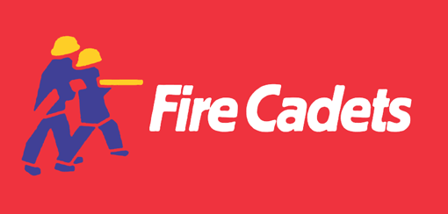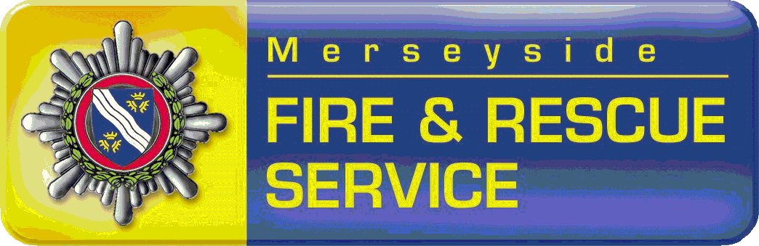

Fire Cadet Quiz

Question 1
How Many litre of water does a fire engine Hold?

Question 2
What is the Name of the grid the Fire Engine receives water from?
H……………

Question 3
Name three items of Personal Protective Equipment?
1
2
2
Question 4
What is a Hoax Call?

Question 5
How often should you check your smoke alarms?

Question 6
Name two incidents a Fire Crew may be called out too
1
2

Question 7
In First Aid Fill in the words?
D
R
A
B
C
Question 8
Name Equipment used to take water from the ground?
……….…………..…………………….
Question 9
Name me 5 pieces of equipment that we may use when completing Fire Drills?
1
2
3
4
5
Question 10
Can you tell me the name of 5 other Cadets at your unit?
1
2
3
4

Question 11
When travelling in a vehicle what must you always put on?

