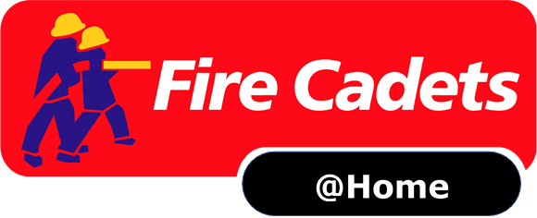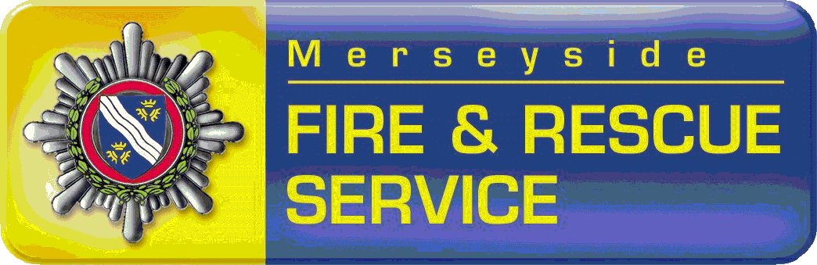

Hi Cadets,

Task 1.
We are delighted to have been asked by the National Fire Chiefs Council (NFCC) to support their #ReadyWillingAble campaign.
The NFCC would like us to promote the great work cadets in the UK are doing throughout our community.

1.Activity

There are lots that cadets can do, and many already are, to support their local communities, some suggestions include:
- Supporting the NHS by clapping on Thursday evenings
- Encouraging other young people to stay safe
- Looking after a member of your family
- Doing something kind for your family

Whatever you do please share it with us BUT please remember it is important that whatever you choose to do, that you are safe and are protecting your health and that of others.
For more ideas and activities, look at The #Iwill website – it has loads of ideas that young people can get involved in while staying safe at home.

2. Positive Images

- Send a photograph or video of your activity to your Unit Leader: DianeDunne@merseyfire.gov.uk
Anthonydunn@merseyfire.gov.uk
They will share your photographs and video’s with UK National Fire Cadets, MFRS Social Media and National Fire Chiefs Council
- If you cannot think of an activity, simply support the campaign by taking a photograph of yourself holding a message that says:
#ReadyWillingAble
- You may wish to use the following script:
Hello I am [name] and I am a Fire Cadet in [area]
I am Ready Willing and Able to support my local community by.....]
To help me to do this I am working with [insert any names/organisations]
Insert a line about how you feel about it, what you get from it.

