Message from the Headteacher
Mrs Ania Hildrey, Headteacher, headteacher@abbotsleaschool.co.uk
Contents:
Head’s Foreword
Key Diary Dates
Students of the Week
Next Week’s Menu
Class News:
- EYFS/KS1
- KS2
- KS3
- KS4
- KS5
Staff News:
- HR
Useful Information and Resources
Dear Students, Families, Colleagues and Friends

Welcome to the new academic year 2022-23!
We are delighted to be welcoming our returning students and also those new to Abbot’s Lea School.
To those joining us for the first time, I am very privileged to introduce myself as our school’s Headteacher and to warmly invite you to take an active part in your child’s education over the coming year. I am certain that it will be a very positive one, with many successes to be seen.
The publication of today’s newsletter follows yesterday’s announcement of the passing of Her Majesty Queen Elizabeth II. This makes for a more sombre foreword… Our thoughts are with the Royal Family, all those who knew The Queen, as well as those for whom she mattered deeply.
May she rest in peace and may long live King Charles III.
We held our first assemblies of the year this morning, and I am proud to say that the observance of a moment’s silence to pay respect to The Queen, has been a profound experience for many of us. The students were so respectful and even those who are yet to learn to cope with such cultural expectations and customs, behaved really well – thank you.
Next week’s assemblies will be devoted to each class sharing with us their reflections on The Queen, her contributions to the modern Britain and the changes she witnessed around the world during her 70-year reign. As ever, assemblies are open to families and so, I hope you are able to join us and pop in to the Friday Coffee Morning, too!
Until then, I wish you a very good weekend and trust you enjoy reading this first issue of the Head’s Weekly Newsletter.
With kindest regards
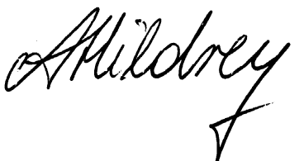
Mrs A Hildrey
Headteacher

School Year Calendar

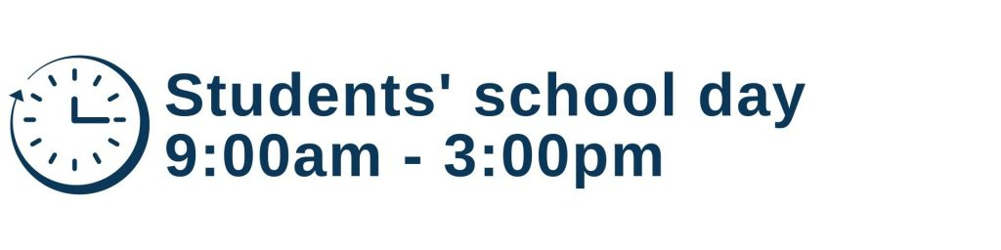
Term Dates for School Year 2022-23 (next academic year) – Term dates 2022-23

Term 1
1 – 2 September – INSET
5 September – students return
Ends: 21 October 2022 at 3pm
Half term: Monday 24 to Friday 28 October

Term 2
31 October – students return
Ends: 21 December 2022 at 1:30pm
Christmas break: Thursday 22 December to Tuesday 3 January 2023

Term 3
4 January – students return
Ends: 10 February 2023 at 3pm
Half term: Monday 13 to Friday 17 February 2023

Term 4
20 February – students start
Ends: Friday 31 March 2023at 1:30pm
Easter break: Monday 3 to Friday 14 April 2023

Term 5
17 April – students return
May day: Monday 1 May
Ends: Friday, 26 May 2023 at 3pm
Half term: Monday 29 May to Friday 2 June 2023

Term 6
5 June – students return
30 June – School Leavers’ Date
7 July – Transition INSET
10-14 Transition Week
Ends: 14 July 2023 at 1:30pm
17-18 July – INSET (worked in lieu as twilights throughout the year)

Key Diary Dates for Term 1 (1.9.22-21.10.22)

Date | Activity | Notes
Monday 12 September – Friday 16 September | Family survey | A link will be sent to you via Parentmail. We ask that you take time to complete it so that we can learn from you.
Monday 12 September and Tuesday 13 September | School photographs – please ensure that your child is wearing a full formal school uniform on these days | Our photographer works with us every year and has a high level of knowledge in the field of Autism
Tuesday 13 September | Roald Dahl Story Day | Students will enjoy a range of activities in their classrooms
Thursday 15 September and Friday 16 September | Recruitment of Head Student (and deputy) position | Held by our Headteacher, based on applications (KS5 only).  Appointments will be shared with students, staff and families on Friday
Friday 16 September | Weekly open assemblies and coffee morning  Assembly times:  9.10 – 9.30 – KS4 and 5  9.35 – 9.55 – Primary  10.00 – 10.20 – KS3  Coffee morning:  9.30 – 11am  Head’s Weekly Newsletter published on our website and shared via Parentmail and FB page | We encourage families to attend where they are able. If there is any topic you would like to hear about or contribute to during the coffee mornings, please advise Dr Sara Mursic at Sara.Mursic@abbotsleaschool.co.uk
Monday 19 September – Monday 26 September | Application window for our Student Council and Young Student Leaders Club | Our student voice is split in two groups this year:  - Young Student Leaders’ Club for Primary Department  - Student Council for Secondary Department  All students can apply by filling in the application form that their teacher will share with them (available in alternative formats if needed)
Wednesday 21 September | Photographs taken of students who were absent on 12 or 13 September | Our photographer works with us every year and has a high level of knowledge in the field of Autism
Friday 23 September | Weekly open assemblies and coffee morning  Assembly times:  9.10 – 9.30 – KS4 and 5  9.35 – 9.55 – Primary  10.00 – 10.20 – KS3  Coffee morning:  9.30 – 11am  Head’s Weekly Newsletter published on our website and shared via Parentmail and FB page | We encourage families to attend where they are able. If there is any topic you would like to hear about or contribute to during the coffee mornings, please advise Dr Sara Mursic at Sara.Mursic@abbotsleaschool.co.uk
Monday 26 September | European Languages Day | Students will enjoy a range of activities in their classrooms and there will be an opportunity to taste test a range of European foods.
Friday 30 September | Weekly open assemblies and coffee morning  Assembly times:  9.10 – 9.30 – KS4 and 5  9.35 – 9.55 – Primary  10.00 – 10.20 – KS3  Coffee morning:  9.30 – 11am  Head’s Weekly Newsletter published on our website and shared via Parentmail and FB page | We encourage families to attend where they are able. If there is any topic you would like to hear about or contribute to during the coffee mornings, please advise Dr Sara Mursic at Sara.Mursic@abbotsleaschool.co.uk
Friday 30 September | Student Council elections | The Secondary Department will elect their representatives for the Student Council (while Primary Department applications automatically join our Young Student Leaders’ Club)
Tuesday 4 October | Online training (Zoom)  Working with and for families (Dr Sara Muršić) | Online event (Zoom)  Find out about our support and events offer this year.  Information is available on our Facebook, Twitter and Webpage.  Two sessions will be delivered:  - 12 pm (lunchtime)  - 6pm (after school)
Thursday 6 October | National Poetry Day (Class Choice) | Students will enjoy a range of activities in their classrooms
Friday 7 October | Weekly open assemblies and coffee morning  Assembly times:  9.10 – 9.30 – KS4 and 5  9.35 – 9.55 – Primary  10.00 – 10.20 – KS3  Coffee morning:  9.30 – 11am | We encourage families to attend where they are able. If there is any topic you would like to hear about or contribute to during the coffee mornings, please advise Dr Sara Mursic at Sara.Mursic@abbotsleaschool.co.uk
Friday 7 October | World Dyslexia Awareness Day (Class Choice) | Students will enjoy a range of activities in their classrooms
Monday 10 October | World Mental Health Day (Class Choice) | Students will enjoy a range of activities in their classrooms
Friday 14 October | Weekly open assemblies and coffee morning  Assembly times:  9.10 – 9.30 – KS4 and 5  9.35 – 9.55 – Primary  10.00 – 10.20 – KS3  Coffee morning:  9.30 – 11am | We encourage families to attend where they are able. If there is any topic you would like to hear about or contribute to during the coffee mornings, please advise Dr Sara Mursic at Sara.Mursic@abbotsleaschool.co.uk
Monday 17 October | World Food Day (Whole School) | Students will enjoy a range of activities in their classrooms
Tuesday 18 October | Discussion with an expert – Dr Anna Mariguddi: Music in Education  Online (Zoom)  3.00 – 4.00pm | Online event – Zoom  Discussion about the impact music has on creativity and development of students  Information is available on our Facebook, Twitter and Webpage.
Friday 21 October | No assemblies  No coffee morning
Friday 21 October | Sharing of Term 1’s Learning Journey | Each term, your child’s teacher will share with you their learning journey via email.
Friday, 21 October | School closes for October break after students leave at 3pm

Letters Home:

All group communications sent home can be found on our website:
http://www.abbotsleaschool.co.uk/parent-information/
All information will be sent via Parentmail. If you have not yet opened an account on Parentmail, please contact our office for details: reception@abbotsleaschool.co.uk

Welcome to school
http://www.abbotsleaschool.co.uk/wp-content/uploads/2022/08/Welcome-to-school-year-2022-23-31-August-2022.pdf
Transport and Uniform Update
http://www.abbotsleaschool.co.uk/wp-content/uploads/2022/09/Transport-and-uniform-update-7.9.2022-1.pdf
Key Diary Dates
http://www.abbotsleaschool.co.uk/wp-content/uploads/2022/09/KDD-letter-for-families-7.9.2022-1.pdf
Head Student – for students
http://www.abbotsleaschool.co.uk/wp-content/uploads/2022/09/Head-Student-2022-23.pdf
Head Student – for families
http://www.abbotsleaschool.co.uk/wp-content/uploads/2022/09/Families-Head-Student-information-2022-23.pdf

Our social media accounts:

Website:
www.abbotsleaschool.co.uk
Facebook:
https://www.facebook.com/AbbotsLeaSchool
Twitter:
Official whole school: @AbbotsLeaSchool
Early Years and Key Stage 1: @ALS_EYKS1
Key Stage 2: @ALS_KS2
Key Stage 3: @ALS_KS3
Key Stage 4: @ALS_KS4
Key Stage 5: @ALS_KS5
Headteacher: @HeadteacherALS
Deputy Headteacher: @DeputyALS
Head of Care and Safeguarding: @ALS_care
Head of Autism Research and Development: @ALS_AutismRandD
Head of HR: @HeadfHRALS
Head of Finance and Operations: @HFO_ALS

Next Week’s Menu

Student of the Week

Class | Student | Reason why
Key Stage 1
Ireland | Amiya | For joining in with her friends for rhyme time.
Wales | Sam | For fantastic independent mark making in the diary in the home corner.
Key Stage 2
Canada | Alfie | Alfie has worked really hard this week. He has been focused and on task every day!
Italy | Alice | For phenomenal engagement in all activities.
Portugal | Adil | For a great first week and settling into Portugal Class very well by taking part in activities and communicating his needs to staff.
France | Jaylen | For settling into his new school and class beautifully.
Spain | Georgie | For painting a “my feeling monster” and describing his feelings with his words!
USA | Oliver | For always following the golden rules.
Key Stage 3
Brazil | Matthew | For always trying his best.
Peru | Jonny | For eagerness to succeed and making really good class choices.
Mozambique | Martin | Martin has had an amazing week settling into his new class, we are really proud of how hard he has worked. Well done Martin!
Botswana | Hayden | For a massive improvement in class activities and a great fresh start to the year.
Madagascar | Conor | For being a kind friend when another student needed help.
Kenya | Ryan | For adapting well to your new class.
Seychelles | Taki | For showing great resilience and self-belief when regulating throughout the week. They turned up every day with a smile on their face, also producing great work in English.
Cape Verde | Charlie | For a great start back to the new school year and contributions in lessons.
Key Stage 4
Australia | Lucas | For settling into his first week back, with a positive and willing attitude.
Tasmania | Lucas | For working extremely hard throughout the week and making notes in lessons.
Samoa | Ellis | For completing an excellent piece of work in English and settling into his new class well.
New Zealand | Joel | For settling in so well with his new class. As well as always giving his best efforts in class with the academic tasks given to him.
Key Stage 5
Malawi | Hamza | For having a positive week and settling in to Malawi class very well.
Christmas Island | Thomas | For settling in to his new class and working very hard to complete all of his work.
Fiji | Kazie | For an excellent first week and trying hard in English.
PNG | Joshua | For making a positive contribution to a new term in school

Early Years and Key Stage 1
Ireland class
Welcome to our first newsletter of this academic year. Ireland class have had a great first week back. Lots of friendships being formed and memories being made. Our focus this term is 'My community and me' and we have been learning about families, our people and ourselves who help us. Our rhyme of the week was '5 Little Ducks' and everyone had fun counting and singing along to the rhyme. Have a great weekend, Ireland class team.
Wales class
Wales Class have had a brilliant start to the new school year. The staff team have been really impressed with how the pupils have come to and from school on their bus or other transport, especially since this is something new for so many of our students. In the classroom, the pupils have been exploring their new environment, spending quality time with their Key Worker and getting to know their new friends. The class have enjoyed visiting the sensory spaces around school as well as visits to the Pirate Ship and Play Park areas. After their first full week in school following the summer break, the children in Wales Class are understandably quite tired. We hope they all have a lovely, restful weekend and look forward to seeing them again on Monday morning!

Wales Class Team.

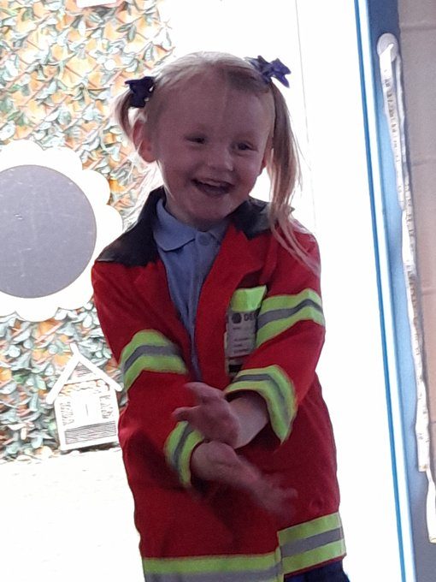
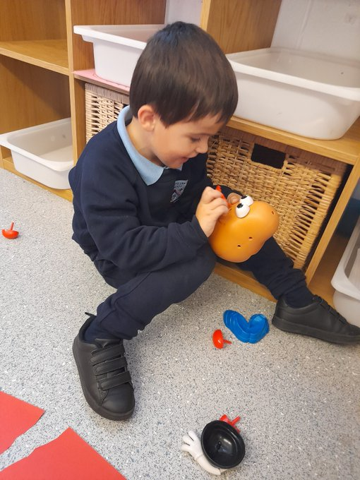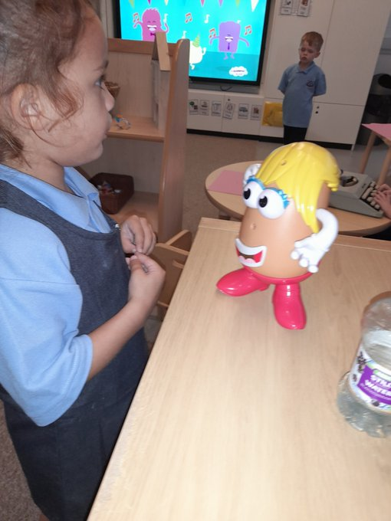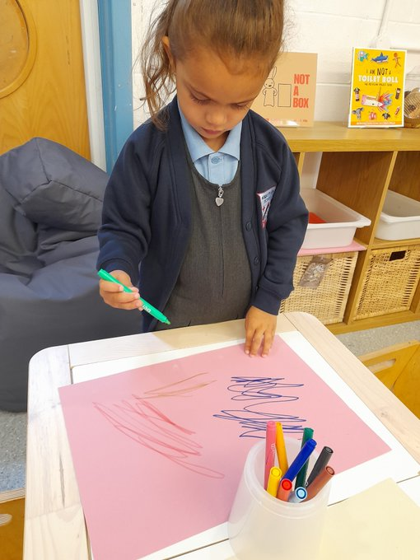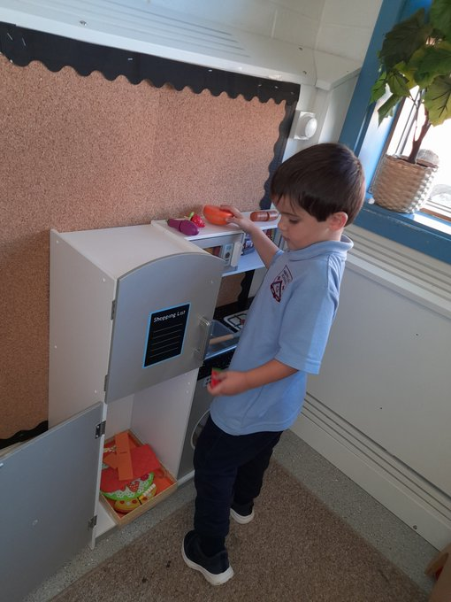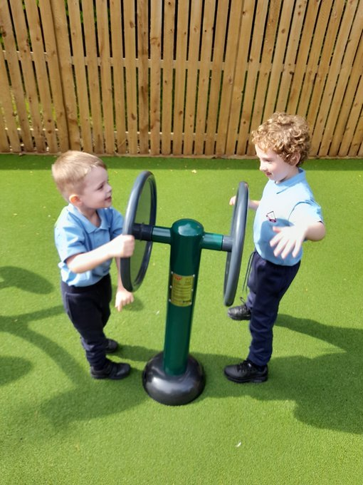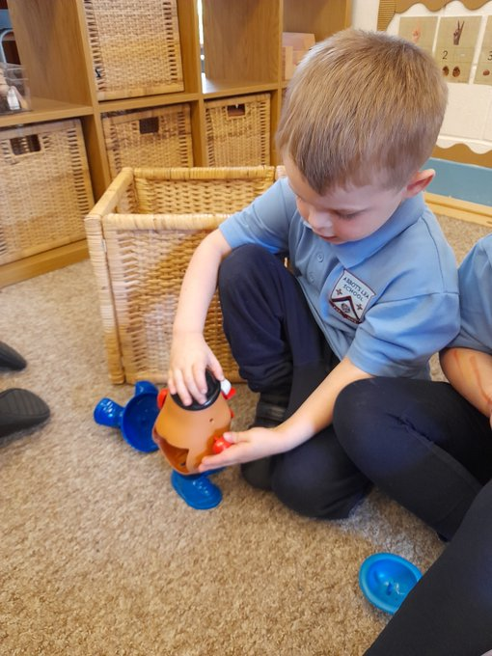

Key Stage 2
Canada class
A fantastic start for the new school year in Canada class. We have been sharing our news from the summer holidays and also getting to know each of the new staff and students within Canada class. Our focus on teaching and learning this week has been looking at place value in Math's, English looking at the book of worries and recognizing characters, science classifying animal categories and learning family members in French. A very busy and fulfilled week.
Portugal class
Portugal Class have had an excellent first week! We have been looking at 'The Colour Monster Goes to School' and linking our own emotions and feelings to the Zones of Regulation and how The Colour Monster is feeling. We have really enjoyed sensory activities using water play, paint and glitter to learn about Bonfire Night. We shared our favourite colours in Art and have started to practice basic terms for members of our family in French. It has been a fantastic week, well done Portugal Class! Have a lovely weekend.
France class
France class have had an amazing first week back. We have lots of fun getting to know each other and making new friends. In English this week, we read the book 'The Colour Monster goes to School'. We all discussed our feelings about coming back to school and how all our different feelings are normal. In Maths this week, we have being exploring numbers using Numicon. In Science, we are beginning to classify animals and enjoyed a guess the animal game. In History, we are going to be learning about Guy Fawkes and Bonfire Night. We discussed our experiences of fireworks and used lots of adjectives to describe them.
Keep up the hard work France class, we are very proud of you!

Spain class
Spain class have enjoyed exploring their new classroom this week! Spain have loved figuring out how to play our new guitar and ukulele, building train tracks with one another, making their own fruit ice lollies and completing activities around the book ‘what makes me a me’, well done Spain class!
Italy class
This week in Italy class we have had lots of fun painting self-portraits and making fruit faces. We have learnt about zones of regulation and the colour monster; we designed our own colour monster and spoke about the VIP’s in our lives for our PHSE. We hope everybody has a lovely weekend.
Please remember PE kits on Monday :)
USA class
USA Class have had a lovely first week back looking at different species in science and food safety in food technology when making a fruit salad.

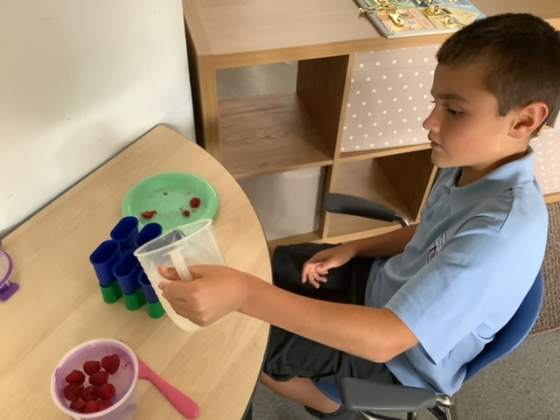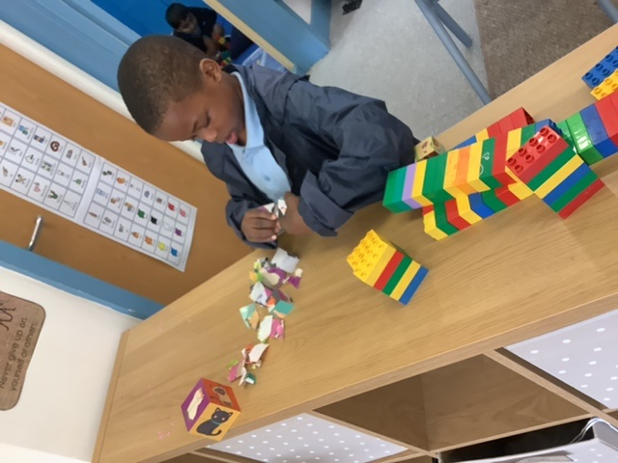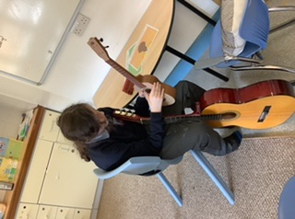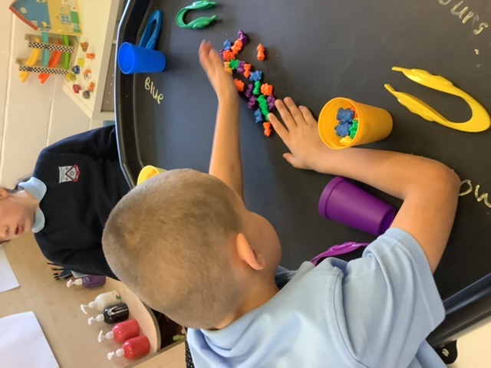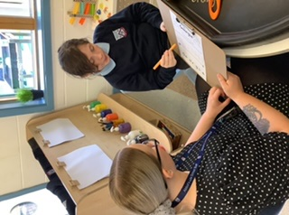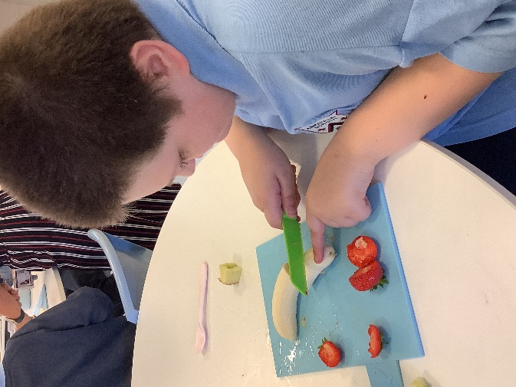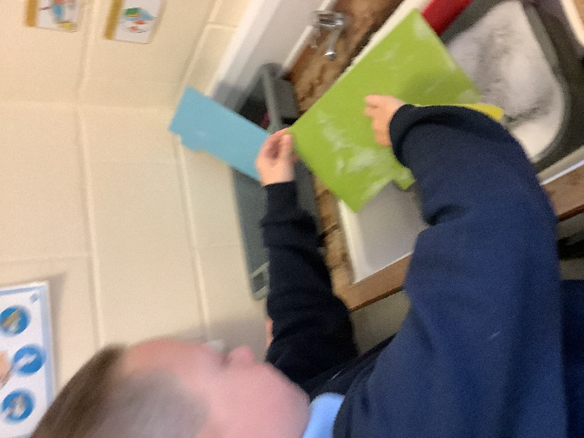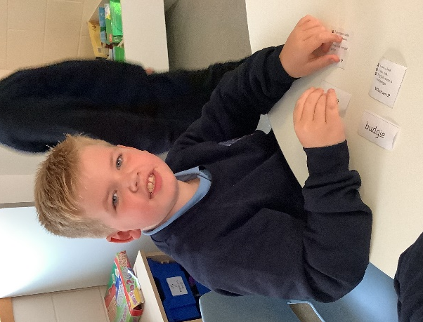

Key Stage 3
Mozambique class
This week Mozambique class have enjoyed settling into their new class and routine. We have had lots of fun getting to know each other and working together to make our class Golden Rules. In Math we began learning about representing numbers to 100, using the Base 10 packs. In English we started reading the book 'voices in the park'. Students made some predictions and we discussed what we liked about the book. In Food Technology we learnt about safety and the important rules we must follow when in the Food Technology room. Students are looking forward to making fairy cakes next week. Have a great weekend!

Cape Verde class
In History we have been learning about the ancient Greeks. Students shared what they already knew about the ancient Greeks and what they would like to learn. In food technology/life skills we were leaning about food safety. P.E- fitness test. In English, we are reading Stig in the dump, some students read aloud and students made some interesting predictions on what happened next in the book. In P.E Cape Verde, played some fitness games, including traffic lights and grandma’s footsteps.
Madagascar class
Madagascar class have had a lovely first week back in school. Staff have really enjoyed listening to the students share their holiday news together.
In English we have been reading the diary of Samuel Pepys to find out historical settings. We have looked at the diary entries for everyday during the great fire of London. In maths we have been learning about number and using our knowledge of place value. Well done Madagascar class for a great first week back in school!
Kenya class
Welcome back Kenya class!
As it is the start of a new term we have completed the following activities:
In English, we have explained what we did over the summer and have started the topic of instructions. For Maths, the students have looked at how many days are a week, months and year. Finally, in Science the class identified the differences between the moon, Earth and sun.
Well done Kenya class for a great start to the term!
Seychelles class
Seychelles have had a very enjoyable start to the academic year. We have enjoyed different sporting activities around the components of fitness for P.E. Throughout the week we have completed independent and group based reading, expanding our different topics of enjoyments from anime to auto biographies. Our class has also looked at the different styles of paintings used in France in the late 1800s known as pointillism and even attempting our own type of Pointillist pictures.
Brazil class
The students have settled in well during their first week back in school.
They have been learning English, Maths and even some French with activities and some PE too, which they really enjoyed.
Botswana class
Botswana class have had a great first week back in the class room. We have already started lots of our terms topics including: pointillism in art, ancient Greece in history and reading the book 'Private Peaceful' in English. We are looking forward to a great year together as a class.

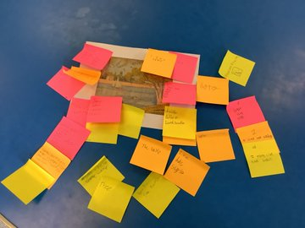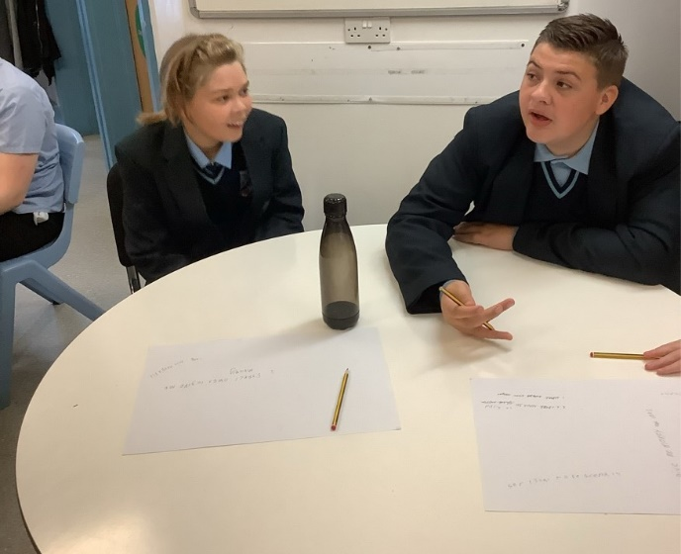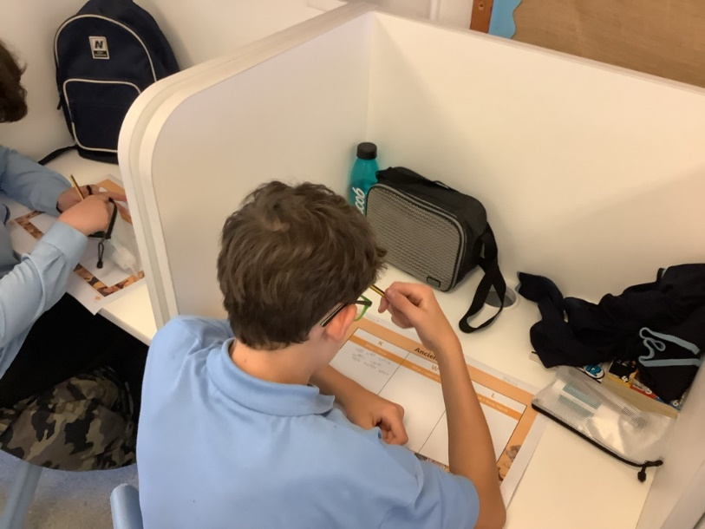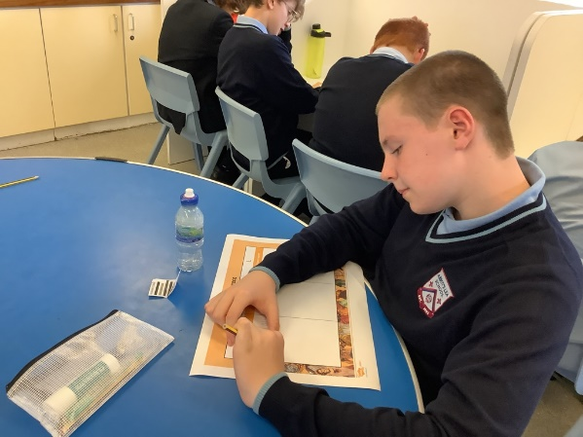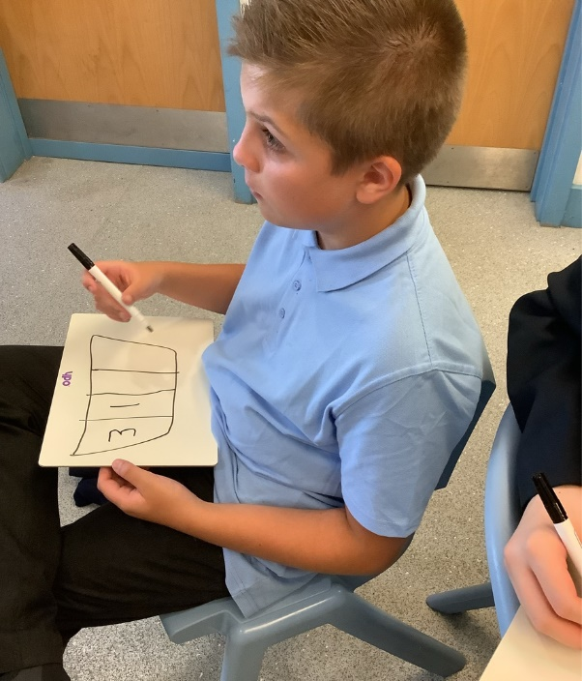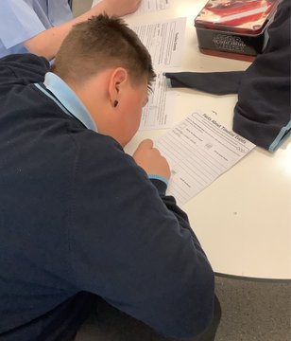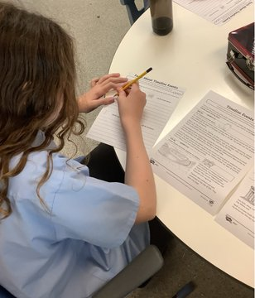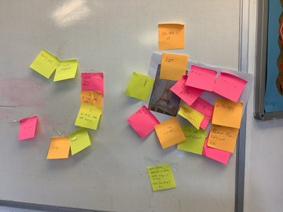

Key Stage 4
Australia class
During our first week with the students we have, explored time travel during our English lessons and patterns and Sequences in maths. The class took part in fitness tests in PE, recording results to see progression as the year moves forward.
New Zealand class
Class is settling well, students are engaging very well in all subjects. However, one in particular would be the English lesson in which students were introduced to 'Starry Night'.
In this lesson students demonstrated a great understanding of themes surrounding the art of 'Starry Night'.
Tasmania class
Tasmania has worked extremely hard in all of our lessons in our first week back to school! In English we read an extract from a classic text: The Wizard of Oz. We focused on analysing the descriptions of the setting and the characters in the text. We practised on summarising the text and making inferences on what the author is trying to suggest. We also practised on the use of punctuation and capital letters in sentences.
In Maths, we learned about describing and continuing linear sequences. We worked out the rules the sequences follow and use the rules to find out the next terms. We interpreted sequences in a table, in picture representations and graphically.
In Science, we learned about the basic structures of both plant and animal cells. We compared the difference between the structures of the two types of cells and looked at the function of each structure.
In PE, we completed our first fitness test of the year. We practised on sit up, sit and reach, press up and a 12 minutes run. In Food Tech, we learned about Food hygiene and food safety. In RE, we learned about the existence of God and Revelation. We looked at the Nature of God.
We also celebrated 4 birthdays back in August and 1 birthday in September this week. We had some cakes and snacks to share.
Samoa class
This week in Samoa we have been working really hard. In English, we are focusing on understanding an extract. We have created visual mood boards and written a diary entry as though we are Dorothy. In Maths, we have begun our topic of sequence. We have been using counters and cubes to help us physically replicate the terms in our sequence, to help us understand the next term.
We have all began our Accredited Learning options this week, this has given us a taster of learning about subjects we have chosen!
Everybody in Samoa has settled in really well and we are excited to see what Week 3 brings!

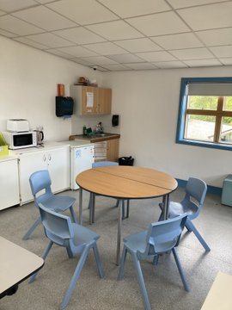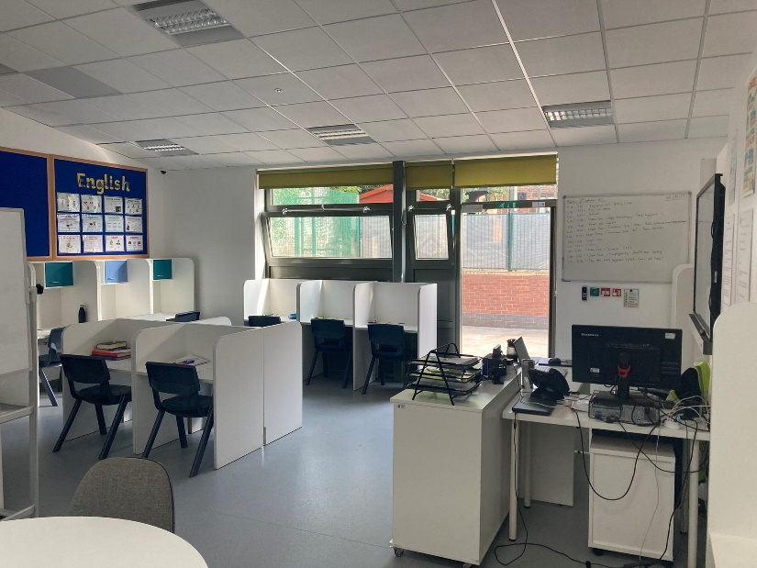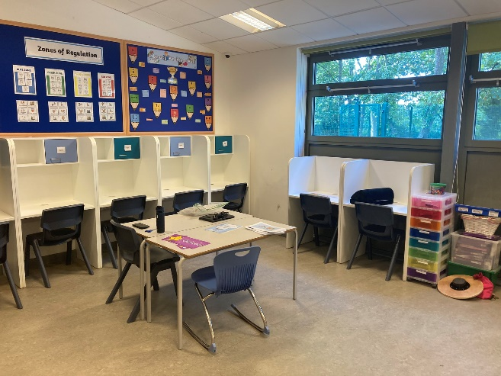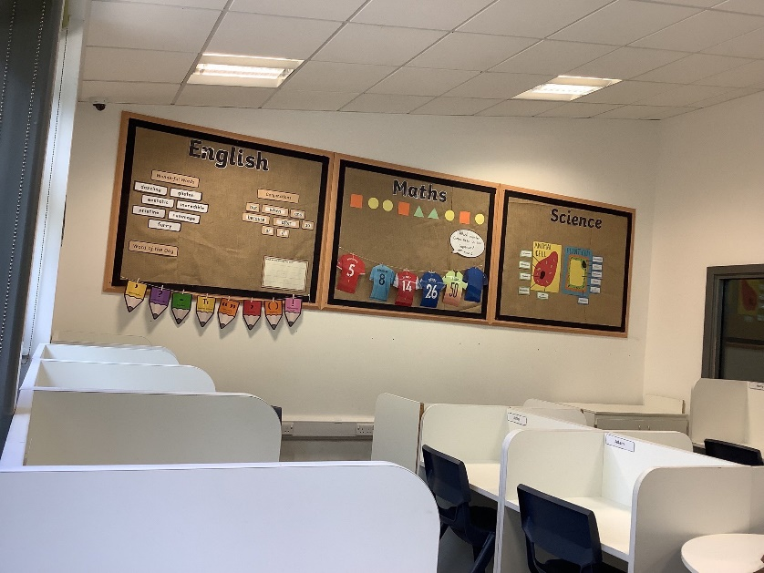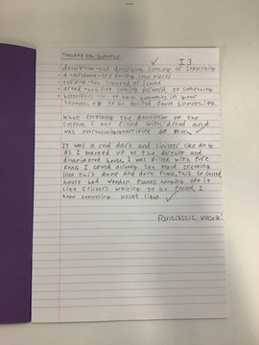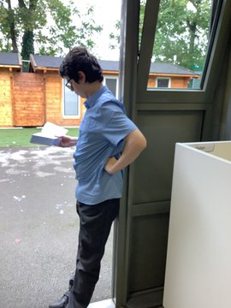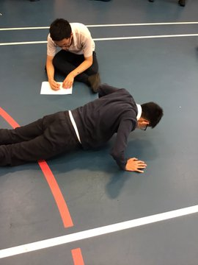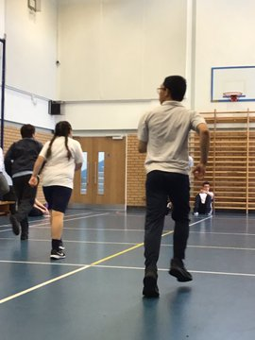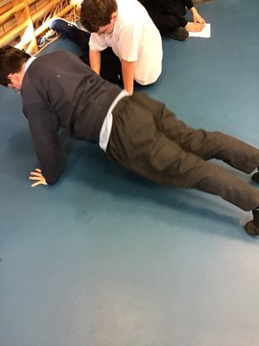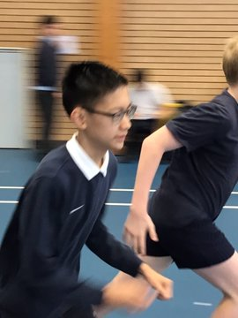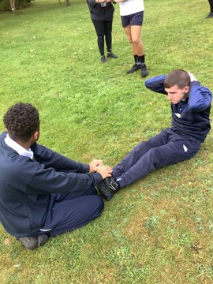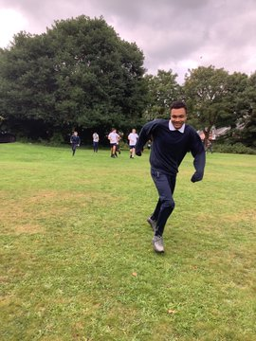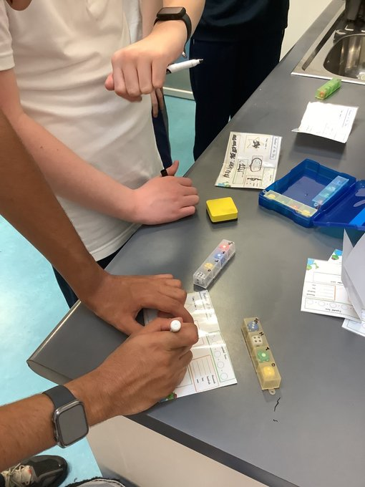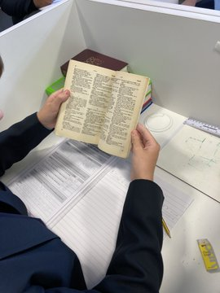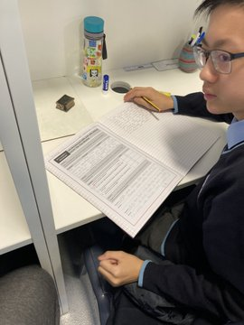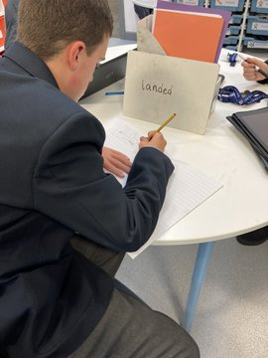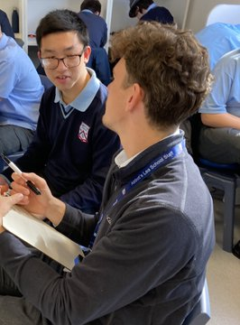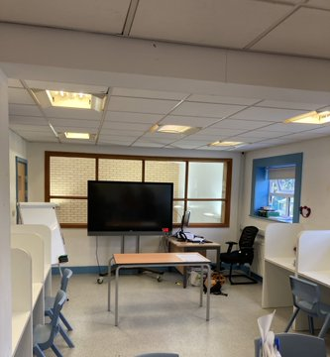

Key Stage 5
Malawi class
It has been a brilliant first week in Malawi class this week. Students have took part in team building activities to get to know each other. In maths, students started the topic of read, write and order numbers up to one million. In English, the class started a new class book, survivor by Tom Hoyle, which students are really enjoying. In PE, students took part in some health and fitness activities, including the 12 minute cooper run!
Overall, we have had an amazing first week in Malawi class!
Fiji class
Fiji Class this week have had a lovely first week settling in and getting to know staff and pupils. We have been talking about what we have done over the summer and what we want to achieve from this year. In English we have been looking at punctuation. Maths we have been looking at hundreds tens and ones. Have a lovely weekend.
Christmas Island class
This has been a great first week back for all Christmas Island students! We began the week with a 'get to know you' session, where students created a power point about what they did over the summer and some fun facts about themselves. In food tech and life skills, the class looked at the importance of food hygiene, what temperature food should be stored at and how to prepare food to avoid food poisoning. In English, we went back to basics, looking at punctuation, grammar and spelling. In Maths, we practiced ordering numbers from smallest to largest. The class also had a great time in their various accredited learning lessons, they learnt about famous Liverpool landmarks in Geography, learnt about medicine development in History and making bird feeders in design technology. In employability, we worked in teams and came up with our own unique designs for everyday new and improved everyday items, such as rubber scissors and a hat with pockets! On Friday, the class enjoyed their chosen enrichment club, and got to know what they are going to be doing throughout the rest of the year in either catering, gardening or sports club. These clubs are particularly helpful in providing the students with an insight into potential college courses so they can begin to plan for their future. We also took advantage of the warm weather and went on various sensory walks around the forest school.
Papua New Guinea class
Wow, what a fantastic start to the academic year. We have had a lovely first week back and it is so nice to see all our students old and new.
In PNG class, we have started the new term really well and have completed some fantastic work. Amongst all our learning we have combined a healthy approach to eating with art. We created some portrait art using a selection of fruit. We even managed a recreate a member of staff. Can guess who it is?
Also, we enjoyed learning about the placement of planets in the solar system. Another WOW moment. All students engaged thoroughly and appeared to love this lesson.
As first weeks to a new term go, this has exceeded all expectations. Well done to all students.
We look forward to the rest of the term and thank you all for your support. Have a lovely weekend
PNG team.

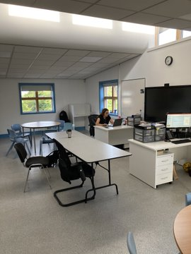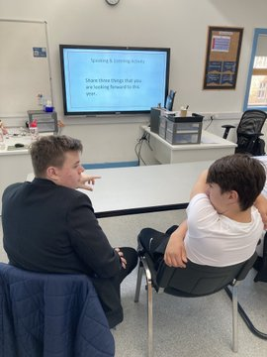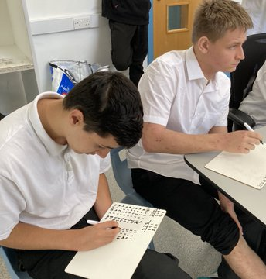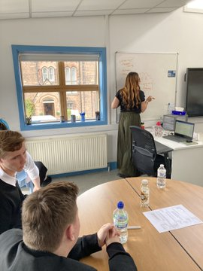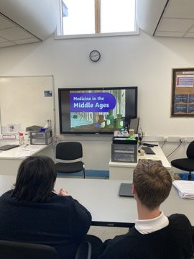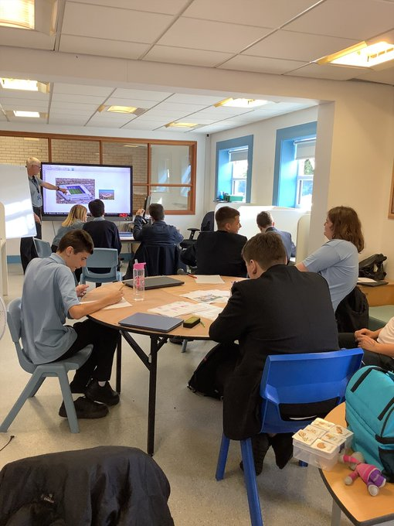

Human Resources

September is always the time when we welcome new members of the team, and come together as one to work for the benefit of our students and to celebrate all the wonderful personal news - from new marriages, to babies, pets, and new homes or travel experiences.
Possibly one of the most exciting developments at Abbot’s Lea School this summer was the coming together of a brand new team of specialists – our Positive Behaviour Support Team (or PBS for short).
Let by Ms Welch, our PBS Leader, we welcome a team of six PBS Assistants, with some familiar faces and others new to the school. All bring in a wealth of experience in the field, and a passion for support students with most complex needs.
The brief for the team is to work to improve school attendance and engagement and class-based learning, whilst also helping us better understand our students’ needs and meet those in our daily work.
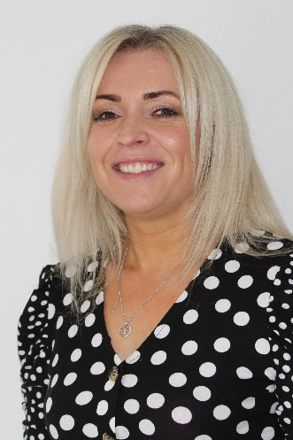
Claire Welch
Positive Behaviour Support Leader
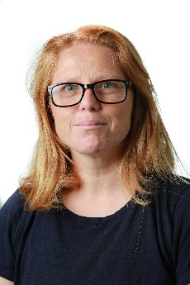  Jackie Coysh  PBS Assistant | Mari Owen  PBS Assistant | Leah Palombella  PBS Assistant | Jonathan Plant  PBS Assistant | Liam Vipond  PBS Assistant | Kelley Weadock  PBS Assistant

PBS team is based in our new Support Hub and joins our existing Multi-Disciplinary Team of care, safeguarding and therapeutic specialists.
I am sure you will join me in warmly welcoming them all to our Abbot’s Lea family!

Young Person’s Advisory Service Liverpool
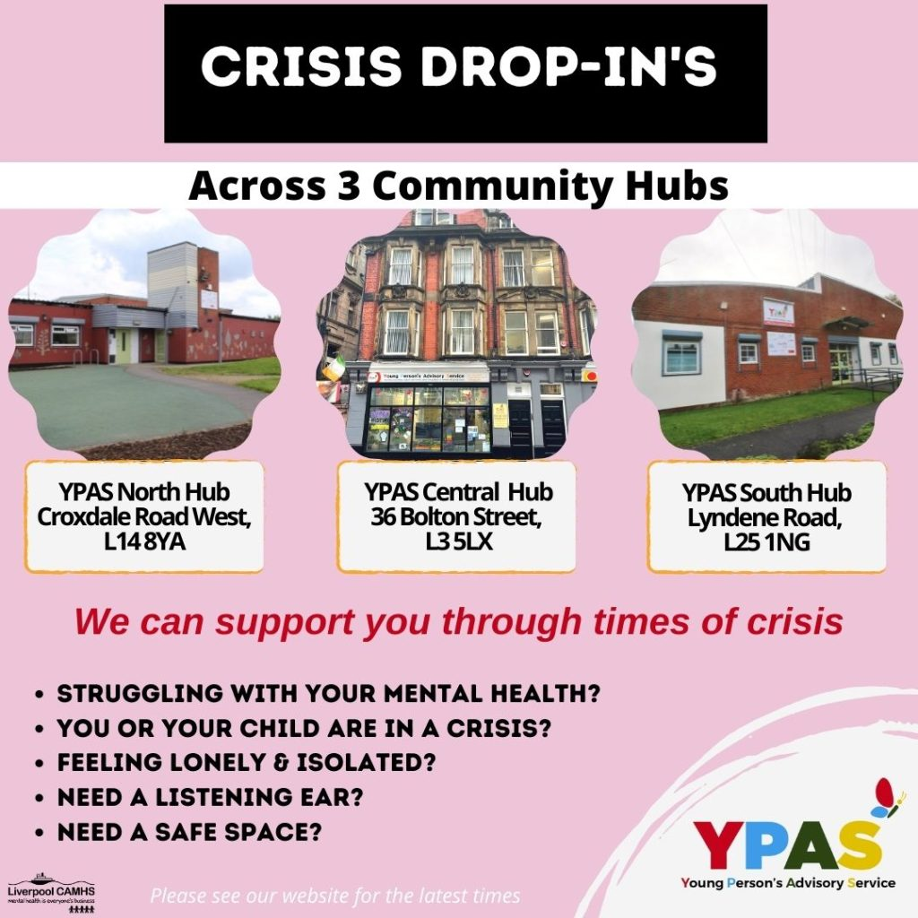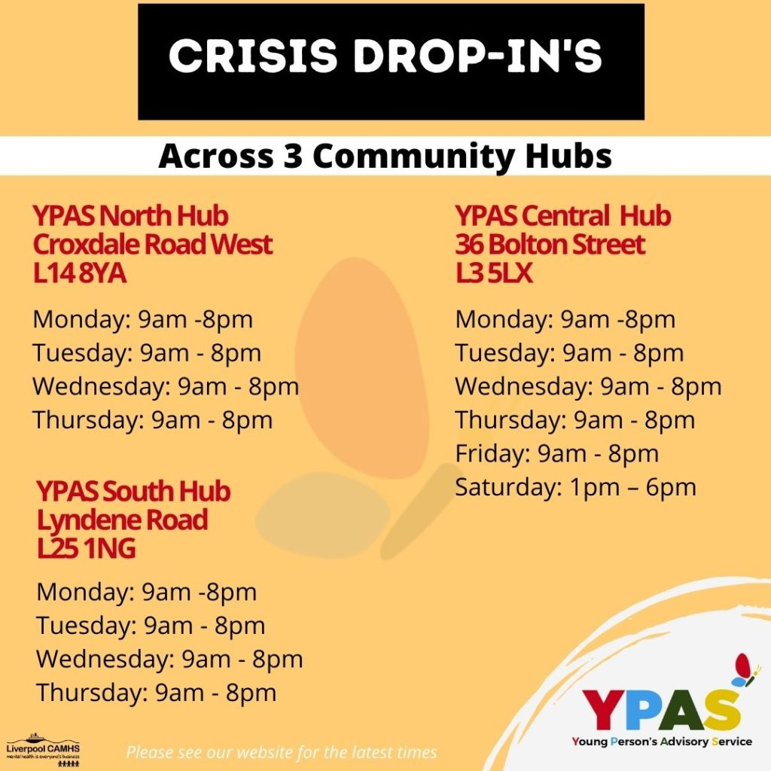
SKY - open access group for 16-25 year olds
When
Mon, 12 September, 18:00 – 19:30
Where
36 Bolton St, Liverpool L3 5LX, UK (map)
Description
SKY is for 16-25-year-old young people. It provides a safe, comfortable space in a relaxed environment. You can drop in for a chat, meet new people, discuss YPAS’s services or take part in informal education sessions. A member of staff is always available to meet and assist you if you need support.
Tea & Talk - parent/carer wellbeing drop-in
When
Tue, 13 September, 09:30 – 11:30
Where
Young Persons Advisory Service, Croxdale Rd W, Liverpool L14 8YA, UK (map)
Description
Parents and Carers Wellbeing Drop-in Mornings Offering a range of themed wellbeing and selfcare activities, hosted by YPAS Parenting Team. For more information please contact: parentingteam@ypas.org.uk
SMARTY'S - open access group for primary school age children
When
Tue, 13 September, 16:00 – 17:30
Where
YPAS South Community Hub, Lyndene Rd, Liverpool L25 1NG, UK (map)
Description
Smarty’s is an open access group for primary school aged children. Smarty’s provides a secure, happy and stimulating environment; enabling children to learn and develop attitudes, skills and abilities. Smarty’s offers a wide range of activities including creative play, arts, drama, dance and singing etc. Registration will require parent/carers consent. Please contact us to complete a registration pack.

