Message from the Headteacher
Mrs Ania Hildrey, Headteacher, headteacher@abbotsleaschool.co.uk
Contents
Head’s Foreword
Key Diary Dates
Useful Information and Resources
Dear Students, Families, Colleagues and Friends

Welcome to today’s issue of the Head’s Weekly Newsletter – the penultimate copy of this term!
This week has been brilliant in so many ways – we celebrated all things Science-related and we also focused on Oracy skills. I hope you enjoy our “week in pictures” section of the newsletter, giving you an insight into the amazing variety of students’ learning opportunities (indoor, outdoor and offsite).
We also welcomed Community Police Officers, who came in two police vans and held talks with students in Key Stage 2 (Years 5 and 6 only) and Key Stage 3 – thanks to Miss Gibney, our Key Stage 2 Leader for arranging this and making it happen – it was an educational, inspirational and fun visit enjoyed by all.
We did have some challenges related to staff’ sickness absences and so, you may have been made aware of the operational changes on some days, with classes being merged or timetables amended to make sure we can cater for all students’ needs. We wish our team a speedy recovery and hope that next week will prove to be healthier and, in turn, more stable for us all. Huge thanks to all colleagues for creative solutions!
Next week, as the Easter celebrations approach, there might be some fun activities involving eggs, chocolate, bunnies and hunting for treasures all around our wonderful grounds. Watch this space!
Next Friday, students will finish school at 1pm and so, please be reminded of the need for the transport to be advised of this early finish.
Please note that we do not hold open assemblies of coffee mornings on the last Friday of Term and so, we will see you all on 21 April 2023 – our Family Coffee Morning will run from 9:30am until 11am – it is always a pleasure to see many of you join us for a chat! Term 5 will start on Monday, 17 April 2023 at the usual 9am.
With kindest regards and best wishes for the weekend ahead!
Mrs A Hildrey
Headteacher

School Year Calendar

Term Dates for next academic year:
http://www.abbotsleaschool.co.uk/wp-content/uploads/2022/09/Term-dates-2023-24.pdf
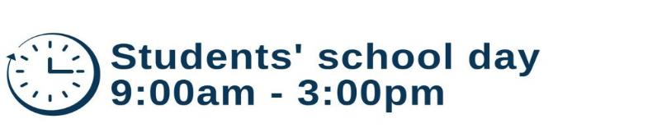

Term 4
Ends: Friday 31 March 2023 at 1pm
Easter break: Monday 3 to Friday 14 April 2023

Term 5
17 April – students return
May day: Monday 1 May
Ends: Friday, 26 May 2023 at 3pm
Half term: Monday 29 May to Friday 2 June 2023

Term 6
5 June – students return
30 June – School Leavers’ Date
7 July – Transition INSET
10-14 Transition Week
Ends: 14 July 2023 at 1pm
17-18 July – INSET (worked in lieu as twilights throughout the year)

Key Diary Dates for Term 4
Date | Activity | Notes
Thursday 30 March | Drop everything and read day | There will be challenges for students as well as an opportunity for the older students to come and read stories to our younger students
Friday 31 March | Easter celebrations and Spring activities | The outdoor learning group will lead our Easter Egg hunt where all students will receive an Easter Egg!
Friday 31 March | Last day of school for students | School closes at 1pm for the Easter break and re-opens again on Monday 17 April 2023

Assemblies
Assemblies are facilitated by Mrs Tobin (Deputy Headteacher.) However, each week a different person or class will lead the assembly. When your child’s class leads the assembly, their teacher will contact you in advance to let you know.

Weekly Attendance Reports
There is clear evidence that strong attendance at school links to strong educational outcomes for students. Mrs Hildrey set out in her letter last week the processes regarding student attendance. Each Friday you will be sent your child’s attendance data so that you can support the school in ensuring it remains as close to 100% as possible.

Student Progress Reports
You will have received a mid-term progress report and you will receive an end of year report (5 July 2023) for your child.
The reports summarise progress in all areas of the curriculum as well as providing a summary of the qualities your child displays at school.
If you have any questions on comments related to your child’s progress at school, please contact Mrs Tobin on deputy@abbotsleaschool.co.uk

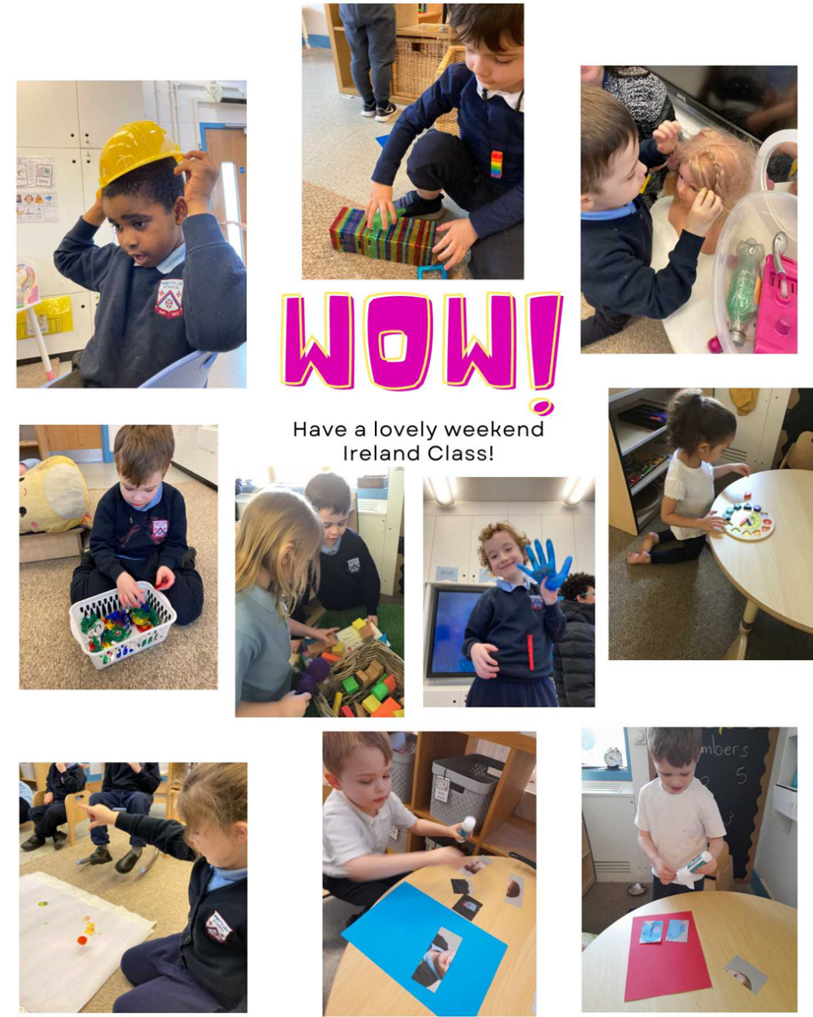
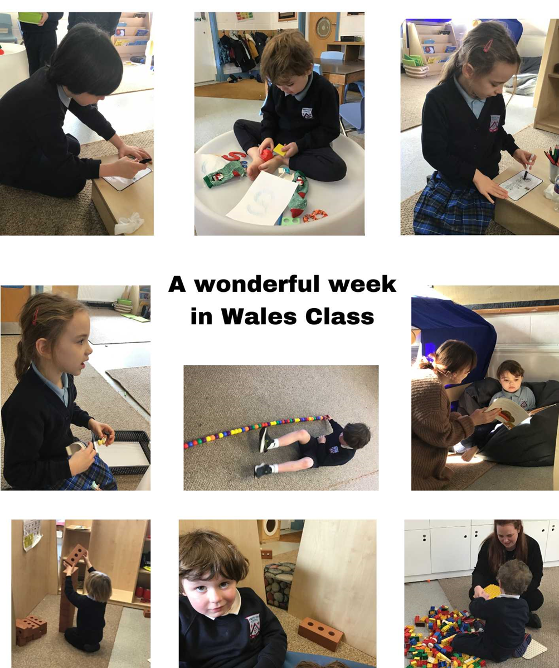
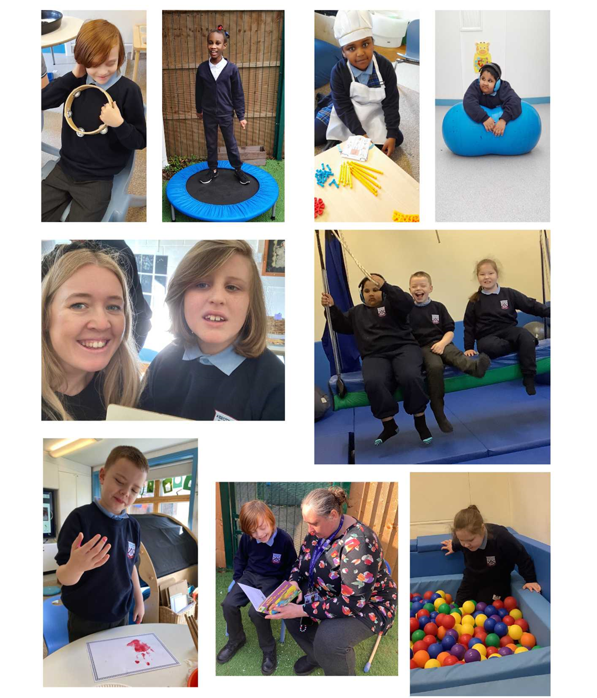
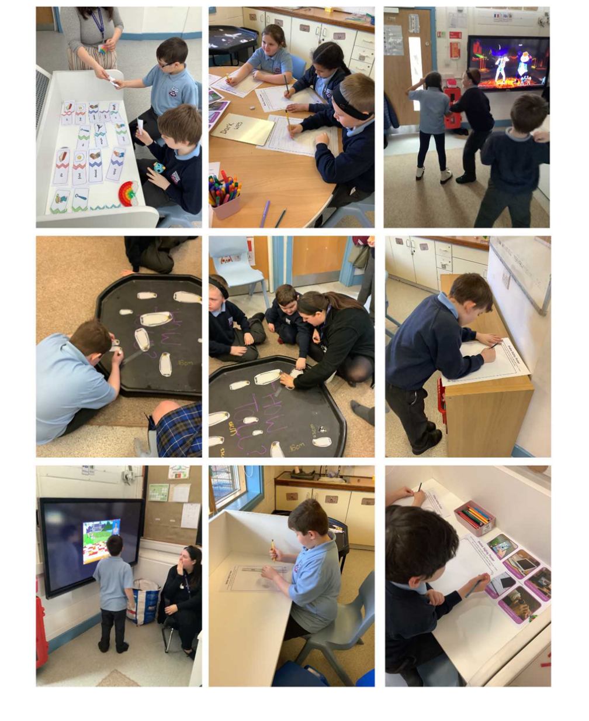
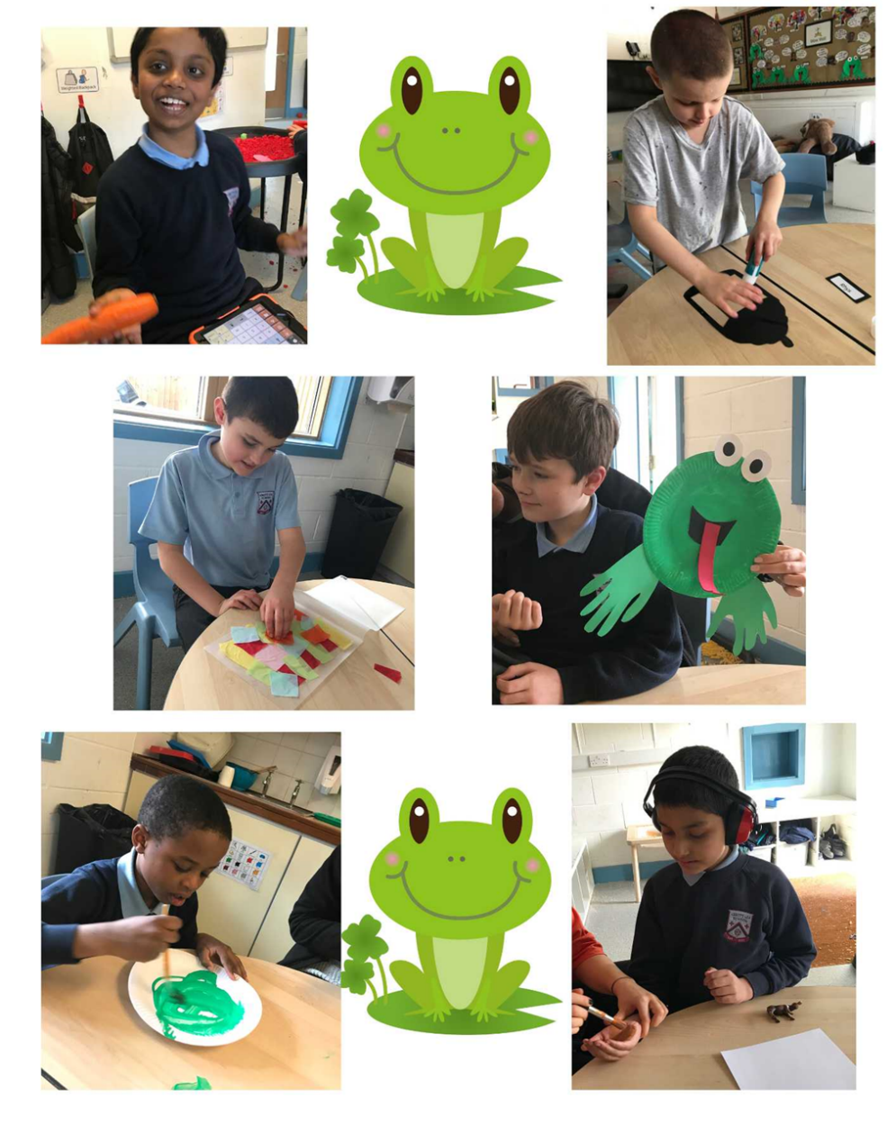
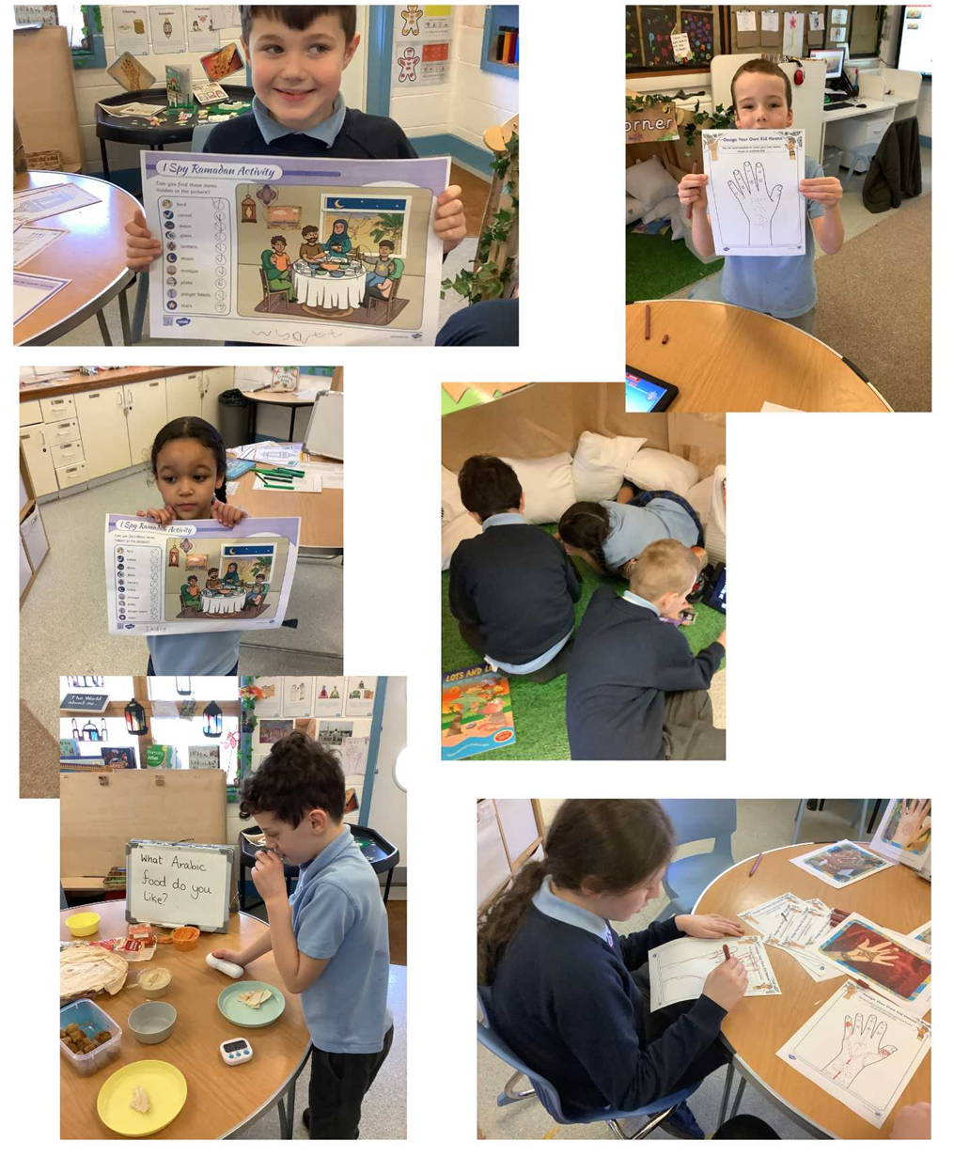
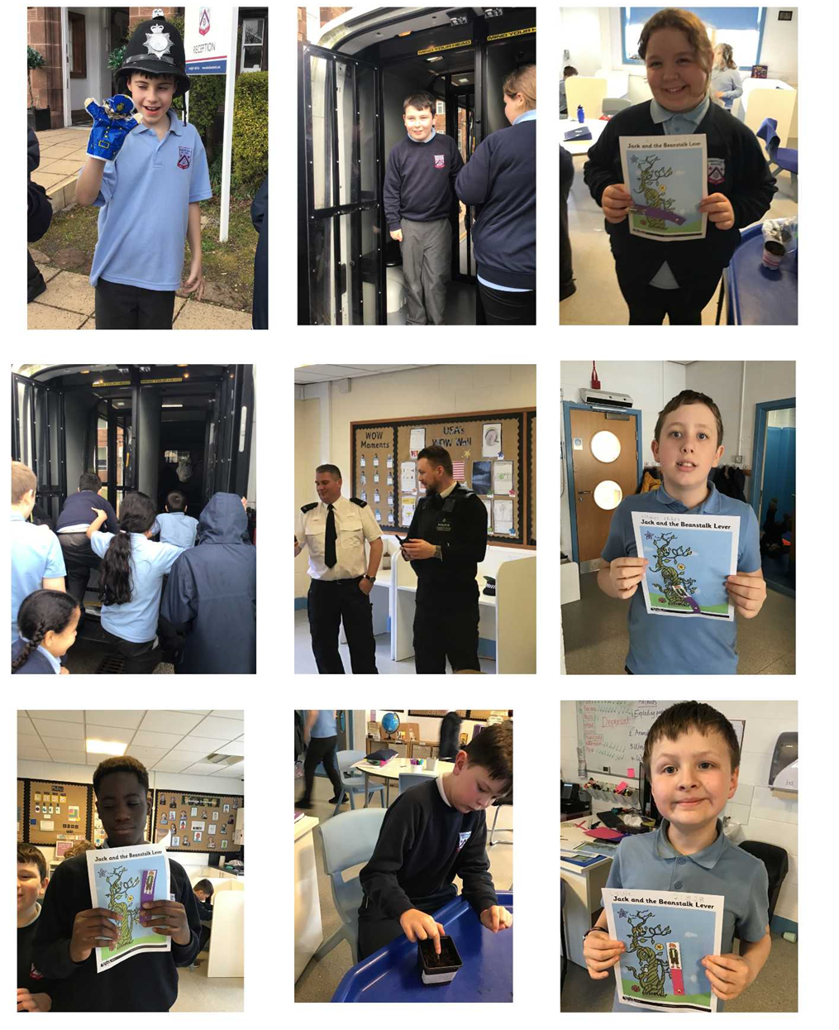
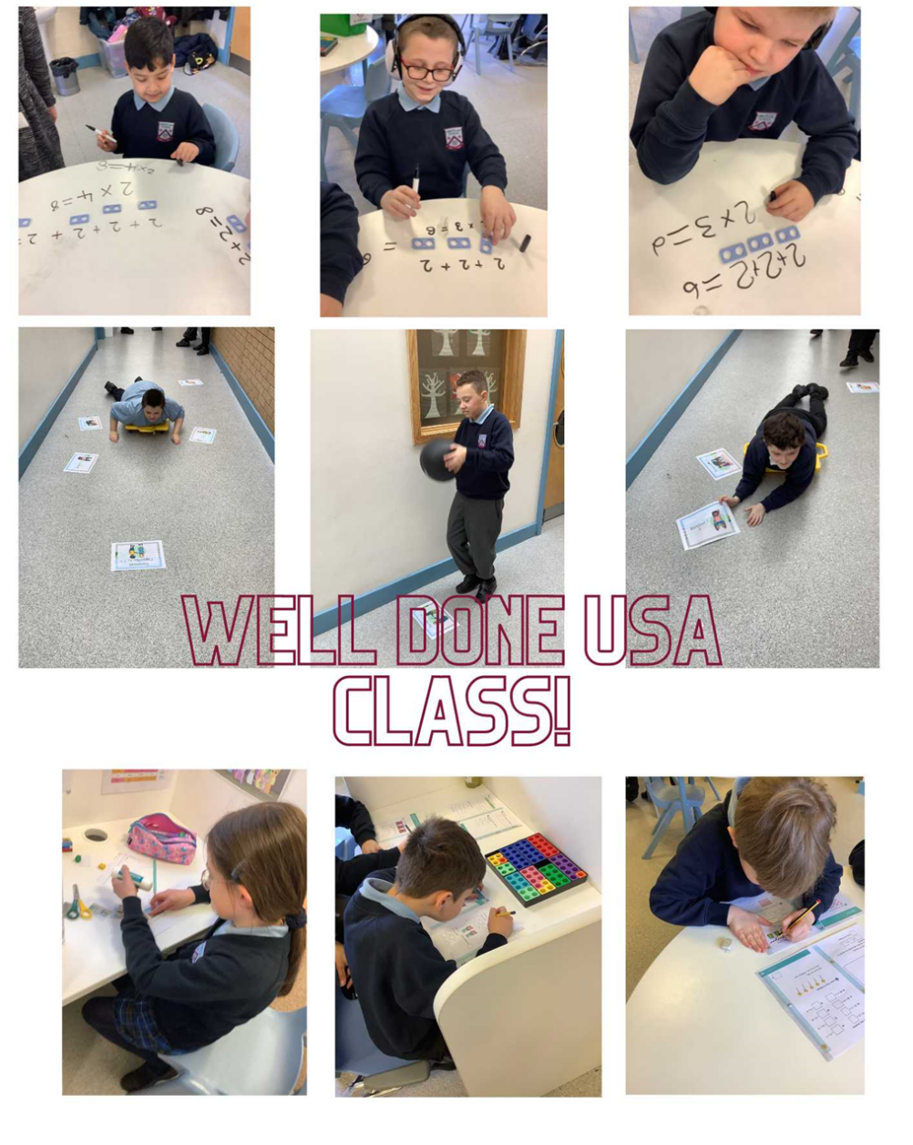
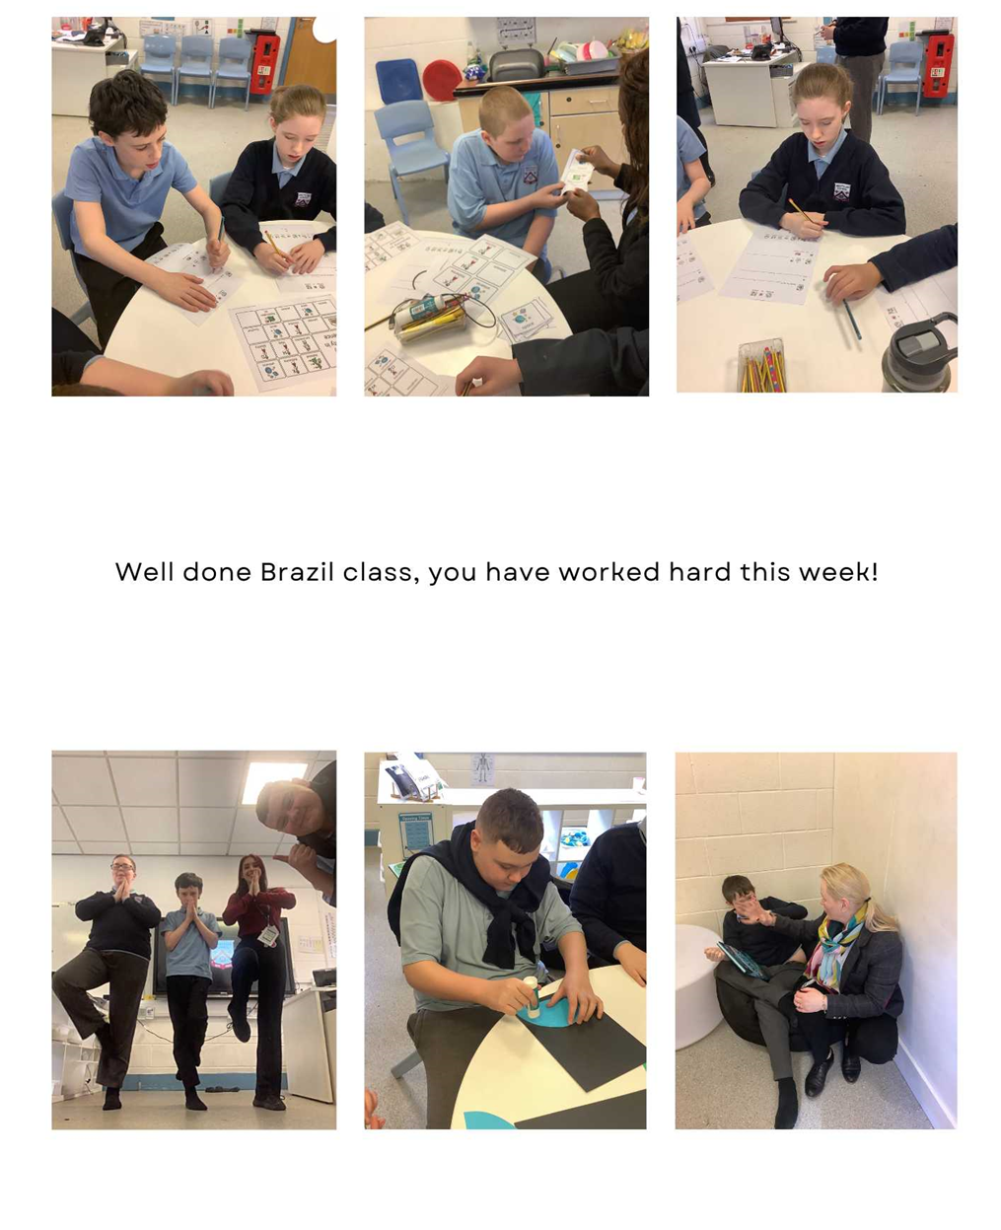
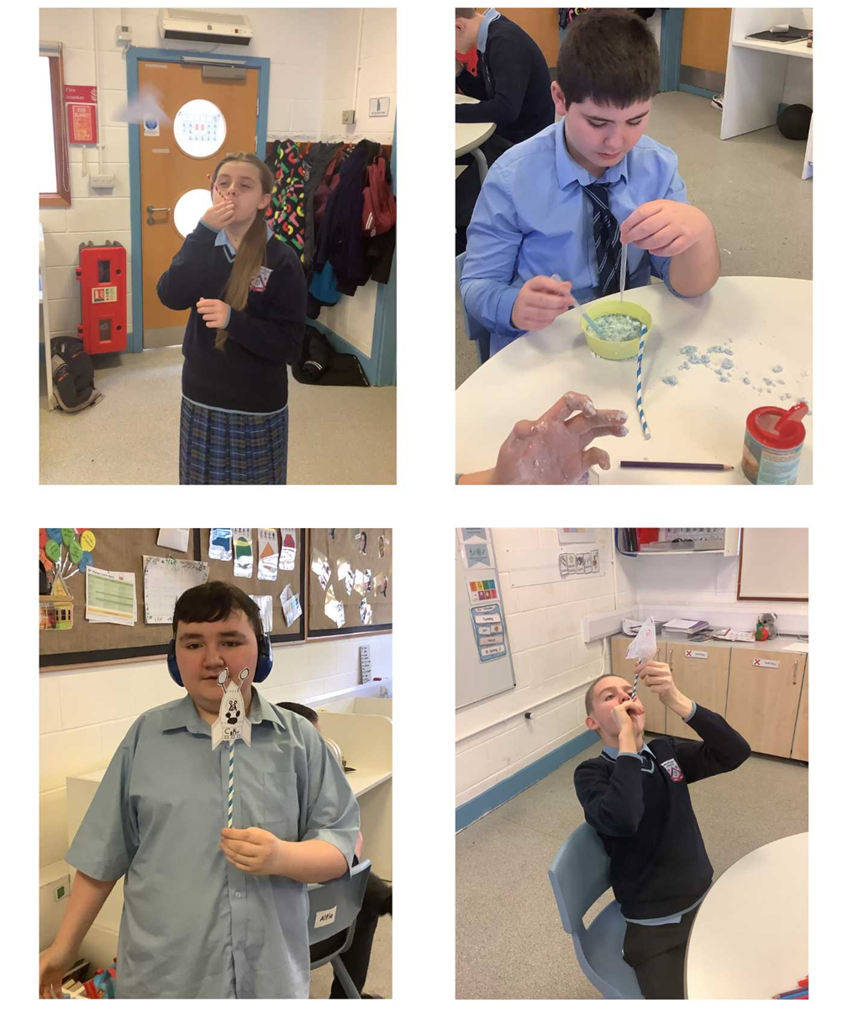
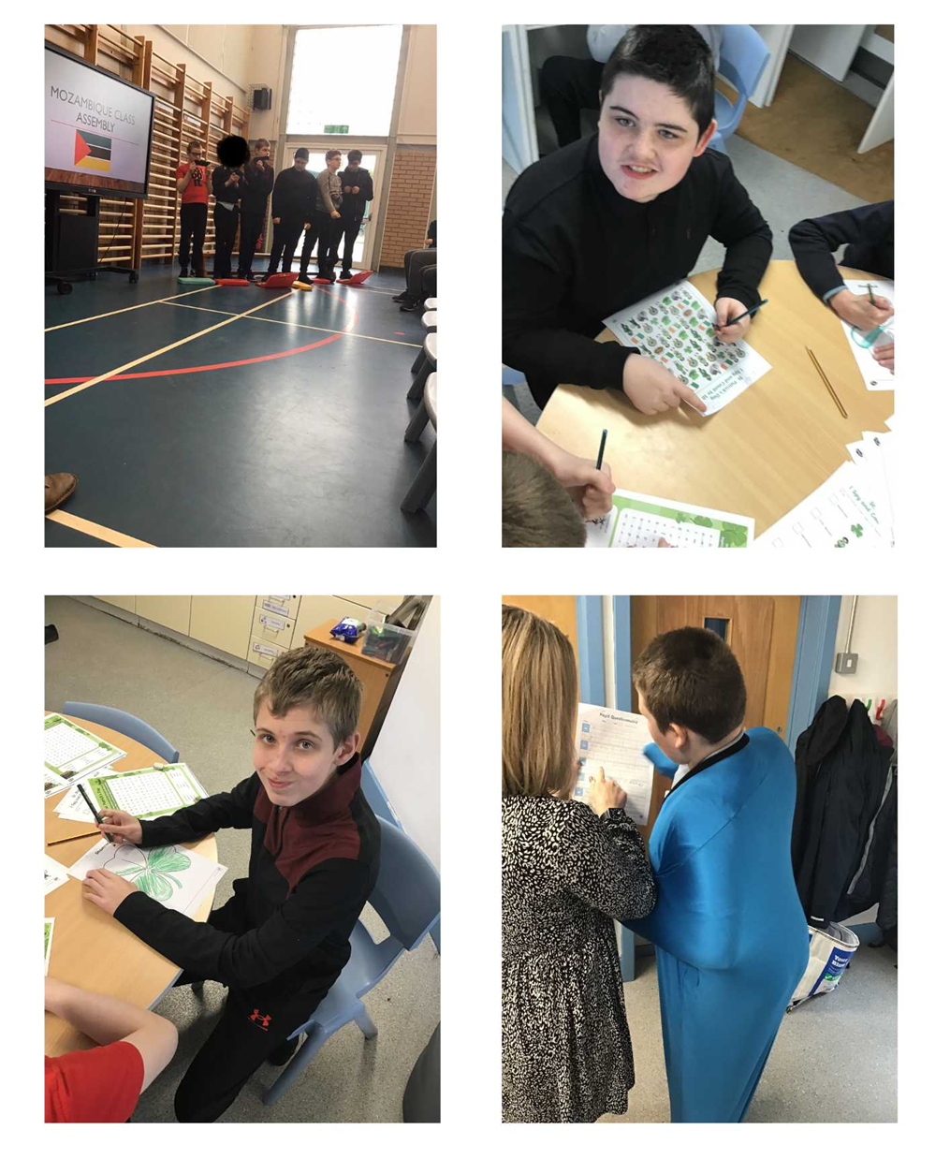
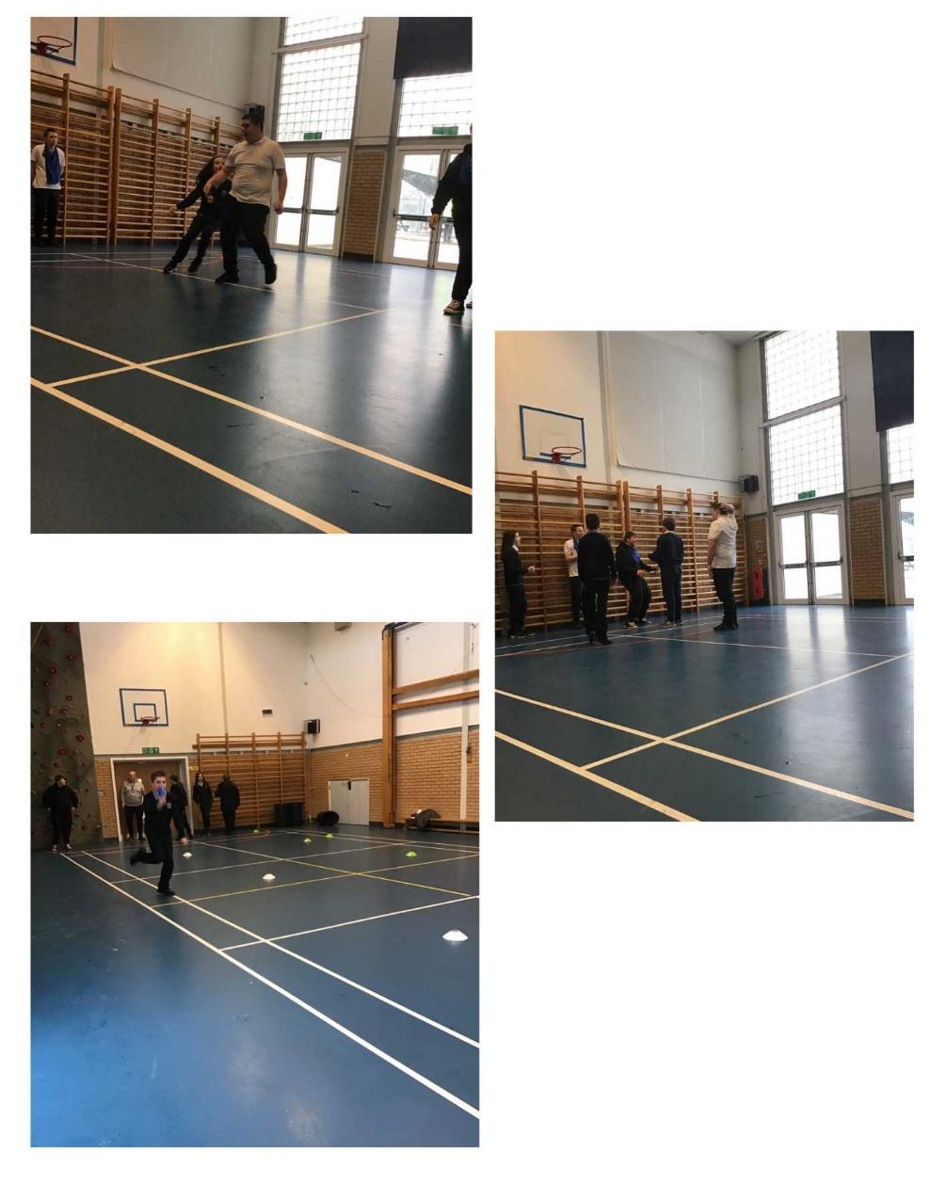
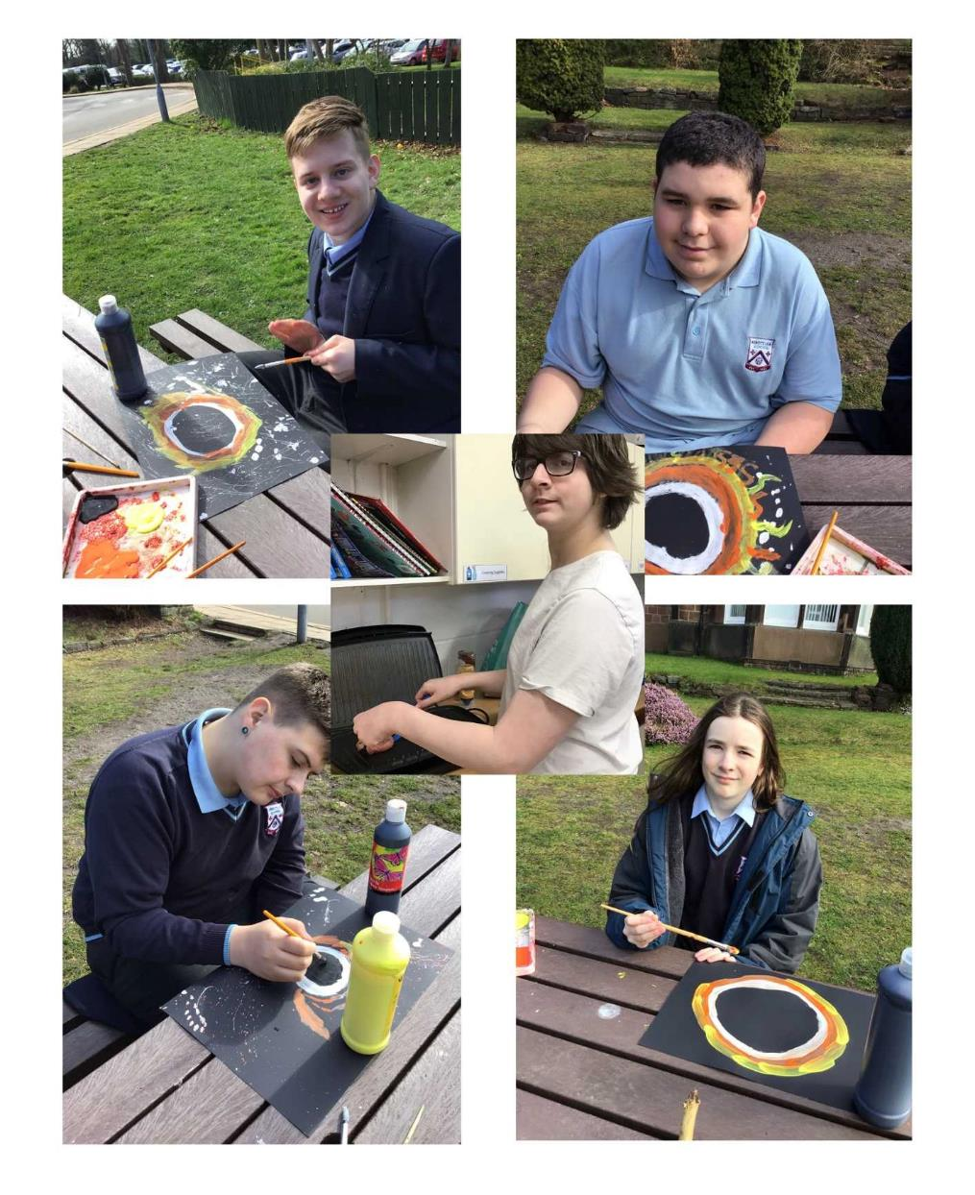
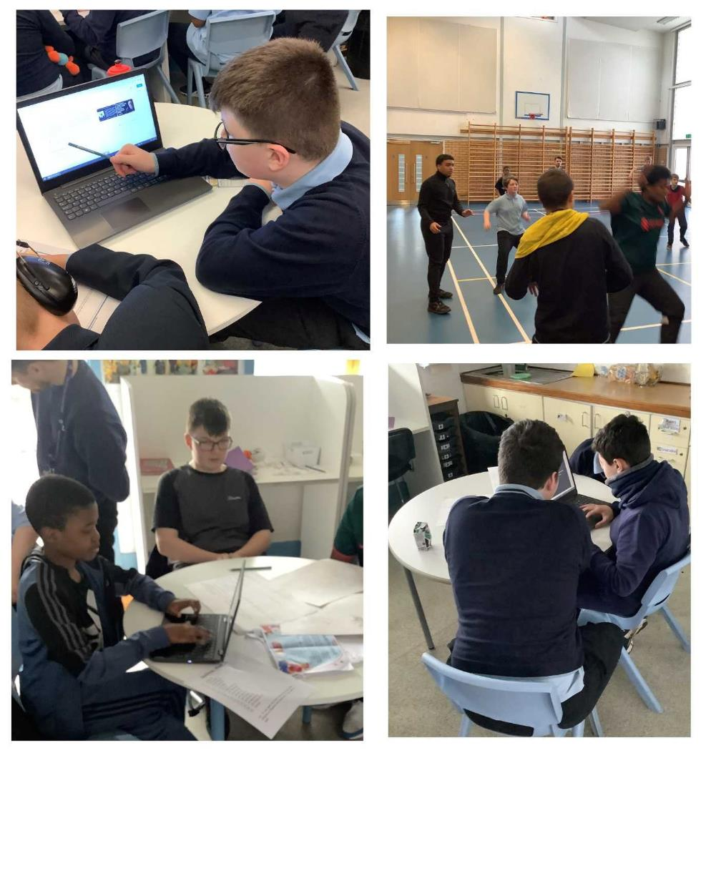
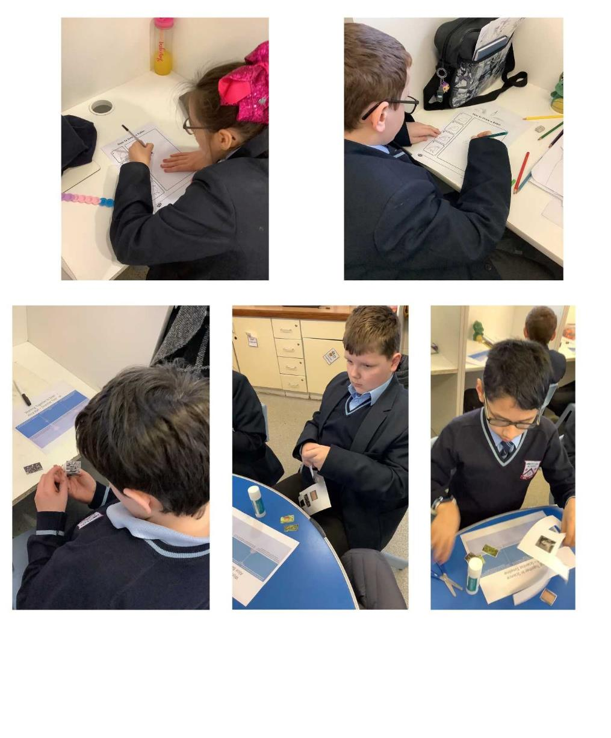
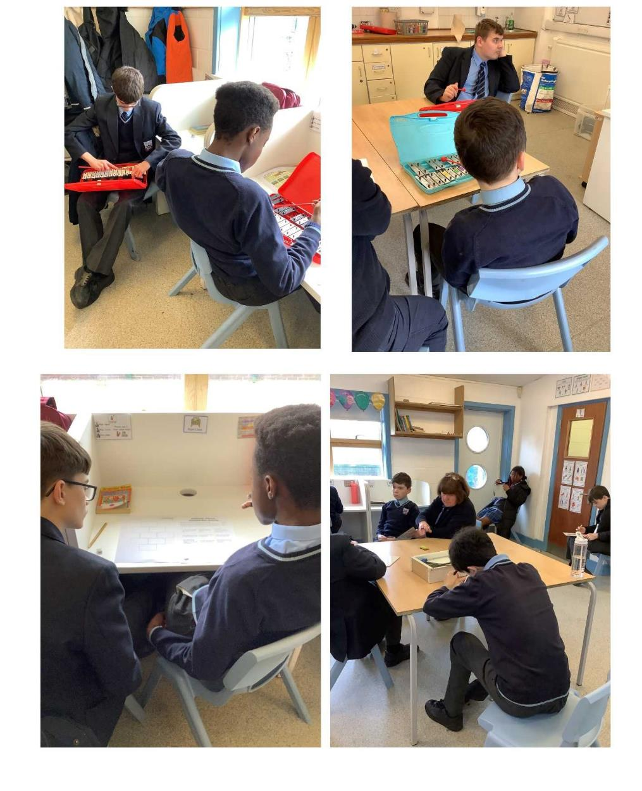
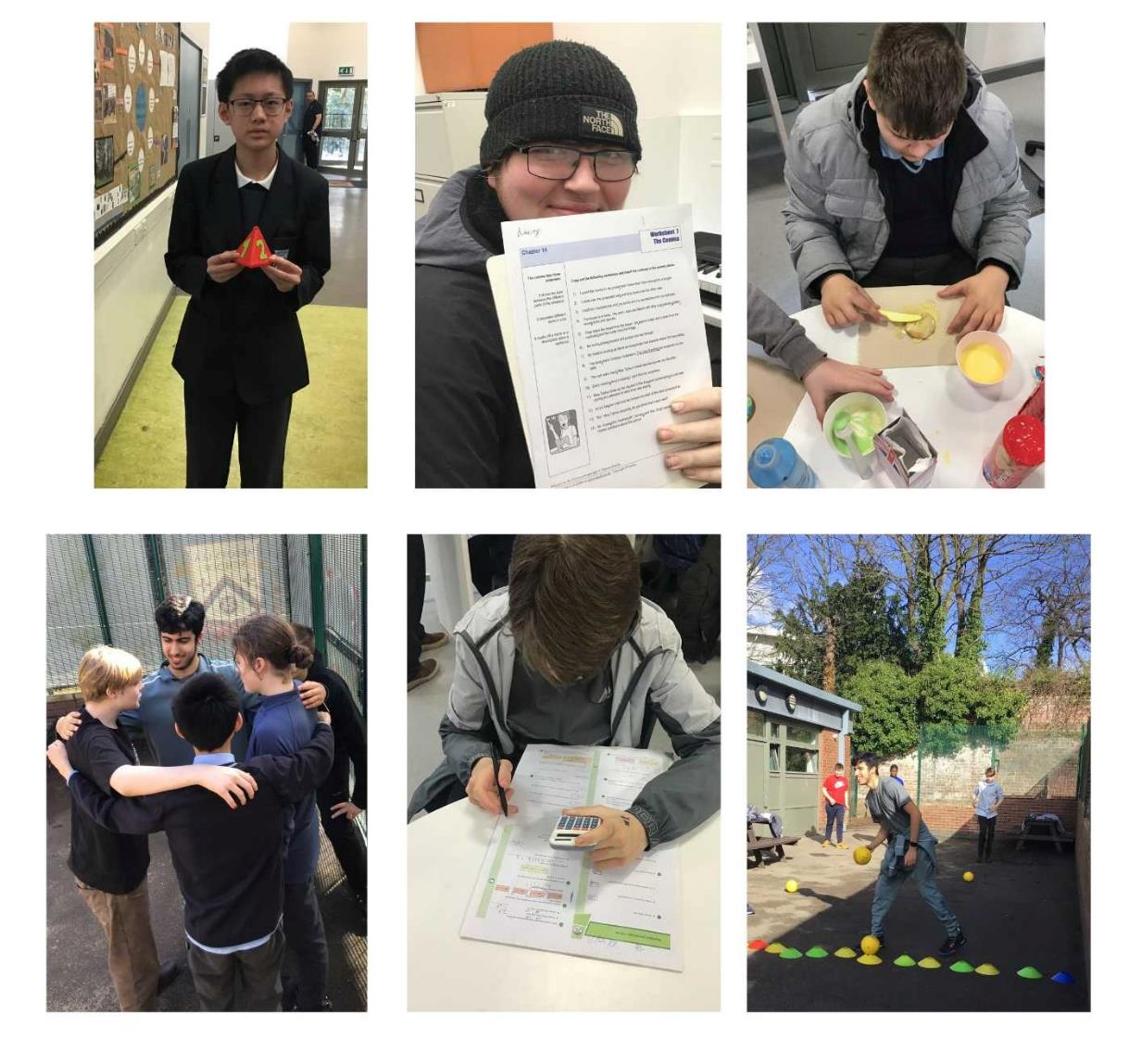
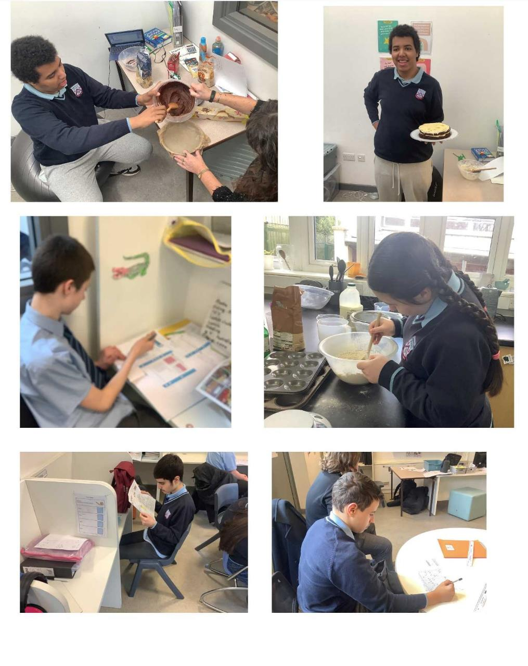
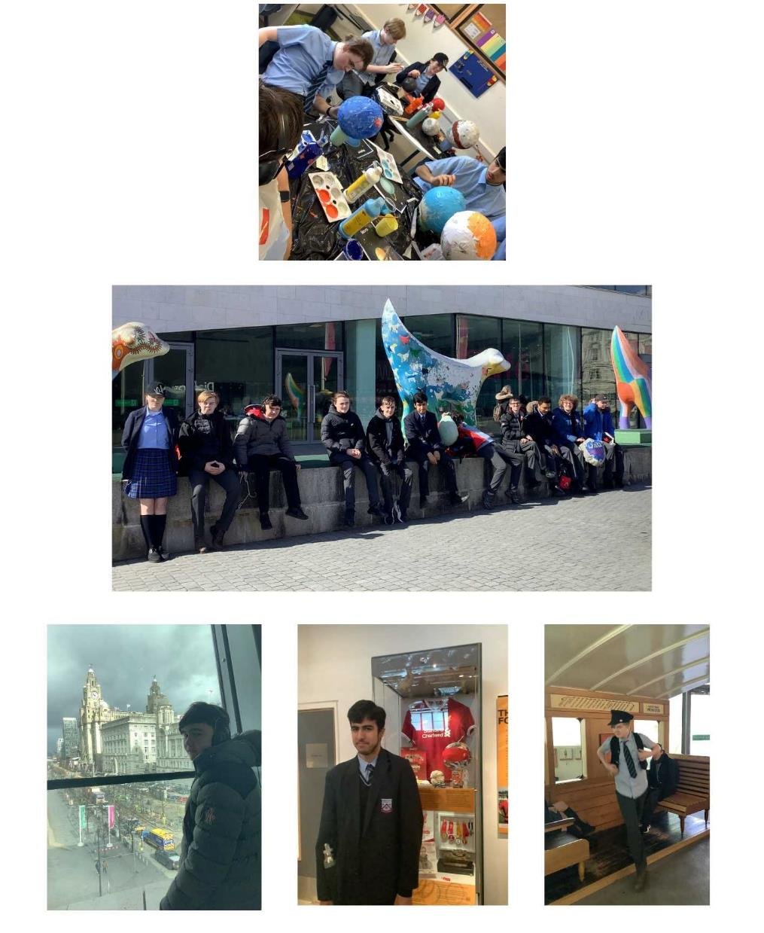
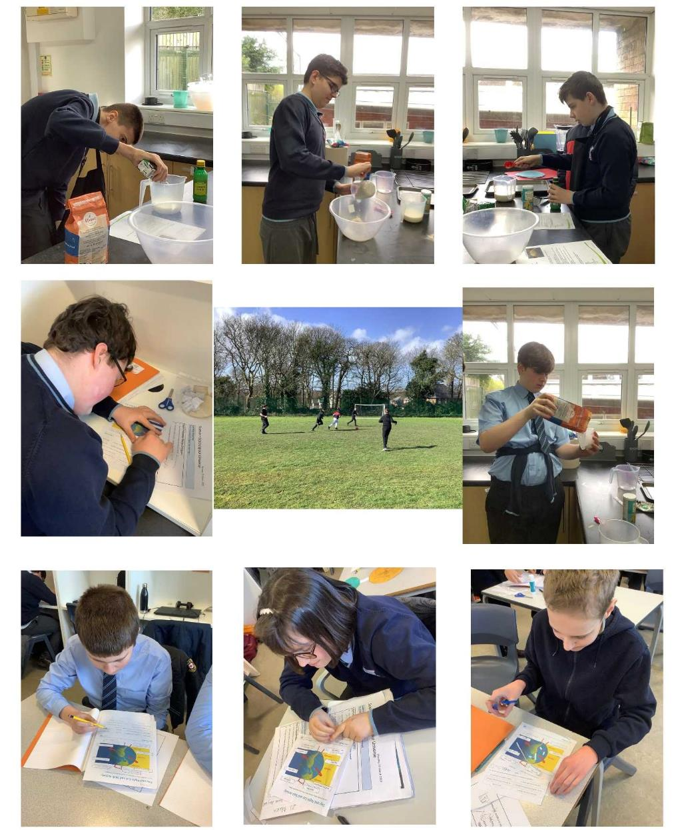
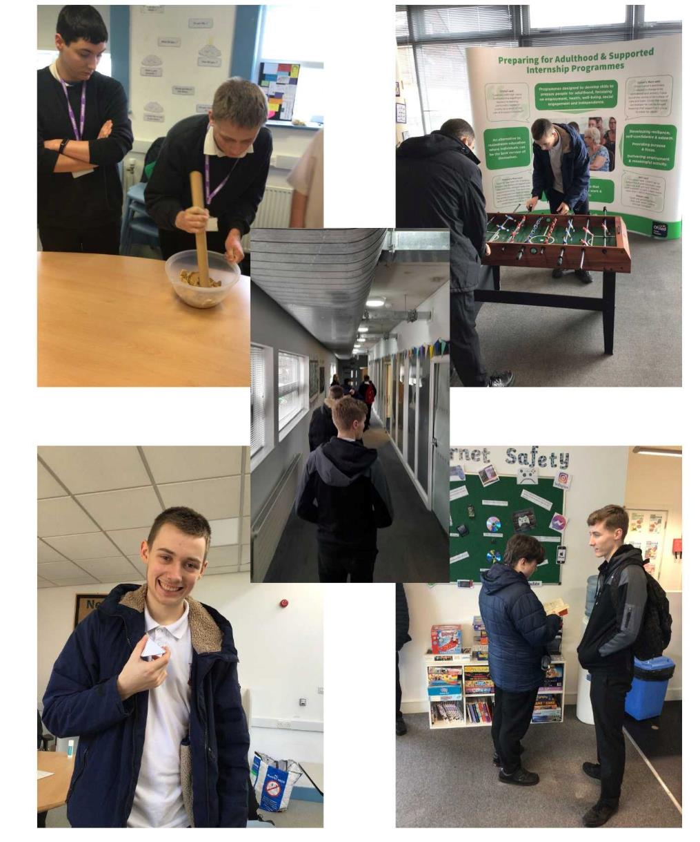
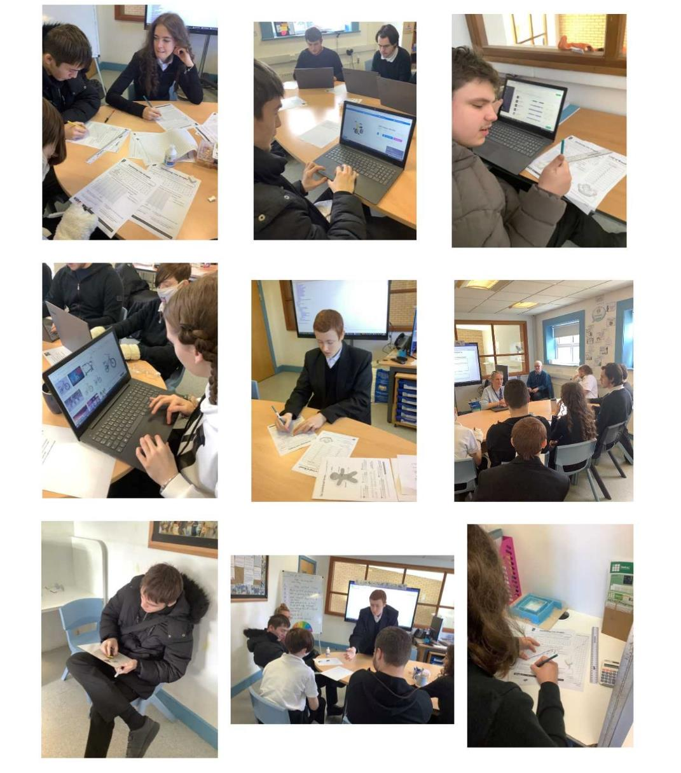
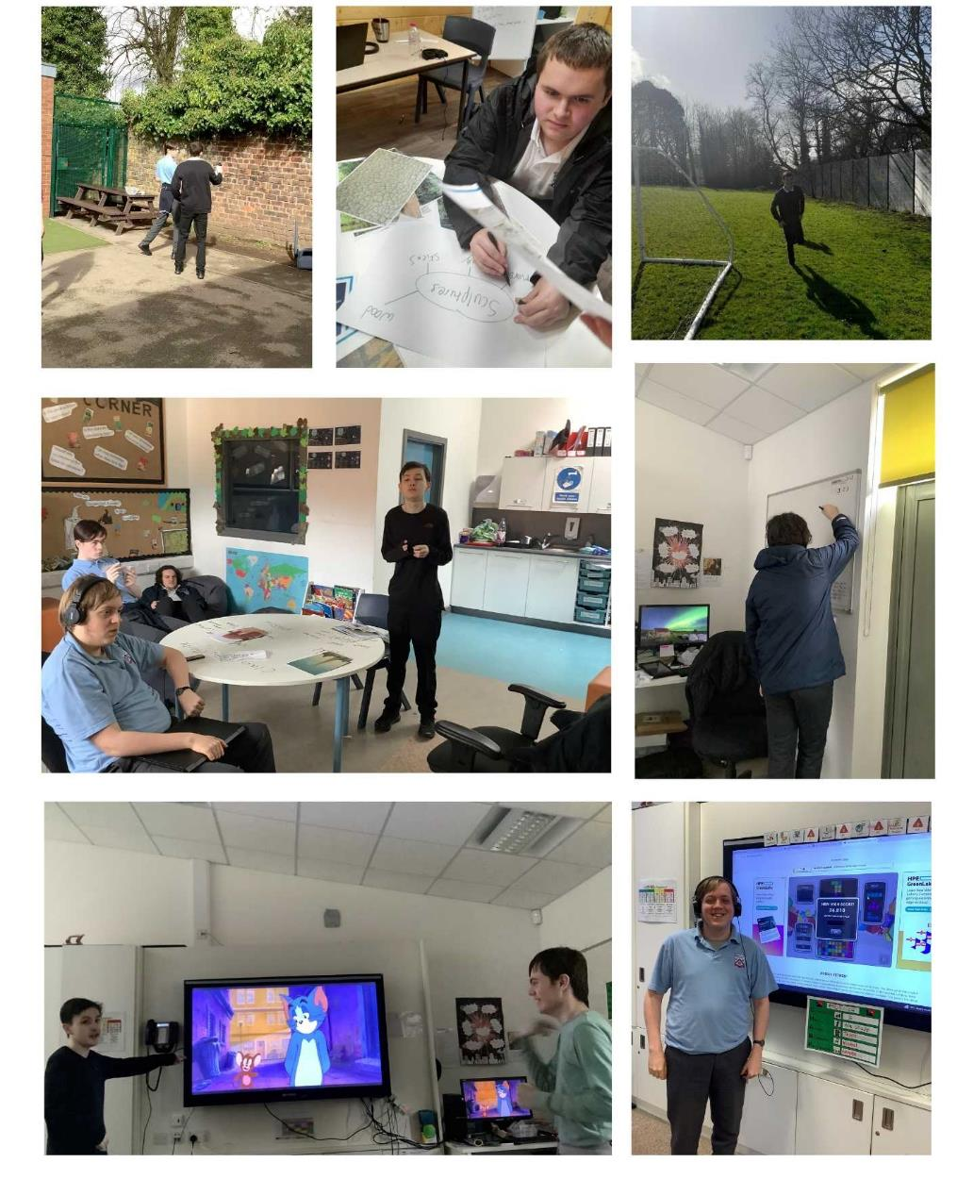
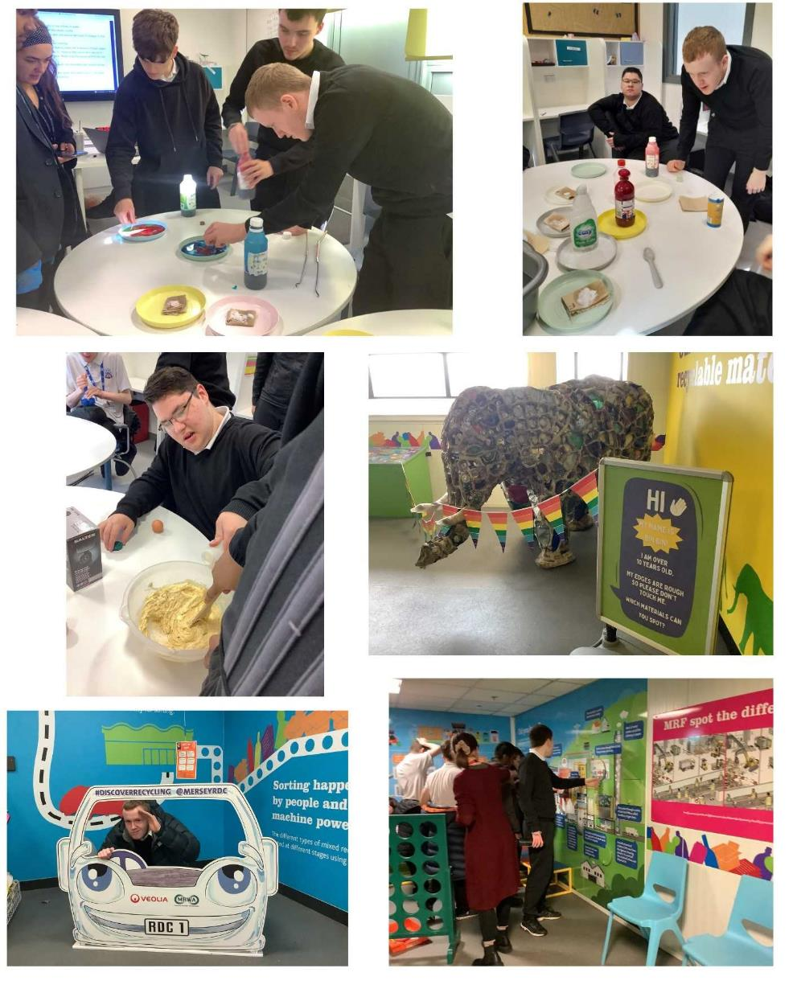

Student of the Week
Class | Student | Reason why
Key Stage 1
Ireland | Clodagh | For joining in with group activities
Wales | Barnaby | For fantastic engagement in lessons and listening
Key Stage 2
Canada | Michael | For being accepting of others and showing a mature attitude around others.
Italy | Glory | For excellent role play and communication in our speech and language session.
Portugal | Perry | For following CHAMPS brilliantly everyday
France | Thor | For successfully challenging himself within the classroom.
Spain | Tanish | For having a happy positive attitude.
USA | Alex | For engaging well with staff and students
Key Stage 3
Brazil | Adam | For trying his best to make good choices this week.
Peru | Andrew | For sharing knowledge on space effectively during a lesson.
Mozambique | Jacob | For working really hard and having a great week.
Botswana | John | For showing real maturity in a serious incident. Well done John, Botswana are proud of you
Madagascar | John | For working hard during our diversity lessons.
Kenya | Ryan | For having a positive attitude in all lessons.
Seychelles | Finley | For doing imaginative English work and Socialising well with staff and peers.
Cape Verde | Ben | For working really hard in class to complete his work.

Key Stage 4
Australia | Justin | For always having a positive attitude and caring for others.
Tasmania | Mason | For working hard in all lessons, following CHAMPS instructions and being a role model for the golden rules.
Samoa | Jack | For being so mature, making great choices and being an absolute pleasure to be around!
New Zealand | Joel | For engaging more with staff and peers in class and for being extremely brave whilst getting his vaccination.
Key Stage 5
Malawi | Mya | For having an amazing attitude, being open to new things and always trying her best.
Christmas Island | Lily | For her positive attitude to every aspect of school and being kind and respectful to all staff.
Fiji | Francis | For an excellent week and trying hard in all his lessons
PNG | Ciaran | For amazing engagement in activities and showing that they are ready to do lessons more.

School Swimming 2023 (EYFS/KS1 - KS4)

EYFS/KS1 - KS4 Students will be having swimming lessons as a part of the Physical Educational Curriculum this academic year. Swimming sessions will take place between January and June 2023, with all classes assigned specific weeks.

A school minibus will take the children to Halewood Leisure centre during the morning sessions of their assigned weeks. The sessions are led by trained swimming instructors and are supported by the class team.

All EYFS/KS1 - KS4 Students will be included in these lessons; they will need to bring a small plastic bag or backpack containing: -

- Swimming kit (one-piece swimming costume for girls please)
- Towel
- Hairbrush
- Bathing caps (All children with long hair must have their hair tied back)

If you require any further information or support, please do not hesitate to contact your child's class teacher or Key Stage Leader.

Swimming Dates

We are sorry that some of our swimming sessions have been affected by the closure of the school and the staffing shortages, making our risk assessments dictate cancellation. Safety must come first.

Date | Class
Tuesday 2nd May  Wednesday 3rd May  Thursday 4th May  Friday 5th May | Canada  Ireland  Madagascar  Cape Verde
Tuesday 9th May  Wednesday 10th May  Thursday 11th May  Friday 12th May | Canada  Ireland  Madagascar  Cape Verde
Tuesday 16th May  Wednesday 17th May  Thursday 18th May  Friday 19th May | USA  Wales  Seychelles  Botswana
Tuesday 23rd May  Wednesday 24th May  Thursday 25th May  Friday 26th May | USA  Wales  Seychelles  Botswana

Young Person’s Advisory Service Liverpool
